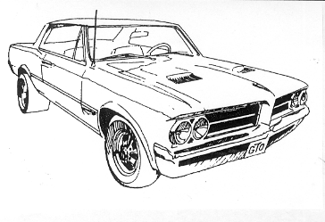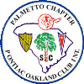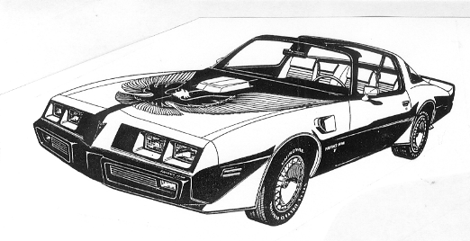

Pontiac - GMC Show and Shine

Saturday, July 16, 2011

Chiefs Wings & Firewater, 723 Congaree Road, Greenville, SC
(See directions below)

Open to all Pontiac, Oakland, and GMC owners

Trophies Awarded

Raffle for auto related goodies

Special deals on wings and meals

Registration starts at 10 AM - Show ends and trophies awarded at 2 PM

Vehicle registration $5 - No charge for looking

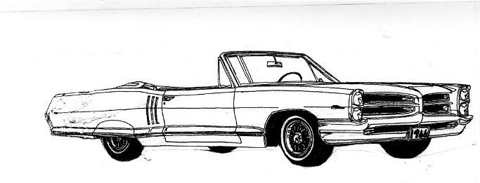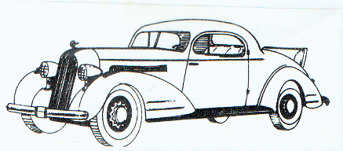

Directions: From Columbia: Take I-385 North from I-26 to Greenville. From the I-85 corridor: Take I-385 North into Greenville. Then take the Roper Mountain exit (Exit 37) off of I-385, cross over 1-385 and head toward Greenville on Roper Mountain Road. One block past the interchange is the stoplight for Congaree Road. Turn right on Congaree and go about ½ mile. Chiefs Wings & Firewater is to your right.

For more information call: 864-268-2851 or email user46810@charter.net. Also check out the Chiefs website at www.chiefsonline.com.

