How the NBo2 Sensor Controls Fuel Delivery
Revision 3 October, 2021

*************** Not for Commercial Use ****************
* FOR EDUCATIONAL PURPOSES ONLY. USE AT YOUR OWN RISK *
*************** Not for Commercial Use ****************
Copyright 2017, Tom Oliphint (84Elky, ThirdGen.org) All Rights Reserved

The goal of this document is to provide a single point of reference for: 1) Narrow Band Oxygen Sensor (NBo2)-related engine management information, and 2) the effect of o2-related Calibration items on fuel delivery.

Robert Rauscher (RBob on ThirdGen.org), published an excellent paper covering ECM Proportional Control which addresses o2 activities in the ‘7747 ECM (Post #11 here:
http://www.ThirdGen.org/forums/diy-prom/404747-o2-swing-points.html).
Rather than approach things from the proportional control perspective, this document is geared toward how Injector Base Pulse Width (BPW) is calculated, and then how it is corrected in Closed Loop (CL) with NBo2 sensor input.

While this document specifically applies to Speed Density $8d (AUJP), commentary and hacks of other GM OBDI masks, including MAF applications, indicate their usage of o2 sensor input is similar to $8d. The process of arriving at a BPW and subsequent CL corrections may be slightly different, but the end result is the same.

Every line of the AUJP fueling-related code was examined. Only the activities of the NBo2 sensor are discussed since that’s the sensor controlling BPW. Some may find the detail here over-kill, but it’s provided to support the single point of reference goal mentioned above, and for documenting how the code works. Even if not interested in the details, scanning the Fuel Minor Loop Code Flow section is recommended as it contains commentary not provided elsewhere.

Thanks to JP86SS (ThirdGen.org) for providing Logs for analysis.

Document Comments
Calibration Items and RAM Variables
Calibration Items (indicated by ‘0xnnn’)
Scalars, Flags and Tables are identified by their hex addresses using ‘0xnnn’ where:
‘0x’ indicates a hex value
‘nnn’ the item’s relative hex location from the beginning of the Calibration
(the $8d Calibration begins at byte 0x000 of the BIN when viewed in a hex editor)
The ‘0xnnn’ hex notation is used rather than only XDF Item Descriptions because the descriptions are not consistent among XDF files. Calibration values referenced here are either Factory AUJP or S_AUJP defaults, each being noted as such.

RAM Variables (indicated by ‘Lnnnn’)
‘L’ indicates a variable
‘nnnn’ the variable’s hex address in RAM.
Variables are used by the code to store the state of various conditions, sensor data and calculated values. Many, but not all, are reported in the ALDL Data Stream. The ‘nnnn’ address is used in the XDF ALDL Reporting Scalars to tell the ADX the variable to be reported.
Also in this document are references to Calibration items in parentheses after a Calibration value is provided. For example, “3.90ms (0x5EC)”. Here,” 0x5EC” is the hex address in the Calibration containing the value 3.90ms. If a description is also provided, it is the description in the S_AUJP XDF.

Links to Document Sections:
Definitions
The NBo2 Sensor
Understanding o2 Voltages and Impact on BPW
SLOW And FAST o2 Voltages Explained
SLOW and FAST o2 Voltage Errors and going-Rich/Lean Explained
o2 Calibration Items
Summarizing the Effect of SLOW and FAST o2 Direction (going Rich/Lean)
BPW Calculation and Correction
Summarizing the Conditions Under Which BPW is Corrected
Sequence of BPW-related Activities
Effect on BPW and VE if Stoich AFR is Changed
o2 Cross-Counts and Lack Thereof
TPI o2 Calibration Values
Differences in GM 5.7L TPI o2 Calibration Values
Effect of Altering Factory o2 Calibration Values
1. Changing o2 Voltage Boundaries and Swing Points
2. Changing Scalars that Define o2 Error Trigger Points
3. Changing o2 Proportional Gain Count Table Values
4. Changing the Frequency of INT Increment/Decrement (+/-)
Code Simulations
Simulation A - Effect of BLM and INT on BPW
Simulation B - Effect of MAT and Coolant Temperature on BPW
How Flag 0x018 b4 Affects BPW
Simulation C - How Changing o2 Calibration Parameters Affects BPW
Summary of o2 Log Results

Code Flow:
Fuel Minor Loop: Calculation and Correction of BPW
Code Flow-Synchronous Fuel Out Routine: Determination of Final Synchronous PW
Fuel Minor Loop: BLM Update

Appendix A: o2 Calibration Differences-AUJP versus Other $8d 5.7L BINs
Appendix B: Code Simulation C: BPW Correction Example
Appendix C: Visual Representation of Reading the o2 Sensor and Related FAST and SLOW
Voltage Errors
Appendix D: Log Results Using Various o2 mv Values
Appendix E: S_AUJP v5 Onward: o2 Sensor and Fueling Related Calibration Values
Appendix F: SLOW and FAST o2 Errors and Effect on INT, BLM, and BPW

Document Revisions

Definitions
These definitions are provided to explain terms used to make this complex subject easier to understand:
- Calibration: A set of data residing in the BIN file used by the code in its execution. Calibration values can be changed using an XDF file or by directly changing values at their addresses in the BIN.
- XDF File: A file providing the ability to view and edit Calibration data in a BIN.
- Threshold or Boundary: Used interchangeably to define a Calibration o2 voltage, which when exceeded, results in an o2 Voltage Error.
- BLM: The CL Block Learn Multiplier. GM defines this as the “CL Long Term Fuel Trim”.
- INT: The Integrator. GM defines this as the “CL Short Term (or instantaneous) Fuel Trim”. The distance from 128 of both the INT and BLM is used to correct BPW in CL.
The term “Trim” used to describe the INT and BLM is somewhat misleading as it implies a reduction. BPW is also increased. “Correction” or “Adjustment” might be a better descriptor.
- o2 Voltage Error: An o2 Voltage Error occurs anytime o2 sensor voltage is above or below a Calibration o2 voltage Threshold. It’s not really an error -- just what it’s called. While there is only one voltage read from the o2 sensor, the code uses a technique called “Lag Filtering” to create two o2 voltages and associated Voltage Errors: SLOW and FAST (see SLOW and FAST o2 Voltages Explained below for details). o2 voltage is designated hereafter as FAST or SLOW where appropriate.
- BPW: Injector Base Pulse Width is a code-calculated fuel provision based on current engine conditions and Calibration values. Units are milliseconds (ms) which define how long injectors are to be held open providing fuel.
- BPW Compensations: PW is added to the o2-corrected BPW:
  - based on ignition switch or fuel pump voltage (also called “Voltage Offsets”)
  - if BPW is low (< 3.90ms)
- Final PW: This is the pulse duration in ms sent to the ECM to fire the injectors. It includes CL o2-based BPW Corrections and BPW Compensations, plus other on-demand requirements such as TPS Acceleration Enrichment (AE TPS), DFCO Stall-Saver and AC first being turned on.
- MAT and IAT: Used interchangeably to describe the incoming air temperature used in the BPW calculation (MAT=Manifold Air Temperature; IAT=Intake Air Temperature) .
- Closed Loop (CL) CL is the condition after the NBo2 sensor has been declared active, and engine run-time, coolant temperature and BLM Learn thresholds have been exceeded. The calculated BPW is corrected using NBo2 sensor input. Throughout this document, anytime a BPW correction is mentioned, it only applies to CL because there is no “o2-sensor-related” BPW correction in OL. The terms ‘correct’, ‘adjust’, and ‘update’ are used interchangeably to describe a change in BPW.
- Open Loop (OL): BPW is calculated the same as in CL, but is not corrected because NBo2 sensor input is ignored.
- Commanded Idle RPM: Closed Throttle Idle RPM from a Calibration Table based on Coolant Temperature. Also called “Commanded Idle RPM”.
- Fuel Minor Loop: A segment of the code that primarily computes and corrects the BPW. It is executed every 12.5ms or 80 times a second.
- Spark Minor Loop: A segment of the code executed immediately before the Fuel Minor Loop. It primarily computes the spark advance/retard required based on engine conditions, but also Lag Filters SLOW o2 voltage. It is also executed 80 times per second.
- Synchronous Fuel Out Routine: A segment of the code called for execution by both the Fuel and Spark Minor Loops, causing it to be executed every 6.25ms or 160 times per second. The o2-corrected BPW is compensated for voltage and low PW to create a Final PW. The Final PW is sent to the ECM to fire the injectors.
- “Low TPS & MPH” and “NOT Low TPS & MPH” Conditions: This is something not well understood. The Low TPS & MPH and NOT Low TPS & MPH conditions determine the o2 Boundaries and Swing Points used for o2-related decisions:
Low TPS & MPH: TPS% <= 2.3 ---AND--- MPH <= 15
NOT Low TPS & MPH: Any condition other than above
The Low TPS & MPH condition differs from the more familiar “Closed Throttle Idle” condition defined by:
TPS < 0.78% ---AND--- MPH < 0.9
In the remainder of this document, “Idle”, “Idling” or “Low TPS & MPH” refers to the above o2-related Low TPS & MPH state. “NOT Idling” refers to other than the Low TPS & MPH state. Closed Throttle Idle or Idling is indicated as “Closed Throttle Idle” to distinguish it from “Low TPS & MPH”.
- o2 Sensor Declared “Active”: The NBo2 sensor is declared “active” the first time o2 sensor voltage is above an upper, or below a lower, sensor-is-active Calibration o2 voltage threshold.
- “going”-Rich/Lean: The use of the word “going” in conjunction with Rich and Lean is important in understanding how the SLOW and FAST o2 voltages are used. If a voltage is above 450mv, it is indicating a rich condition; and if below 450mv, a lean condition. But it’s only the “going”-Rich/Lean conditions that are used. “Going” indicates the direction the o2 voltage is headed when compared to a previous voltage. For example, assume the previously recorded o2 voltage was 300mv and the current voltage is 400mv. In this instance, the voltage is said to be “going-Rich” (increasing from 300mv to 400mv, or “going” in the Rich direction), even though both voltages are Lean because they are < 450mv. This is a very important concept.
- FAST o2 going-Rich/Lean: A FAST o2 going-Rich/Lean condition is indicated every pass through the Fuel Minor Loop. It indicates the current direction of FAST o2 voltage.
- FAST o2 Voltage Swing Point: A Calibration value around which o2 voltage is targeted to cycle above and below. The Swing Point must be equal to the Upper or Lower Boundary, or be a value in between those boundaries.
- FAST o2 Voltage Error: FAST o2 voltage is compared to a Swing Point +/- 53 mv. We’ll call this the ‘FAST o2 Swing Point +/- 53mv’. This is the “trigger point” for a FAST o2 Voltage Error which occurs when FAST o2 Voltage is above or below the Swing Point +/- 53mv. Although computed, the magnitude of this error is not used. A FAST o2 Voltage Error is only used to indicate that FAST o2 voltage is “going”-Rich or Lean.
When a FAST o2 Voltage Error occurs, a FAST o2 going-Rich/Lean condition is indicated in the same direction as the error. If a FAST o2 Error does not occur, the current FAST voltage is compared with the FAST voltage recorded the prior pass through the Fuel Minor Loop (12.5ms ago) to set the condition. This ensures a FAST o2 going-Rich/Lean condition is always indicated each pass through the Fuel Minor Loop (every 12.5ms). The condition determines the direction of INT and BLM changes and the direction of BPW correction.
- Cross-Counts: A Cross-Count occurs when there is a transition from a FAST o2 going-Rich to a FAST o2 going-Lean direction, and vice-versa (we’ll call it a ‘FAST o2 going-Rich/Lean Transition’). Cross-Counts reflect how frequently FAST o2 voltage is changing direction which indicates the responsiveness/condition of the o2 sensor. Cross Counts accumulate from 1 to 255 and are then reset. Cross Counts per second can be determined by examining ALDL data in Logs.
- SLOW o2 Voltage Error and SLOW o2 going-Rich/Lean: SLOW o2 Rich/Lean Voltage Errors occur when SLOW o2 Voltage is, respectively, above an Upper or below a Lower SLOW o2 Boundary. A SLOW o2 going-Rich/Lean condition occurs concurrent with and in the same direction as a SLOW o2 Voltage Error. A SLOW Error is the difference between the SLOW o2 voltage and the SLOW o2 Boundary. Unlike a FAST Error, the magnitude of a SLOW Error is used (see % Adjusted SLOW o2 Voltage Error below).
- % Adjusted SLOW o2 Voltage Error: A SLOW o2 Voltage Error will be percentage adjusted downward when sensor voltage exceeds a SLOW 02 Boundary, depending upon whether in a low TPS & MPH or NOT Low TPS & MPH state:
NOT Low TPS & MPH Low TPS & MPH
If going Lean: 100.0% 62,5%
If going Rich: 87.5% 55.0%

This % Adjusted SLOW o2 Voltage Error value is the prime determinant for incrementing/decrementing (+/-) the INT and correcting the BPW. The larger the % Adjusted SLOW o2 Voltage Error, the larger the BPW correction and the larger the CL Proportional Gain Counts (discussed below).
- CL o2 Proportional Gain Counts: Are used:
  - to compute an INT-based “Rough” BPW Correction using Counts from a Calibration Table based on the % Adjusted SLOW o2 Voltage Error. When these Counts are > 0, they provide a BPW correction in addition to that provided by the INT’s deviation from 128.
  - to provide a “Fine” BPW Correction that somewhat offsets the effect of the “Rough” Correction.
“Rough” and “Fine” BPW Corrections are described below. Hereafter for brevity, CL o2 Proportional Gain Counts will be referred to as “Prop Gain Counts”.
- INT-based “Rough” BPW Correction = (INT +/- Prop Gain Counts): Corrects the BPW based on the INT’s deviation from 128 plus any Prop Gain Counts. Will be referred to as the ‘Rough BPW Correction’.
- “Fine” BPW Correction: This correction is ½ of the Prop Gain Counts, but is made in the opposite direction of the Rough BPW Correction to somewhat offset it.
- Summed Proportional Gain Counts: These Counts are different from, and not to be confused with, the above Prop Gain Counts. Summed Counts are from two Calibration Tables. One Table contains Counts based on RPM; the other based on the % Adjusted SLOW o2 Voltage Error. These Counts are summed after being obtained from the Tables. The sum of these Counts represents one 12.5ms pass through the Fuel Minor Loop. They are used to determine when to later correct BPW if conditions did not initially warrant it. The Summed Proportional Gain Counts will be referred to hereafter as ‘Summed Prop Counts’.

If after these definitions you’re in overload, don’t worry. This is not easy. Hopefully this document will simplify understanding and put all the pieces into perspective.

The NBo2 Sensor
NBo2 sensor voltage contributes to BPW correction in CL. The senor does not provide reliable output until it reaches approximately 600°F. Once a single o2 sensor voltage exceeds an upper or falls below a lower sensor-is-active voltage threshold, the sensor is declared “active”. Sensor-is-active thresholds that must be exceeded are:
Lower: 0x490 =199mv
Upper: 0x49F = 699mv

Once active, FAST o2 voltage direction begins to be determined. This voltage direction is used to make FAST going-Rich/Lean-related decisions, even though not yet in CL. CL occurs later once engine run-time, coolant temperature and BLM Learn thresholds have been exceeded.

GM describes a properly functioning sensor as one oscillating smoothly above a minimum of 600mv and below a maximum of 300mv.
Note: When the sensor voltage is evenly cycling above and below 450mv, the Calibration Stoich AFR is being targeted because the average of all voltages approximates Stoich voltage and thus Stoich AFR, or a Lambda of 1.0. With an irregular o2 voltage pattern, Stoich AFR may not be consistently approximated. Refer to Appendix D o2 patterns obtained with different o2 Calibration values.
Lacking continuous sensor voltage movement, sensor Error Codes will be indicated:
Error 13: Occurs with an open ECM-to-sensor circuit, or along with other conditions when
the engine has been running more than 2 minutes and o2 voltage remains
between 300 and 600mv for 30 seconds
Error 44: Lean too long (voltage < 200mv for > 50 seconds)
Error 45: Rich too long (voltage > 700mv for > 50 seconds)

Debunking some NBo2 sensor and o2-related beliefs:
- Belief: The sensor voltage automatically swings high and low.
Truth: It swings due to changes in the oxygen content in the exhaust (the difference between ambient o2 and exhaust o2). This oscillation results from changes in the fuel mixture (BPW). The constantly changing INT, BLM and Prop Gain Counts from the Table at 0x4DE, continually adjust the BPW in one direction and then in opposite direction, which changes the oxygen content of the exhaust. That alone drives the o2 Sensor to oscillate.
- Belief: The sensor reports voltages which approximate AFR.
Truth: The sensor only knows 3 things: Stoich voltage (approximately 450mv), voltage is above Stoich voltage (the fuel mixture is Rich), or voltage is below Stoich voltage (the fuel mixture is Lean).
- Belief: A Cross-Count occurs when o2 voltage crosses 450mv.
Truth: In $8d and other masks as well, a Cross-Count occurs when there has been a change in the direction of the FAST o2 voltage, and not when it crosses 450mv.

Various published material provides the following additional information about NBo2 sensors:
- They satisfy catalytic converters. Converters need cycling at proper amplitude and frequency to function at their maximum efficiency. The fluctuating BPW causes the sensor to report a Lambda of approximately 0.96 to 1.04, or within about 4% of 1.0 Lambda Stoich. This process saturates and then starves the converter (running rich of 14.7:1 [saturate] and then lean of 14.7:1 [starve]).
Opinion: If catalytic converters are not installed and emissions are not an issue, there is no reason to use CL. It greatly complicates the fueling process. Replace the NBo2 sensor with a WBo2 sensor, run in OL and use the reported Lambda or AFR to tune. In CL, BPW is calculated and then corrected based on o2 voltage. In OL, it’s calculated identically as in CL, but there is no correction based on o2 voltage.
- They approximate Stoich AFR in CL by cycling above and below 450mv to hopefully provide an optimal fuel mixture to reduce emissions.
- A minimum sensor cycle frequency of 1 Hz, or one full cycle per second is generally acceptable.
- An aging or fouled sensor tends to have a slower response time and may indicate a leaner voltage causing the engine to run rich, both of which can degrade engine performance and gas mileage
- o2 sensors over time tend to shift their cycling to the upper (Rich) side of the voltage scale.
- Sensor output varies with exhaust gas temperature.
- An o2 sensor with a high voltage reading does not necessarily mean the mixture is rich. An EGR valve problem can send the o2 voltage high.
- Silicone is the leading cause of sensor contamination
- Even though an o2 sensor is cycling above and below 450mv and/or creating Cross-Counts, it does not mean it is working properly

A comment about 450mv: There is nothing in the $8d code that measures anything against 450mv. The Calibration item at 0x3F3 does however contain 450mv, but it is only used at ECM power-on to initialize three o2 variables:
Filtered o2 Voltage for FAST Error
Filtered o2 Voltage for SLOW Error
Filtered FAST o2 Voltage for AIR (every 100ms)
These variables are initialized to 450mv to provide a “previous (old)” value needed for Lag Filtering the voltages after the o2 sensor is first read, (see SLOW And FAST o2 Voltages Explained for an explanation of Lag Filtering).

Understanding o2 Voltages and Impact on BPW
The BPW determination process using the input of the o2 sensor is complicated. It occurs in three sections of the code which have been named: the “Fuel Minor Loop”, the “Synchronous Fuel Out Routine” and the “Asynchronous Fuel Out Routine”. This section provides a starting point for describing and simplifying the calculated BPW and Final PW determination process.

However, before covering how BPW is calculated and corrected, it’s necessary to understand the very important SLOW and FAST o2 voltages which are used to guide the process:

SLOW and FAST o2 Voltages Explained
As mentioned in the Definitions above, only one voltage is obtained from the sensor; but SLOW and FAST voltages are computed from this one voltage using “Lag Filtering”. Lag Filtering uses two input values and a smoothing factor to provide a “smoothed”, Lag Filtered result (output), somewhere between the two inputs. The two inputs are:
- a Current (more recent) value, and
- an Older (previous) value with which a Current value is “filtered” or “smoothed”

The Lag Filtering formula is:
NewFilteredValue = OldFilteredValue + ((CurrentValue – OldFilteredValue) * SmoothingFactor)

The Smoothing Factor plays an important role in the NewFilteredValue result:
- The larger the smoothing factor, the closer the NewFilteredValue is to the Current input value (CurrentValue). A factor of 100% yields a NewFilteredValue equal to the CurrentValue.
- The smaller the factor, the closer the result is to the OldFilteredValue value. A factor of 0% yields a result equal to the OldFilteredValue.
- A smoothing factor of 50% provides a result exactly half way between the OldFilteredValue and CurrentValue.

The two o2 voltage variables below are used for FAST and SLOW o2 Voltage Error determination. Remember from the Definitions that Voltage Errors are not really errors, but occur when the sensor voltage exceeds a threshold.
- Filtered o2 Voltage for FAST Error (called ‘FAST Voltage’): This voltage is Lag Filtered in the Fuel Minor Loop using the voltage just read from the sensor (CurrentValue) and the voltage Lag Filtered the previous pass through the Fuel Minor Loop (OldFilteredValue 12.5ms ago). The smoothing factor is a constant 93.7% (0x3F1). This large factor ensures the NewFilteredValue will be close to the CurrentValue.
- Filtered o2 Voltage for SLOW Error (called ‘SLOW Voltage’: This voltage is Lag Filtered in the Spark Minor Loop 6.25ms after the Fuel Minor Loop is executed. The CurrentValue is FAST Voltage above, which was Lag Filtered in the Fuel Minor Loop 6.25ms ago. The OldFilteredValue is SLOW Voltage, which was Lag Filtered in the previous pass through the Spark Minor Loop 12.5ms ago.
The smoothing factor for SLOW Voltage is a combination of:
- A multiplier from the Table at 0x4C6=’SLOW o2 Lag Filtering Coefficient .vs. Air Flow’ using a previously calculated representation of Ideal Gas Law Air Flow in the range:
If Air Flow = 0 gm/sec Coefficient = 0.063
If Air Flow = 64 gm/sec Coefficient = 0.172
- Coolant Temperature
- A Scalar at 0x4A0=’Coefficient for SLOW o2 Filter Constant’ =60.2%, which is used to factor the Coolant Temperature

The SLOW Voltage smoothing factor computed from the above items is always varying and significantly less than the constant 93.7% FAST o2 factor. As an example, at 200°F coolant temperature and air flows ranging from 8 to 64 gms/sec, the SLOW Voltage smoothing factor ranges from 6.6% to 16.8% versus the unchanging FAST o2 factor of 93.7%.

Here’s a summary of what Lag Filtering looks like for SLOW and FAST voltages:

NewFilteredValue = OldFilteredValue + ((CurrentValue – OldFilteredValue) * SmoothingFactor)
 | FAST Voltage in Fuel Minor Loop | SLOW Voltage in Spark Minor Loop
CurrentValue | FAST Voltage (from Sensor) | FAST Voltage  (from Fuel Loop 6.25ms Ago)
OldFilteredValue | Filtered FAST Voltage (12.5ms Ago) | Filtered SLOW Voltage (12.5ms Ago)
SmoothingFactor | Constant (93.7% and Large) | Variable (6.6% to 16.8% & Small)
NewFilteredValue | FAST Voltage (closer to CurrentValue) | SLOW Voltage (closer to Old Input)

Two things distinguish FAST Voltage from SLOW Voltage due to Lag Filtering:
- The CurrentValue voltage for FAST Voltage lag filtering is the voltage just obtained from the sensor. The OldFilteredValue is 12.5ms old. The CurrentValue for SLOW Voltage is 6.25ms old and the OldFilteredValue is 12.5ms old. The 6.25ms difference between FAST Voltage and SLOW Voltage makes FAST Voltage 6.25ms more current.
- The smoothing factor used for FAST Voltage is much larger than that used for SLOW Voltage, making FAST Voltage more closely resemble the CurrentValue, which is the most recent o2 sensor voltage (again FAST Voltage is more current).

Summary: So what does all this mean?
- The Lag Filtered FAST Voltage is more sensitive to recent changes in o2 sensor voltage. That’s why it’s called the FAST voltage. Because it’s the most recent voltage, it is used to indicate changes in voltage direction (Cross-Counts). This is also the voltage reported in the ALDL Stream.
- On the other hand, the Lag Filtered SLOW Voltage will more closely resemble the OldFilteredValue SLOW Voltage due to the smaller smoothing factor, and will not be very sensitive to recent changes. For this reason, it’s referred to as the SLOW Voltage. It is used to determine if the INT is to be +/-‘d, decide if a Rough BPW Correction is to be calculated and influence Fine BPW Corrections. This “slower” voltage protects against radical INT changes and BPW corrections.

SLOW and FAST o2 Voltage Errors and going-Rich/Lean Explained
Remember from the Definitions that:
- An o2 Voltage Error occurs anytime o2 sensor voltage is above or below a Calibration o2 voltage Threshold, and
- the word “going” is important. It defines the direction sensor voltage is moving, and not just that it is rich or lean. This direction of o2 voltage movement is used throughout the code to make many important o2 related decisions.

o2 Calibration Items
Let’s first look at o2 Calibration values that define the Swing Points and Boundaries, or Thresholds. There are separate Calibration Swing Points and Boundaries for Low TPS & MPH and NOT Low TPS & MPH states:
- If Low TPS & MPH, a single o2 Swing Point and a single Lower and single Upper o2 voltage Boundary are used for o2 voltage error determination. Each resides in a Calibration Scalar.
- If NOT Low TPS & MPH, multiple MAP(kPa)-based Swing Points and Upper/Lower Boundaries in three separate Tables are used for o2 voltage error determination:

The Table below provides the Factory AUJP/S_AUJP values:
 | For SLOW Error | For FAST Error | For SLOW Error
 | LOWER Boundary | SWING POINT | UPPER Boundary
Low TPS & MPH (Scalars)  Calibration Item:  Value (mv): | 0x498  566 | 0x496  601 | 0x497  601
NOT Low TPS & MPH (Tables)  Calibration Item:  Value (mv):  MAP (kPa): | 0x4AB  530 583 469  20 40/50 100 | 0x4B4  574 627 521  20 40/50 100 | 0x4A2  619 672 553  20 40/50 100

Summarizing the Effect of SLOW and FAST o2 Direction (going Rich/Lean):
Note that SLOW and FAST o2 voltage activities and errors occur independently of each other.
When going-Lean
- o2 voltages are falling and possibly below the Swing Point and/or Lower Boundary
- If the % Adjusted SLOW o2 Voltage Error is > 18mv (0x49E) AND both FAST and SLOW o2 are going-Lean:
- the INT will be incremented to reflect the going-Lean condition,
- Prop Gain Counts will be calculated and
- the Rough BPW Correction computed
- The Rough BPW Correction will be >= 128 (=INT + Prop Gain Counts), and BPW will be increased more than the INT’s deviation from 128 due to the Prop Gain Counts in the Rough BPW Correction (ABS = Absolute Value):
Adjusted BPW = Current BPW + ABS(Rough BPW Correction - 128)
When going-Rich
- o2 voltages are rising and possibly above the Swing Point and/or Upper Boundary
- If the % Adjusted SLOW o2 Voltage Error is > 18mv AND both FAST and SLOW o2 are going-Rich:
  - the INT will be decremented reflecting the going-Rich condition,
  - Prop Gain Counts will be calculated and
  - the Rough BPW Correction computed
- The Rough BPW Correction will be <= 128 (=INT - Prop Gain Counts), and BPW will be decreased more than the INT’s deviation from 128 due to the Prop Gain Counts in the Rough BPW Correction (ABS = Absolute Value):
Adjusted BPW = Current BPW - ABS(Rough BPW Correction - 128)

BPW Calculation and Correction
Remember from above that NBo2 sensor input is only needed for emissions and catalytic converters. So before delving into the nuances of how the NBo2 sensor controls fueling, it is again my opinion that if catalytic converters are not installed, OL is preferred to CL provided a WBo2 sensor is used to indicate Lambda/AFR. A WBo2 is necessary because the INT and BLM always =128 in OL.

In CL, the INT and BLM are constantly changing BPW, and BPW is constantly being corrected based on o2 sensor input. In OL, things are much simpler because BPW is not being corrected based on o2 voltage. If cylinder volume and injector flow rate are properly defined, OL relies primarily on the VE Tables for BPW calculation to provide the desired BLMs or Lambda/AFR.

Robert Rauscher in the previously-referenced article summed-up the process:
Another way to look at it: during closed loop operation the stoich AFR is used in the PW calculation. This is to create an initial PW. This PW is then modified with the INT & BLM values (and proportional gains), to create the PW used at the injectors.
The feedback from the o2 sensor is used by the ECM to aim at the target AFR. The fueling will be changed (via INT/BLM) to move the PW to the targeted o2 switch point (the window).
The bottom line is that in closed loop operation the ECM is always targeting the o2 switch point(s).
The statement in that last sentence can be visually seen in the Log results in Appendix D.

Summarizing the Conditions Under Which BPW is Corrected
The BPW calculation and correction process:
- Begins with reading the NBo2 sensor to get a voltage.
- That’s followed by using current engine conditions, a VE Table value and other Calibration items to calculate a BPW.
- Next, based on the direction of SLOW and FAST voltages:
  - the INT is possibly +/-‘d
  - Prop Gain Counts are determined and
  - the Rough BPW Correction is computed.
These items, along with the current BLM and a “Fine” BPW Correction which is ½ of the Prop Gain Counts but in the opposite direction of the Rough BPW Correction, are used to adjust the BPW. This occurs 80 times a second.
BPW is always corrected based on the BLM’s and INT’s deviation from 128.

BPW Correction: When SLOW and FAST voltages are both going-Rich, BPW is reduced which in turn begins to reduce (pull down or lean) the sensor’s voltage. When both SLOW and FAST o2 are going-Lean, BPW is increased. This begins to increase (pull up or richen) the sensor’s voltage. As the magnitude of % Adjusted SLOW o2 Voltage Errors increases, so do the magnitude of BPW corrections which ultimately causes a reversal in voltage direction. These activities cause the sensor’s oscillation.

INT and BLM: o2 voltage errors determine when the INT will be +/-d’, which affects the BLM. Both INT and BLM determine the magnitude of BPW correction. The INT is +/-‘d more frequently as RPM and air flow increase. The INT and BLM above and below 128 are a reflection of the direction and magnitude of a BPW correction (below 128, reducing BPW; above 128, increasing BPW). BPW is corrected significantly more based on the BLM’s deviation from 128 than the INT’s deviation from 128 (see Simulation A - BLM and INT Effect on BPW below).

Synchronous Fuel Out Routine: After BPW is corrected in CL based on o2 voltage, control is transferred to the Synchronous Fuel Out Routine which adds BPW Compensations to arrive at a Final Synchronous PW. This Final Synchronous PW is sent to the ECM to fire the injectors. Control is then returned to the Fuel Minor Loop to possibly update the BLM.

Sequence of BPW-related Activities
Relevant BPW-related activities are provided below in the order they occur. They are also indicated as they occur in both OL and CL, OL only and CL only. Each of these activities is covered in detail in the Fuel Minor Loop Code Flow section:
In OL and CL
- 0x03E b2 is set to define which o2 Boundaries and Swing Points will be used for o2 Error measurements:
1=Low TPS & MPH
0=NOT Low TPS & MPH
- A theoretical “Commanded AFR” is determined based on engine state:
    - An AFR is calculated for each of these states:
Turbo; in PE; in OL and NOT in PE; in CL Highway Fuel Mode, CL
    - CL AFR, if not in Highway Fuel Mode, is always Stoich AFR defined in the Calibration item at 0x41A (Default=14.7:1)

- When FAST o2 voltage exceeds the ‘FAST o2 Swing Point +/- 53mv’:
    - Indicate a FAST going-Rich/Lean condition (voltage direction) for later use if:
      - a FAST o2 Voltage Error occurred:
        - Indicate a going-Rich/Lean condition in the same direction as the error
      - NO FAST o2 Error:
        - Test if current FAST o2 voltage differs from that 12.5ms ago:
          - If >, indicate FAST o2 going-Rich
          - Else if <=, indicate FAST o2 going-Lean
This FAST o2 going-Rich/Lean condition is used to later determine the direction of BPW correction and the direction of INT and BLM changes.
- Test for a change in the FAST o2 voltage direction (a FAST o2 going-Rich/Lean Transition):
    - If voltage direction has changed:
      - Record a Cross-Count and clear the count of 12.5ms Fuel Minor Loop Passes without a Cross-Count
    - Else if voltage direction has NOT changed:
      - Increment the count of 12.5ms Fuel Minor Loop Passes without a Cross-Count

In OL Only
- Force the INT to 128

In CL Only
- Force the INT to 128 if in CL and any of the three conditions below exist:
    - IN PE or in Deceleration Fuel Cut Off (DFCO)
    - NOT in PE or DFCO, but IN Highway Fuel Mode
    - NOT in PE or DFCO or Highway Fuel Mode
--- AND---
      - Flag 0x018 b5=1 (Set INT=128 When BLM Cell Changes) AND the BLM Cell Address has changed, OR
      - Flag 0x018 b1=1 (Set INT=128 if in AE) AND in MAP of TPS AE, OR
      - Flag 0x019 b3=1 (Set INT=128 if CCP Active) AND CCP Active, OR
      - CCP NOT Active and either of the following conditions exists:
{
In Decel Enleanment ---AND---
Fast o2 going-Lean ---AND---
INT >= 128 (Lean)
}
---OR---
{
NOT in Decel Enleanment ---AND---
kPa <= 0 ---AND--- (MAP sensor problem)
RPM > 1200 ---AND---
Fast o2 going-Lean ---AND---
INT >= 128 (Lean)
}
- If the % Adjusted SLOW o2 Voltage Error <= 18mv, compute Summed Prop Counts for possible later use
- When SLOW o2 voltage exceeds a SLOW o2mv Upper/Lower Boundary:
    - If a SLOW o2 Voltage Error occurred:
      - Set a SLOW o2 going-Rich/Lean condition in the same direction as the error
      - Possibly downwardly percent-adjust the SLOW o2 Voltage Error
    - Else if NO SLOW o2 Voltage Error:
      - The % Adjusted SLOW o2 Voltage Error is set =0 (no error)
- If the % Adjusted SLOW o2 Voltage Error > 18mv ---AND---
FAST and SLOW o2 voltages are both going-Rich or going-Lean:
- +/- the INT if the required amount of time has passed
- Determine Prop Gain Counts
The more the % Adjusted SLOW o2 Voltage Error exceeds 18mv, the larger the Prop Gain Counts and the larger the BPW correction.
- Compute Rough BPW Correction = INT +/- Prop Gain Counts
- Else if the % Adjusted SLOW o2 Voltage Error <= 18mv
    - Set the % Adjusted SLOW o2 Voltage Error =0
    - Do not +/- the INT, and do not determine Prop Gain Counts or compute the Rough BPW Correction. However, if SLOW Errors continue to be <= 18mv for a period of time, the Summed Prop Counts will determine when to obtain Prop Gain Counts and compute the Rough BPW Correction.
(See Compute Summed Prop Counts below for details.)

In OL and CL
- Obtain a value from the appropriate VE Table
- VE, RPM, MAP kPa and EGR Partial Pressure are used to compute Grams Air per Cylinder
- RPM and Grams Air per Cylinder are used to compute Ideal Gas Law Air Flow in gm/sec for later use for air flow decisions and Table lookups
- Calculate Speed Density BPW:
    - Grams Air per Cylinder, AFR, and the Injector Flow Rate (0x41C) are multiplied to compute the BPW

- This is the point at which the Calculated CL BPW is corrected in three ways based on o2 sensor input:
These corrections are also executed in OL, but there is no change to BPW because the correction Base Count =128, which is equivalent to no correction:
- BPW is first proportionately corrected based on the BLM’s distance from 128:
If the BLM < 128
BPW is reduced (leaned)
Else if the BLM > 128
BPW is increased (richened)
There is no BLM-based BPW correction if BLM =128.
- Next, BPW is adjusted using the Rough BPW Correction:
Rough BPW Correction = INT +/- Prop Gain Counts
BPW = BPW +/- ABS(Rough BPW Correction - 128)
(“+” if going-Lean; “-” if going-Rich)
- After the BLM and Rough BPW Corrections, if BPW is > 0, a Fine BPW Correction is made. This Fine Correction is ½ of the Prop Gain Counts, but in the opposite direction of the Rough BPW Correction.
- A fourth correction is made after the above if in Decel Enleanment to slightly decrease BPW regardless of Loop Status (not covered).
- If sufficient time has passed since the last BLM update and the INT is more that 5 counts from 128, the BLM in the current BLM Cell is changed +/- 2 counts. The BLM is not changed if in OL because the INT will =128.

BLM Update-related values:
Minimum time between BLM updates =1.0 second (0x51B)
If the INT is Lean, it must have changed by more than 5 counts (0x51F)
If the INT is Rich, it must have changed by more than 5 counts (0x520)
BLM change increment each update =2 counts (0x51C)

Complete details of the BPW correction process are provided in the Code Flow areas below and also Appendix F which describes how SLOW and FAST o2 Errors are used in OL and CL to affect the INT, BLM and BPW.

Aside regarding tuning
The BLM’s percentage deviation from 128 proportionally corrects BPW. This is why in CL and tuning without a WBo2 sensor, it’s best to set the BLM minimum and maximum values to =128 (Scalars, respectively, at 0x51E and 0x51D). This forces the BLM =128 and will prevent the BLM from affecting the BPW in Correction #1 above.

Also, if all Prop Gain Counts in the Table at 0x4DE are set =0, Corrections #2 and #3 above will have no impact on calculated BPW, and only a change in the INT will affect it. This means the calculated BPW is now primarily influenced only by VE values.

Eliminating BLM and Prop Gain Counts from correcting BPW allows the INT’s deviation from 128 to be the sole determinant of CL BPW change. Corrections to VE Tables can then accurately be made based solely on the INT’s deviation from 128.

Effect on BPW and VE if Stoich AFR is Changed
The Factory Default AFR Calibration Scalar at 0x41A =14.7:1. That Stoich value is an AFR estimate for use in the BPW calculation, regardless of OL/CL status.

If the Calibration Stoich AFR is increased to reflect a leaner value, calculated BPW will be decreased; and if reduced to reflect a richer value, BPW will be increased. That’s obvious, but the following also needs to be considered if Stoich AFR is changed:
- Exactly how does changing the AFR affect BPW?
- Is a change to VE Table values required for CL?
- Are there different VE Table considerations for OL?
Each is addressed below.

1. Exactly how does changing the Calibration AFR affect BPW?
The Tables below answer this question. They show the effect of reducing Stoich AFR from 14.7 to 14.2 as an AFR estimate for E10 (10% Ethanol) fuel - a 3.4% reduction (see Appendix B for Simulation details).

The first Table below shows the BPW percent change at Stoich AFRs 14.7 and 14.2. These BPW values are after o2 related corrections but before Synchronous Fuel Out Routine compensations. The compensations are omitted because they are the same for any corrected BPW regardless of AFR.

Calculated BPW
Stoich AFR | BPW(ms) | % Change
14.7 | 2.34
14.2 | 2.44 | +4.3%

BPWs were 4.3% richer at 14.2 AFR than at 14.7 AFR.

The second Table below shows BPW values and percent changes after CL correction and before Synchronous Fuel Out compensations.

After BPW o2 Correction
Stoich AFR | BPW(ms) | % BPW Change
***Going Lean***
14.7
With BLM +2 / INT +4 (Both Lean) | 2.85
With BLM/INT=128 | 2.77
14.2
With BLM +2 / INT +4 (Both Lean) | 2.95 | +3.2%
With BLM/INT=128 | 2.85 | +3.3%
***Going Rich***
14.7
With BLM -2 / INT -4 (Both Rich) | 2.53
With BLM/INT=128 | 2.64
14.2
With BLM -2 / INT -4 (Both Rich) | 2.63 | +3.6%
With BLM/INT=128 | 2.73 | +3.5%
 | Average | +3.4%

As seen in this Table, the 3.4% reduction in Stoich AFR from 14.7 to 14.2 is inversely proportional to an average 3.4% increase in BPW.

2. Is a change to VE Table values required?
Based on the above increased BPW results, it would seem that VE Table values would need to be reduced to provide less fuel with the 14.2 AFR. However that may not be required because E10 fuel burns leaner than unleaded fuel without ethanol (E0). How much leaner? That data could not be found, but research did provide the BTU energy rating of these fuels. Unfortunately they vary depending upon the publication. However, what is consistent among publications is that the BTU energy ratings for E10 fuel are 2%-3% below E0. That means it will take that more E10 fuel to provide the same power output as E0. Would that be 3.4% more E10 fuel as in our example? That’s unknown without detailed analysis with a WBo2, but it’s likely that no change, or only a very small change, to VE Tables would be required.

3. Are there different considerations for OL?
Again, a change to VE Table values will be dependent upon WBo2 Lambdas/AFRs. Unlike CL with an average 3.4% BPW increase, Simulation of OL provided a 4.2% BPW increase which may necessitate a slight decrease in overall VE. The BPW percentage change is different for OL than CL because OL BPW is not corrected for o2 activity.

o2 Cross-Counts and Lack Thereof
Cross-Counts are important and indicate a properly functioning sensor, but equally important is the lack of Cross-Counts.

When a Cross-Count occurs:
  - A Cross-Count counter is incremented for reporting in the ALDL Stream.
  - 0x03D b4 is set =1. This bit is only used in CL Field Service Mode to indicate an o2 sensor going-Rich/Lean condition (engine is running and ALDL connector Pins A&B are shorted). In CL Field Service Mode, the CEL is turned ON if FAST o2 voltage is going-Rich, OFF if going-Lean. On/off counts of the CEL indicate o2 sensor performance.

Outside of Field Service Mode in normal ECM operating mode, Cross-Counts are not used. But when a Cross-Count does not occur, a counter accumulating the number of 12.5ms Fuel Minor Loop Passes without Cross-Count is incremented. This lack of Cross-Counts combined with Summed Prop Counts is a fail-safe that ensures BPW will eventually be corrected should the % Adjusted SLOW o2 Voltage Error remain <= 18mv for an extended period. Remember that as long as the % Adjusted SLOW o2 Voltage Error remains <= 18mv, the INT is not +/-‘d and BPW is not corrected. While in this condition, the continuously incremented count of Passes Without a Cross-Count is compared with Summed Prop Counts to determine if it’s time to correct BPW. When Summed Prop Counts are >= Passes without a Cross-Count, Prop Gain Counts are determined and the Rough BPW Correction is calculated (see above 3. Changing o2 Proportional Gain Count Table Values).

Clearly there is a balance between Cross-Counts occurring and not. A properly functioning sensor provides that balance.

TPI o2 Calibration Values
Differences in GM 5.7L TPI o2 Calibration Values
Five, 1990 to 1992 5.7L TPI $8d Calibrations were analyzed and compared to AUJP to determine where GM set o2 Calibration values. The differences are provided in Appendix A.

The $8d TPI Broadcast Codes (BCCs) examined were:
BCC | Description
ANJF | 1990 F-Car TPI
AXCN | 1991 Corvette TPI 6-Speed Manual with 2.73
ARFP | 1990 Corvette TPI 6-Speed Manual with 2.59
AXCS | 1991 Corvette TPI Auto with 2.73
ANHT | 1990 Corvette TPI Auto with 3.07
AUJP | 1990-92 TPI “VIN 8” L98
It’s believed AUJP contains the latest version of the $8d Calibration.

GM changed only five o2-related Calibration Tables in the above BCCs:
Calibration Address | Table Changed by GM
0x4B4 | FAST o2, NOT Low TPS & MPH Rich/Lean Threshold .vs. MAP (Swing Point)
0x4AB | SLOW o2, NOT Low TPS & MPH Rich/Lean LOWER Threshold .vs. MAP
0x4A2 | SLOW o2, NOT Low TPS & MPH Rich/Lean UPPER Threshold .vs. MAP
0x4BD | SLOW o2, INT Delay Time .vs. Air Flow
0x4DE | CL o2 Proportional Gain Counts .vs. % Adjusted SLOW o2 Voltage Error

We know the above Calibration differences only affect NOT Low TPS & MPH conditions because only the Table values were changed (Low TPS & MPH values are in Scalars). Details of the differences are provided in Appendix A.

Effect of Altering Factory o2 Calibration Values
The frequency of INT +/- and the frequency and magnitude of BPW correction can be altered by changing one or more of the following:
- o2 Voltage Boundaries and Swing Points
- Scalars that determine o2 Boundary and Swing Point error triggers
- Prop Gain Count Table Values
- Frequency of INT +/-
Each is discussed below.

CAUTION: If catalytic converters are installed, one should proceed with caution making any changes discussed here so as to not materially alter the converter’s saturate/starve requirements (see The NBo2 Sensor above where catalytic converter characteristic are discussed).

- Changing o2 Voltage Boundaries and Swing Points
The Factory AUJP/S_AUJP Boundaries and Swing Points are:
 | For SLOW Error | For FAST Error | For SLOW Error
 | LOWER Boundary | SWING POINT | UPPER Boundary
Low TPS & MPH (Scalars)  Calibration Item:  Value (mv): | 0x498  566 | 0x496  601 | 0x497  601
NOT Low TPS & MPH (Tables)  Calibration Item:  Value (mv):  MAP (kPa): | 0x4AB  530 583 469  20 40/50 100 | 0x4B4  574 627 521  20 40/50 100 | 0x4A2  619 672 553  20 40/50 100

Analyzing the Factory $8D AUJP values:
- All have a significantly rich bias which contributes to a rich BPW. No value is on the lean side of 450mv. This indicates GM purposely placed them on the rich side to prevent a lean condition.
- All of the MAP based Tables begin with a rich voltage at 20 kPa (530mv), which rises to an even richer voltage at 40/50 kPa (583mv) where Closed Throttle Idling and cruising generally occur. Moving toward 100 kPa, voltage tapers down to a value lower than that at 20 kPa (469mv).
- The Low TPS & MPH Upper Boundary equals the Swing Point and at significantly rich voltage (601mv). This richens BPW during Low TPS & MPH as shown in Appendix C-Visual Representation of Reading the o2 Sensor and FAST and SLOW Voltage Errors. An option for setting Low TPS & MPH o2 values is discussed at the end of this section.

- The NOT Low TPS & MPH Swing Points are for the most part 45mv equidistant from the Upper and Lower Boundaries. This indicates GM felt this spacing was optimal. Below are the Boundaries and Swing Points at each kPa in the Factory $8D AUJP/S_AUJP o2 Tables:
Factory $8D AUJP/S_AUJP NOT Low TPS & MPH Boundaries and Swing Points
mv   kPa  | LOWER  Boundary  (0x4AB) | Spacing   | SWING  Point  (0x4B4) | Spacing   | UPPER  Boundary  (0x4A2)
20 | 530 | 44 | 574 | 45 | 619
30 | 566 | 43 | 609 | 45 | 654
40 | 583 | 43 | 627 | 45 | 672
50 | 583 | 43 | 627 | 45 | 672
60 | 566 | 43 | 609 | 45 | 654
70 | 548 | 44 | 592 | 44 | 636
80 | 495 | 44 | 539 | 44 | 583
90 | 492 | 38 | 530 | 36 | 566
100 | 469 | 52 | 521 | 32 | 553

Understanding o2 Boundaries and SLOW o2 Errors
A visual overview of reading o2 sensor voltage and how SLOW and FAST Errors are determined for BPW correction are provided below. Appendix C provides additional detail.

----------------------------------------------------------------------------------------------------
Very Important Concept: Before looking at the chart below, it’s important to understand that once a voltage error occurs (SLOW or FAST), errors and voltage movement continue to be recorded until the direction of the voltage changes.
----------------------------------------------------------------------------------------------------

Changing o2 Boundaries can have unexpected results and must be done with caution. This is seen visually in the SLOW o2 Voltage Error chart below:
- The upper segment of the chart indicates SLOW o2 going-Rich.
- The bottom segment indicates SLOW o2 going-Lean.
- Each segment has example Factory Upper and Lower o2 Boundaries (yellow shading), and those Boundaries reduced by 50mv (green shading).
- The blue shading highlights example minimum and maximum o2 voltages between which the sensor cycles.
- A Swing Point is not shown because the concepts for SLOW voltage apply to FAST voltage.

SLOW Voltage Error Window
Factory -50mv
SLOW o2 mv High ---------------------- 900mv
300mv
Factory Upper Boundary + 18mv ---------- 600mv
350mv
-50mv Upper Boundary ---------------- 550mv

Factory Lower Boundary +18mv ------------ 400mv
250mv
-50mv Lower Boundary ----------------- 350mv
300mv
SLOW o2 mv Low ----------------------- 100mv
--- SLOW o2 Voltage Boundaries and Errors -----

Summarizing the above chart:
- When Upper and Lower o2 Boundaries are both reduced 50mv from Factory settings, the Upper -50mv Boundary is 50mv below the Factory Upper Boundary, and the Lower -50mv Boundary is 50mv below the Factory Lower Boundary. Clearly that’s obvious.
- But what’s not so obvious the chart makes very clear:
  - Reducing Upper and Lower Boundaries by an equal amount creates an unequal number of SLOW o2 voltage errors.
- The chart assumes the SLOW o2 sensor voltage fluctuates between a low of 100mv and a high of 900mv.

- Now look at the voltage errors. We will assume that voltage is moving at a constant frequency which means the voltage movement can be translated into time:
  - Factory: SLOW o2 going-Rich errors will be recorded in a 300mv window (going from 600mv to 900mv), and in a 300mv window going-Lean (going from 400mv to 100mv). The number of recorded SLOW Errors will be equal.
  - -50mv: Here, SLOW o2 going-Rich errors would be recorded in a 350mv window (going from 550mv to 900mv), and a 250mv window going-Lean (going from 350mv minus 100mv). The number of recorded SLOW Errors will NOT be equal. More going-Rich errors will occur than going-Lean errors.
- Over time, this continuing inequality of going-Rich errors exceeding going-Lean errors will cause more fuel to be removed than will be added. How? An INT +/- is a function of the % Adjusted SLOW o2 Voltage Error, and BPW correction is a function of the magnitude of the INT and the SLOW voltage Error. The larger the % Adjusted SLOW o2 Voltage Error, the larger the Prop Gain Counts from the Table at 0x4DE used to compute the Rough BPW Correction. And the larger the Rough BPW Correction, the larger the BPW correction.

We can clearly see that if going-Rich and going-Lean conditions occur exactly 50% of the time (as in the Factory example), BPW corrections will be equally applied in both directions. Naturally, this also depends upon the Swing Point because it takes both SLOW and FAST voltages going in the same direction to cause an INT +/-. But for simplicity, if a Swing point is positioned equidistant from the Upper and Lower Boundaries, the above logic applies.

We can also see that reducing both Upper and Lower Boundaries by an equal amount will result in a leaner BPW. BPW will be richened if SLOW o2 Upper and Lower Boundaries are equally increased. This logic can also be applied to FAST o2 Voltage.

Is changing Boundaries in this way a problem? No. But it’s important to understand the implication of such changes. See also Appendix C for a more detailed explanation of making these changes.

For NOT Low TPS & MPH Conditions:
Changes to o2 Boundaries should generally be directionally equidistant from the Swing Point rather than just reducing/increasing them by an equal amount. That means the Swing Point should be proportionately changed as well. Boundaries being directionally equidistant from the Swing Point is in fact what the above Factory NOT Low TPS & MPH Swing Point Tables reflect. With directionally equidistant values, the BPW reduction/increase will be approximately the same when going-Rich as going-Lean; and a smoother voltage pattern will be achieved. This will result in a better approximation of Stoich AFR (Lambda of 1.0). While not covered, as with Boundaries a Swing Point above 450mv will bias BPW richer; below 450mv it will be biased leaner.

For Low TPS & MPH Conditions:
Having suggested above that NOT Low TPS & MPH Conditions Boundaries should be directionally equidistant from the Swing Point, there is an exception for the Low TPS & MPH state. For big cam engines that fight idling in CL, a significant reduction of the Low TPS & MPH Boundaries and Swing Point voltages should be considered (say to 400mv Swing Point and 400/300mv Upper/Lower Boundaries). This will result in larger and more frequent BPW reductions when going-Rich and smaller and less frequent increases when going-Lean. The effect is a leaning of BPW without adjusting the VE Tables. This is essentially what GM did with the Factory Low TPS & MPH values, albeit with a considerable rich-side bias, where the Swing Point and Upper Boundary both =601mv. As with NOT Low TPS & MPH Conditions above, a Swing Point above 450mv will bias BPW richer; below 450mv it will be biased leaner.

- Changing Scalars that Define o2 Error Trigger Points
In addition to altering o2 Boundaries and Swing Points, the following Scalars can also be changed to alter the voltage at which an o2 error will be triggered:
Scalar 0x49C DIFF TO MAKE R/L WINDOW (FAST o2) =53 mvDC
Scalar 0x49E MIN SLOW o2 ERROR TO MAKE INT CORR =17 mvDC

Changing 0x49C=DIFF TO MAKE R/L WINDOW (FAST o2) (Default =53mv):
This value is added/subtracted to/from Calibration Swing Points to define the voltage that must be exceeded to trigger a FAST o2 voltage Error:
- A value less than 53mv will increase the number of FAST o2 Voltage Errors and FAST going-Rich/Lean conditions (Cross-Counts are increased). This will cause more frequent INT changes.
- A value more than 53mv will decrease the number of FAST o2 Voltage Errors and FAST going-Rich/Lean conditions (Cross-Counts are decreased). This will cause less frequent INT changes.

Changing 0x49E MIN SLOW o2 ERROR TO MAKE INT CORRECTION (Default =18mv):
This value must be exceeded by a % Adjusted SLOW o2 Voltage Error before the INT can be +/-‘d:
- A value less than 18mv will cause it to be exceeded more quickly by a % Adjusted SLOW o2 Voltage Error. This will cause the INT to be +/-‘d more frequently, which will result in larger and more frequent BPW corrections.
- A value more than 18mv will cause it to be exceeded less quickly by a % Adjusted SLOW o2 Voltage Error. This will cause the INT to be +/-‘d less frequently, which will result in smaller and less frequent BPW corrections.

If these FAST and SLOW o2 Scalars are changed, they should generally be moved in the same direction. Changing in opposite directions, or changing one and not the other, could have unexpected or undesirable results.

- Changing o2 Proportional Gain Count Table Values
There are three (3) o2-related Proportional Gain Count Tables. When viewing these Tables using an XDF file, the Units of Measure might be seconds, milliseconds, loops, counts, etc. That wording is just describing how the XDF is converting the underlying Calibration hex value. It’s the hex values that matter. They are “Counts”. Each Count represents one 12.5ms pass through the Fuel Minor Loop.

Two of the Three SLOW o2 Proportional Gain Count Tables
The third Table is discussed below (see Third Prop Gain Count Table).

Two of the Prop Gain Count Tables contain SLOW o2 Voltage Error-related Counts based on:
- the size of the % Adjusted SLOW o2 Voltage Error:
0x4EA=SLOW o2 Proportional Step Size .vs. % Adjusted SLOW o2 Voltage Error
(higher Error =higher Counts)
0mv Error = 4 Counts (50ms)
388mv Error = 240 Counts (3000ms)
- RPM:
0x4D8=SLOW o2 Proportional Step Size .vs. RPM
(higher RPM =lower Counts)
400 RPM = 20 Counts (250ms)
2400 RPM = 2 Counts (25ms)

IMPORTANT NOTE: These two Tables should not normally be changed but are discussed for completeness. They are used to compute Summed Prop Counts.

Summed Prop Counts
Each pass through the Fuel Minor Loop, Counts from the above Tables are always summed to yield Summed Prop Counts, but they are only used if the % Adjusted SLOW o2 Voltage Error is <= 18mv which means:
- the INT will not be +/-‘d, and
- BPW will not be corrected

Independently, if a Cross-Count has not occurred, the counter indicating the number of 12.5ms Fuel Minor Loop Passes without Cross-Count will have been incremented. Should the % Adjusted SLOW o2 Error remain <= 18mv in future passes through the Fuel Minor Loop, Summed Prop Counts are compared to ‘Passes through the Fuel Minor Loop without a Cross-Count’ to determine when the BPW will be corrected. When the ‘Passes through the Fuel Minor Loop without a Cross-Count’ are >= Summed Prop Counts, the Rough BPW Correction will be computed using the Prop Gain Counts from the Third Table discussed below. This ensures a BPW correction will always eventually occur.

Alternatively, when the % Adjusted Error is > 18mv, the Rough BPW Correction will be immediately computed using the Third table below.

The following scenarios address use of Summed Prop Counts:
Scenario #1
If NO SLOW o2 Voltage Error (voltage NOT above/below a Boundary)

Lacking a SLOW o2 error, the % Adjusted SLOW o2 Voltage Error =0. That means 4 Counts will be returned by the % Adjusted SLOW o2 Voltage Error-based Table. In this situation if RPM is <= 1600, Counts from the RPM-based Table will predominately determine the number of Summed Counts because RPM <= 1600 returns 8 to 20 Counts. Above 1600 RPM only 4 Counts are returned, and both RPM and % Adjusted SLOW o2 Voltage Error will equally contribute to the Summed Counts.

This suggests the RPM-based Table is primarily for Low TPS & MPH situations where it will speed up a BPW correction as RPM drops.

Scenario #2:
Had a SLOW o2 Voltage Error ---BUT---
the % Adjusted SLOW o2 Voltage Error <= 18mv
(the INT is NOT +/-‘d)

Here, because % Adjusted SLOW o2 Voltage Error-based Counts are directly proportional to the size of the % Adjusted SLOW o2 Error, they will likely dominate. These Counts can range from 4 to 240, compared to RPM-based Counts ranging from 4 to 20.

Higher Summed Prop Counts increase the frequency of BPW corrections but not their magnitude. To achieve more frequent BPW corrections under the above Scenarios:
- Increase Counts at lower mv in the % Adjusted Voltage Error Table at 0x4EA
- Increase Counts at higher RPMs in the RPM Table at 0x4D8

IMPORTANT NOTE: Despite understanding the impact of changing values in the two Tables, note in Appendix A that in the $8d BCCs analyzed, GM did not alter any values in these Tables. Given GM chose not to change them, changes should be made with caution.

Third Prop Gain Count Table
0x4DE= CL o2 Proportional Gain Counts .vs. % Adjusted SLOW o2 Voltage Error

This third Table provides Counts used to compute the Rough BPW Correction when the % Adjusted SLOW o2 Voltage Error is > 18mv, or when <= 18mv and Summed Prop Counts indicate it’s time to correct the BPW:

Remember:
- If FAST o2 going-Rich, the Rough BPW Correction is decreased as is BPW
- If FAST o2 going-Lean, the Rough BPW Correction is decreased as is BPW

This third Table is one that GM chose to adjust in many of the Calibrations (see Appendix A). The Factory AUJP/S_AUJP Tables provide Counts in the range 4 to 12. The larger the % Adjusted SLOW o2 Voltage Error, the greater the adjustment to BPW due to larger Rough BPW Correction resulting from more Counts from this Table.

Bottom line, reducing values in this Third Prop Gain Count Table will reduce the magnitude of BPW corrections; increasing them increases the magnitude. If RPM surging is noticed in Closed Loop at constant RPM, reducing these Prop Gain Counts will yield smaller BPW adjustments and may correct RPM surging. The frequency of the adjustments is not affected.

- Changing the Frequency of INT +/-
The values in the following Tables can be changed to affect the frequency of an INT +/- regardless of whether Low TPS & MPH or NOT Low TPS & MPH:
0x504=INT Delay Factor .vs. % Adjusted SLOW o2 Voltage Error
0mv Error =1.0 (100%) 388mv Error =0.25 (25%)
0x4BD=SLOW o2 INT Delay Time .vs. Air Flow
8 gm/sec =600ms 64 gm/sec =150ms

If conditions required to +/- the INT are met, a value from each of the above Tables is multiplied to create what we’ll call the “Calculated # of Passes through the Fuel Minor Loop required before the INT can be +/-‘d”. In other words, a time is computed during which an INT +/- will be delayed. As can be seen from these Tables:
- The larger the % Adjusted SLOW o2 Voltage Error, the smaller the factor from Table 0x504 and thus the product, resulting in more frequent INT changes.
- The higher the air flow, the shorter the time coefficient in Table 0x4BD and thus the product, resulting in more frequent INT changes.

Reducing values in one or both Tables will result in more frequent INT changes, and increasing them will provide less frequent changes. The magnitude of the INT change is not affected because the INT is always only changed by 1 count. Like the possible outcomes from changing the Third Prop Gain Count Table discussed above, a more rapidly changing INT could cause surging in Closed Loop at constant RPM. This indicates that increasing these Table values to reduce the frequency of INT changes may help reduce surging.

If in a Low TPS & MPH state, the frequency of INT +/- can be additionally decreased by increasing the Scalar at 0x49A=’ # 12.5ms Fuel Loops to Delay INT Corr at Low TPS & MPH’ from its default value of zero. This Scalar value is added to the above Calculated # of Passes before INT +/-. Each increment will delay +/- of the INT by 12.5ms.

Code Simulations
Code Simulation is performed by assigning values to variables and Calibration items which are input to the simulation. The code segment being simulated is then executed line-by-line in a debugger program to yield results. Input values are changed as required and the simulation is repeated to obtain results under those conditions.

Three Code Simulations were performed on the Fuel Minor Loop. The purpose was to determine:
Simulation A - Effect on BPW with varying BLM and INT deviations from 128
Simulation B - Effect on BPW with varying MAT and Coolant Temperature
Simulation C – Effect of INT, BLM and o2 sensor voltages on BPW after reducing o2
Calibration Swing Points and Boundaries by 50mv

Simulation A - Effect of BLM and INT on BPW
Simulations show that a BLM deviating from 128 corrects BPW significantly more than the same INT deviation from 128. The examples below held all engine conditions constant except BLM and INT. The two Tables below assume calculated BPW before o2 corrections and Synchronous Fuel Out compensations =5.00ms:

BLM-based Adjustment - Effect on BPW
BLM | % BLM Deviation from 128 | % BPW Correction | Adjusted BPW (ms)
108 (BLM Min) | -15.6% | -15.8% | 4.21
128 | 0.0% | 0.0% | 5.00
160 (BLM Max) | +25.0% | +25.0% | 6.26
Note that the BLM-based BPW adjustment is percentage-wise the same as the BLM deviation from 128.

INT-based Adjustment - Effect on BPW
An INT-based BPW adjustment is significantly less than a BLM-based adjustment. INT-based BPW adjustments range from approximately -6% to +16%, compared to BLM-based adjustments above approximately ranging from -16% to +25%:
INT | % INT Deviation from 128 | % BPW Correction | Adjusted BPW (ms)
108 (INT Min) | -15.6% | - 6.0% | 4.70
128 | 0.0% | 0.0% | 5.00
160 (BLM Max) | +25.0% | + 9.8% | 5.49
180 (INT Max) | +40.6% | +16.0% | 5.80

On average, an INT-based BPW adjustment is approximately 39% of its deviation from 128, compared to a BLM-based BPW adjustment equaling 100% of the deviation from 128:
- 6.0% (% INT-based BPW Correction) / -15.6% (% INT Deviation from 128) = 38.5%
+16.0% (% INT-based BPW Correction) / +40.6% (% INT Deviation from 128) = 39.4%

This analysis emphasizes the importance of accurate VE Tables to yield BLMs as close to 128 as possible to avoid excess BPW correction.

Simulation B - Effect of MAT and Coolant Temperature on BPW
Code Simulation while cruising at a steady 2000 RPM under the conditions listed in Appendix B objectively revealed what we intuitively know:
- BPW decreases as MAT increases regardless of coolant temperature (mixture leaner at higher MAT)
- BPW decreases as coolant temperature increases regardless of MAT (mixture leaner at higher coolant temp)

The Table below summarizes the results of Simulation B:
Table #1: BPW Decreases as MAT Increases (at constant Coolant Temp)
BPW Decreases as Coolant Temperature Increases (at constant MAT)
 | Coolant Temp (°F)
MAT (°F) | 155 | 200 | BPW (% Difference)  (200*F .vs 155*F)
32 & 44 | 2.75ms | 2.66ms | -3.3%
75  % BPW Change with MAT Increase (32 to 75°F) | 2.66ms  -3.3% | 2.58ms  -3.0% | -3.0%
99  % BPW Change with MAT Increase (75 to 99°F) | 2.59ms  -2.6% | 2.52ms  -2.3% | -2.7%
121  % BPW Change with MAT Increase (99 to 121°F) | 2.53ms  -2.3% | 2.44ms  -3.2% | -3.6%
146  % BPW Change with MAT Increase (121 to 146°F) | 2.47ms  -2.4% | 2.38ms  -2.5% | -3.6%
How Flag 0x018 b4 Affects BPW
This is a very important Flag because it significantly affects calculation of the BPW Temperature Scaling Factor, which in turn significantly affects the calculated BPW:
- When 0x018 b4=1 (Factory AUJP/S_AUJP default setting), air flow and a coolant/MAT differential temperature are used to obtain a factor from a Calibration Table for use in computing the BPW Temperature Scaling Factor:
Table 0x80E=Coolant/MAT Differential Factor .vs. Air Flow
- When 0x018 b4=0, air flow and the above Table are not used, and only MAT is used to compute the BPW Temperature Scaling Factor.
- Regardless of the 0x018 b4 setting, a value from the following Table is used along with other values to compute the BPW Temperature Scaling Factor:
Table 0x7FD=MAT or Coolant/MAT Differential Compensation Counts

The Table below provides BPW values at varying MAT, with the 0x018 b4 Flag set and not set (again while cruising at 2000 RPM and coolant temperature =200°F, plus the other conditions shown in Appendix B).

Effect of Flag 0x018 b4 on BPW (Coolant =200°F, Air Flow =32 gm/sec, Sea Level BARO)
 |  | BPW (ms)
MAT (°F) | Coolant – MAT  Difference (*F) | Factory Default  Flag Set=1 | Flag  Not Set=0 | Flag Not Set .vs. Set  % BPW Change
32 & 44 | 168 & 156 | 2.66 | 2.99 | +12.4%
75 | 125 | 2.58 | 2.82 | +9.3%
99 | 101 | 2.52 | 2.69 | +6.7%
121 | 79 | 2.44 | 2.59 | +6.1%
146 | 54 | 2.38 | 2.49 | +4.6%

Observations:
- Regardless of MAT, BPW is always richer when only MAT is used to compute the BPW Temperature Scaling Factor (when b4 =0); versus using air flow to factor the coolant temperature/MAT differential (when b4 =1).
- When b4=0, the above BPW changes at different MAT values are “virtually the same” regardless of coolant temperature because coolant temperature is not used in the BPW Temperature Scaling Factor calculation. Use of “virtually the same” is necessary because coolant temperature is used to compute an INT update delay factor that could have a minor effect on later BPW correction.

These results were confirmed with Logs under varying MAT and coolant temperatures. It’s very clear that temperature fluctuations must be minimized, and that tuning must be done within a relatively constant MAT and coolant temperature range where normal engine operation occurs. Otherwise there will be unwanted deviations in BLMs/AFRs. The results also show that a more consistent tune can be achieved with a relocated MAT sensor that minimizes temperature fluctuations.

The Factory MAT sensor is actually a solid core coolant temperature sensor that is subject to heat-soaking and more prone to reporting the temperature of the TPI plenum than actual incoming air temperature. This is why replacing the factory MAT sensor with a true Intake Air Temperature (IAT) sensor provides a more accurate MAT (for example, LT1 IAT sensor AC Delco 213-243 [GM 12160244]). The relocation is best in the air intake as far from the engine and radiator as possible to ensure measuring true air temperature. Note that MAT relocation will require reduction in VE Table values due to the significantly richer BPW.

If the MAT sensor is replaced and relocated, setting Flag 0x18 b4=0 should be considered. The theory being that the varying air-flow-related coolant temperature/MAT differential will be eliminated from affecting BPW, and the true intake air temperature will produce a more consistent BPW.

But setting b4=0 comes with advantages and disadvantages. When =0, different ambient temperature-based VE Table tunes might be required to match varying intake air temperatures. That could be a problematic where there are significant temperature fluctuations during a day or a season of the year. And, when b4=1, a consistent tune cannot be obtained until both coolant temperature and MAT have stabilized. And with the stock MAT sensor, that may take a while because the sensor will continue to report ever-increasing MAT as the temperature of the heat-soaked plenum continues to rise. Pick your poison understanding the limitations of each b4 setting.

Simulations and Logs show that the best configuration is to set b4=0, replacing the factory MAT sensor with an IAT sensor and relocating it outside the engine compartment to avoid under-hood temperature saturation.

Simulation C – How Changing o2 Calibration Parameters Affects BPW
Code Simulations were conducted with the following o2 values:
- Factory: Used GM Factory AUJP/S_AUJP SLOW and FAST o2 Boundaries and Swing Points
- -50mv: All GM Factory o2 Boundaries and Swing Points were reduced by 50mv

Summarizing BPW after o2 correction but before voltage compensations:
Both FAST and SLOW o2 going-Lean
 | BPW (ms) | BPW % Change from Factory CL
CL Factory | 2.853 | ----
CL -50mv | 2.823 | -1.05%
OL | 2.716 | -4.80%

Both FAST and SLOW o2 going-Rich
 | BPW (ms) | BPW % Change from Factory CL
CL Factory | 2.533 | ----
CL -50mv | 2.502 | -1.22%
OL | 2.716 | +7.22%

The -50mv BPW was 1.05% lower than the Factory BPW when going-Lean and 1.22% lower when going-Rich, indicating slightly more fuel was being removed with the 50ms lower o2 values than with Factory o2 values. This verifies the previous discussion that showed lowering o2 voltage Boundaries and Swing Points leans BPW; increasing them richens BPW.

The Calibration values used in Simulations A-C and the detailed results are provided in Appendix B.

Summary of o2 Log Results
Four Logs were made using 4 different BINs. The purpose was to examine the effect of changing various o2 Calibration values.

Log Set #1
This first set of 2 Logs mirrored conditions used in Simulation C above:
r67 (Factory Log): The BIN contained Factory AUJP/S_AUJP o2 Boundaries and Swing Points.
r67 -50 (-50mv Log): All Factory AUJP/S_AUJP o2 Boundaries and Swing Points were reduced 50mv.

Log Set #2
The second set of 2 Logs varied o2 Calibration values in different ways:
r67 +50 Log: All Factory AUJP/S_AUJP o2 Boundaries and Swing Points were increased 50mv
r67 450 +/-50 Log: All Swing Points were changed to 450mv; all Upper Boundaries set to 500mv (50mv above the Swing Point), and all Lower Boundaries set to 400mv (50mv below the Swing Point). This provided approximately the same spacing above and below the Swing Point as the Factory AUJP/S_AUJP Calibration (50 .vs. 45 Factory). The purpose was to force the FAST o2 voltage to swing around Stoich voltage of 450mv (Lambda =1.0).

Only the o2 items below were changed in the 4 BINs that were logged. Otherwise the BINs were identical:

Boundaries and Swing Points
 | For SLOW Error | For FAST Error | For SLOW Error
 | LOWER Boundary | SWING POINT | UPPER Boundary
Low TPS & MPH (Scalars)  Calibration Item:  Factory:  -50mv: | 0x498  566  400 | 0x496  601  450 | 0x497  601  500
NOT Low TPS & MPH (Tables)  Calibration Item:  Factory  Values(mv):  MAP(kPa):  -50mv  Values(mv):  MAP(kPa): | 0x4AB  530 583 469  20 40/50 100  All =400  At 20 to 100 | 0x4B4  574 627 521  20 40/50 100  All =450  At 20 to 100 | 0x4A2  619 672 553  20 40/50 100  All =500  At 20 to 100

A known good beginning Calibration that had BLMs dialed-in was used as a starting point. Every attempt was made to conduct all Logs under identical conditions. The same route and driving pattern was followed as closely as possible. The engine was in CL at coolant temperature of 205-210°F, with MAT at 110-120°F. Flag 0x018 b4=1 (AUJP/S_AUJP Default – see discussion above about the implications of How Flag 0x018 b4 Affects BPW).

Log Results not discussed below are provided in Appendix D. The ‘r67 450 +/-50’ Log clearly produced a couple of things not seen in the other Logs:
- It provided the best overall FAST o2 voltage pattern and should be considered if CL is used where catalytic converters are not installed. The percentage of time FAST o2 voltage spent above and below 450mv was approximately 50% which is what was targeted. The Low TPS & MPH NBo2 sensor voltage distribution was 5% on the rich side likely due to the cam. This indicates there is room to move the Low TPS & MPH Swing Point to something less than 450mv in addition to reducing the Boundaries as suggested previously for big cam engines. There was also a noticeable engine smoothness not experienced with the other Logs. All other Logs had a going-Rich/Lean distribution that was far from 50%/50%.
- Median o2mv voltage was significantly lower than that of the other Logs (on average, 48% lower). The Median voltage is the midpoint of FAST o2 voltages reported in all Log samples. While still slightly on the rich side of 450mv at Low TPS & MPH, median voltage was slightly lower than 450mv when NOT Low TPS & MPH.

Interestingly, there were no significant differences or patterns in BLM or INT among the 4 Logs. While there were some minor differences, they were within 4% of 128 and were ignored.

It should also be noted that AFR was not measured with a WBo2. That was not part of this study because it solely focused on the effect of NBo2 sensor input on BPW.

Code Flow - Fuel Minor Loop: Calculation and Correction of BPW
This section presents the details of how BPW is calculated, how it is corrected in CL and how the INT and BLM are adjusted.

As the activities below are reviewed, keep in mind everything occurs in a single 12.5ms pass through the Fuel Minor Loop. That’s 80 times a second. The tendency may be to create a Log to observe real-time o2 Voltage Errors, FAST and SLOW o2 voltage changes, etc.; but that cannot be done. At 8192 baud (the 1227730 ECM’s approximate bit-per-second communication rate), the maximum output frequency of the 63 byte ALDL Mode 1 Stream when using the published S_AUJP ADX file is approximately 10 to 12 samples per second. That means activity occurring in 68 to 70 of the 80 passes through the Fuel Minor Loop in one second are not reported. Granted the sample output rate could be increased slightly if the number of bytes reported in the ADX is reduced, but it will never approach 80 samples per second.

For simplicity, calculations described here are as they would be performed using base 10 math. But in the code they are performed using base 16 hex math and values, which affects the precision because there are no fractional values except in division.

Fuel Minor Loop Preliminaries
Before voltage is obtained from the NBo2 sensor to begin the BPW calculation/correction process, the Fuel Minor Loop performs a series of activities irrespective of CL/OL status and at times whether the ignition is on or off or the engine is running or not. There are many variables controlling these activities. All are not considered:
  - If the ignition has been off for less than 3.2 seconds:
    - The ECM is kept-alive until 3.2 seconds have passed. This allows time for the IAC pintle to be fully opened and for certain values to be saved to non-volatile RAM for use at the next ECM power-on.
    - Current BARO MAP kPa is saved to NVRAM for next startup
    - Default fueling modes are saved to NVRAM
  - After 3.2 key-off seconds, the ECM is powered-down
  - The TPS sensor is tested for a low voltage Error 22, and the error bit is set if not previously set.
  - If the TCC is locked and a downshift has occurred, the TCC is unlocked if a change in TPS% has exceeded Calibration gear-dependent thresholds
  - If the engine is cranking, the needed BPW is obtained from Tables based on a combination of coolant temperature, MAT and barometric pressure, and the cranking BPW is factored based on TPS%. Using values from the Table at 0x3BD:
    - If TPS% is <= 87.5%, calculated BPW is reduced by 25%.
    - Above 87.5%, BPW is reduced to zero and no fuel is provided. This is “Clear Flood Mode” to resolve a flooded condition.
  - The Low TPS & MPH bit is set or cleared depending upon engine state (L003E b2; 1=Low TPS & MPH, 0=NOT Low TPS & MPH). Used later for o2 Boundary and Swing Point determination.
  - The following are enabled if the required conditions are met, which will affect BPW (details not covered):
    - Deceleration Enleanment
    - DFCO
    - DFCO Stall Saver
    - Enable, Continue or Disable MAP Acceleration Enrichment (MAP AE)
    - Power Enrichment (PE)

***** Begin the Fuel Minor Loop Code Flow at Label LC7AB: *****

Get o2 Sensor Voltage
- Save the NBo2 sensor voltage obtained 12.5ms ago to L00EA for later use.
- If using S_AUJP and the appropriate WBo2 bits are set, read the WBo2 sensor and save the raw voltage or compute and save the AFR for the selected sensor.
- Read the NBo2 sensor and save this voltage to L008E=Filtered o2 Voltage for FAST Error.
- Lag Filter L008E voltage to create the New Filtered o2 Voltage for FAST o2 Error.

Computation of “Commanded AFR”
Commanded AFR is a “theoretical” value and a component of the BPW calculation. It is theoretical in the sense that it is either a predefined Stoich value if in CL, or a calculated value based on approximations if not in CL – meaning both can be incorrect. The CL AFR can be incorrect because the type or make-up of the fuel being used does not match the Calibration Stoich value. The OL AFR can be incorrect if the values used in its calculation are not optimal.

AFR computation is irrespective of Low TPS & MPH or NOT Low TPS & MPH states, except ‘OL NOT in PE AFR’, which is computed differently for each state. Despite the different ‘OL NOT in PE AFR’ calculations, these states result in the same calculated AFR because a Low TPS & MPH Calibration value affecting the outcome =0 (see details below). Startup conditions are also considered for AFR.

Commanded AFR is separately determined in the following order for:
- Turbo
- PE
- CL Highway Fuel Mode
- OL NOT in PE
- CL
After AFR is determined or calculated, it is saved to L00F1=Commanded AFR.

The details of the calculations are provided below.
Turbo AFR
- Turbo AFR is extracted from the Scalar “Turbo-Air Fuel Ratio In Boost”
(Default = 11.50) if:
  - the Scalar “Turbo-MAP Sensor Bar Type (2 or 3)” if set to 2 or 3, and
  - MAP kPa is > Barometric kPa at ECM initialization.

PE AFR:
    - A Lambda W (Lw) value is obtained from one of two Tables:
      - at 0x617 =PE, % Change to AFR .vs. RPM (Lambda W), or
      - at 0xB3A =S_AUJP Extended Lambda W PE Table (if 0x99E b7=1)
Table 0x617: 400 RPM=1.0313 6400 RPM=0.9766
Table 0xB3A (Extended PE): 400 RPM=1.0313 8000 RPM=0.9766
    - 128 is added to Lw (= Lw + 128)
    - (Lw + 128) is added to a Lambda C (Lc) value from the Table at 0x60E=PE, % Change to AFR .vs. Coolant Temp (Lambda C)
Table 0x60E: -40°F=54.6% 304°F=22.7%
This Table is indexed in the S_AUJP XDF on 0x60E, but the Table actually begins at 0x60D, which defines the number of rows in the Table minus 1. That’s why it’s referenced here as 0x60E.
    - The sum of the Lambdas is multiplied by Stoich AFR to yield PE AFR, which is stored in L00F1=Commanded AFR.
For the programmers: Given this math is done in hex, the rightmost and leftmost bytes are discarded after the 16 bit x 16 bit multiply. The result resides in the middle 2 bytes. For example:
Lw (@ 5000 RPM) + 128 = 0x7a + 0x80(128d) = 0xFA
Lc (@ 202°F) = 0x3A
(Lw+128) + Lc = 0xFA + 0x3A = 0x0134
0x0134 * 0x01BD (Stoich AFR of 14.7) = 0x00021764
PE AFR = 0x0217 = 535d (after discarding ‘00’ and ‘64’)
PE AFR = 6553.6 / 535 = 12.25
Looking at the GM Factory Lw and Lc Table values, Lc provides no change in PE AFR at or above coolant temperature of 133°F because all Lc values are the same (=0.227). So at coolant temperatures >= 133°F, the real change in PE AFR comes from RPM-based Lw.
PE AFR can be approximated using decimal values from the Lw Tables (0x617 or 0xB3A) and Lc (0x60E) Table as:
PE AFR = Stoich AFR / (Lw + Lc)
Using the values in the above example, the PE AFR would be:
PE AFR = 14.7 / (0.9766 + 0.227) = 14.7 / 1.2036 = 12.21 (.vs. 12.25 above)
If for example Stoich AFR is changed to 14.2 for E10 fuel; under the same assumptions as above, the calculated AFR is 11.80 .vs. 12.25 (3.7% richer). This says the following should be done to maintain Lambda consistency if Calibration Stoich AFR is changed:
- The values in the Lw Table (at 0x617 or 0xB3A) should be percentage-adjusted so they produce the same calculated PE AFR as with Stoich AFR of 14.7

CL Highway Fuel Mode AFR (Leans AFR)
    - Highway Fuel Mode requires that all the following conditions be met:
in CL ---AND---
kPa < 65 (Calibration item at 0x480) ---AND---
MPH > 53 (Calibration item at 0x484) ---AND---
Coolant > 139°F (Calibration item at 0x481)
    - If qualified and if NOT currently in Highway Fuel Mode
    - Wait 10 seconds before entering Highway Fuel Mode
(10 seconds =Calibration item at 0x482)
    - If qualified and currently IN Highway Fuel Mode
    - Must have been in Highway Fuel Mode < 60 seconds to continue it
(60 seconds =Calibration item at 0x483)
    - Once all the above conditions are met, an AFR value from the Highway AFR Table at 0x485 based on MAP is obtained:
Table 0x485: 30 kPa=16.0 (highest Table AFR) 60 kPa=14.7 (lowest Table AFR)
    - After a lot of hex math (not covered), the extracted Table value becomes the Highway Fuel Mode AFR (14.7 to 16.0 depending upon MAP kPa). This value is stored in L00F1=Commanded AFR (details of how this occurs are not relevant).
Notes:
- If Stoich AFR at 0x41A is changed from 14.7 and Highway Mode Fuel is activated in the Calibration, the values in the Table at 0x485 should be adjusted by the percentage change in the Stoich AFR. This will ensure consistency of Highway Mode AFR based on the revised Stoich AFR.
- Highway Mode Fuel can be disabled by setting the MPH threshold value at 0x484 =255. This will cause the above tests to fail and ensure Highway Fuel Mode will not be considered.

OL NOT in PE AFR:
    - Sum the following 3 items:
    - If engine is starting or just started and in the start-up delay period, use various values stored in L000D from Start-up Enrichment Tables based on Coolant Temperature or MAT (if not engine startup, this value =0)
    - 0x45D Scalar =OL AFR % Change .vs. Coolant Temp
0xDD =221d
    - A startup value stored in L00F0 from the Table at 0x45E=Loop Open Param, AFR % Change .vs. Temp
-40°F through 153°F = +94.53% Change down to +14.8% Change
154°F through 304°F = + 9.77% Change
    - If in a Low TPS & MPH state (TPS% < 2.1 & MPH < 15), add the value in the Calibration item at 0x41F=’0% Open Loop AFR % Change At Idle’ to the above sum (S_AUJP default =0)
    - The sum of the above items is temporarily stored in L00F1 as an “Interim AFR”.
    - Get a value from the Table at 0x420=Loop Open Param, % Change AFR .vs. MAP
20 kPa = +2 Percent Change 85-100 kPa = +14 Percent Change
    - Add this Table’s percentage change to the Interim AFR value.
    - Multiply the above sum by Stoich AFR to yield Commanded OL AFR, stored in L00F1.
During startup and the startup delay period where the startup enrichment factor L000D is not zero, or when coolant temperature is < 68°F, the calculated OL AFR will be significantly richer than Stoich AFR (not covered).

After startup and at 200°F, Code Simulation shows OL AFR is calculated as shown in the Table below:
MAP(kPa) | AFR
30 | 15.3
40 | 15.2
50 | 14.7
60 | 14.3
80 | 13.6
100 | 13.4

So what about this AFR calculation?
    - This is not an absolutely-accurate AFR calculation because it does not take into account any engine conditions other than coolant temperature and MAP kPa.
    - It suggests that Cylinder Volume, Injector Flow Rate and particularly VE Tables had better be spot-on when in OL. Why? Because those values along with the calculated OL AFR will be used to compute the BPW fuel requirement – and there won’t be any o2-sensor-based BPW correction.

CL AFR:
    - No AFR calculation. Always =Stoich AFR at 0x41A (Factory =14.7:1).

Determine current BLM Cell Number and get BLM for ALDL Reporting
- After computing AFR, a new BLM Cell number is calculated based on current RPM & MAP. The BLM in this cell is extracted and stored in ‘L00E0=BLM’ for ALDL reporting. If the BLM cell changed since the last pass through the Fuel Minor Loop, L0046 b2=BLM Cell Changed is set =1 for later use.

Get Calibration Swing Point Voltage
- Determine applicable o2 Swing Point and save for later use:
Low TPS & MPH: 0x496 Scalar (Constant 601mv)
NOT Low TPS & MPH: 0x4B4 Table (FAST o2 Rich/Lean Thresholds .vs. MAP):
20 kPa =574mv 40/50 kPa =672mv 100 kPa =521mv

Determine if o2 sensor voltage is adequate to indicate the sensor is Active
- Indicate the sensor is active if L008E=Filtered o2 Voltage for FAST Error is:
Above Upper Threshold: 0x48F =699mv
---OR---
Below Lower Threshold: 0x490 =199mv
An “Active” sensor does NOT indicate CL. It’s just an indication that the sensor is working properly by moving above or below an o2 sensor-is-active voltage boundary. CL is determined elsewhere in the code after engine run-time, coolant temperature and BLM Learn thresholds have been exceeded.

Set FAST o2 going-Rich/Lean (detects and records direction of sensor voltage)
- Set FAST o2 going-Rich (L0047 b6=1) if:
L008E=o2 Voltage > ‘FAST o2 Voltage Swing Point + 53mv’
---OR---
L008E=o2 Voltage <= ‘FAST o2 Voltage Swing Point + 53mv’ ---BUT---
L008E=o2 Voltage > FAST o2 Voltage 12.5ms Ago (Higher =going-Rich)

- Set FAST o2 going-Lean (L0047 b6=0) if:
L008E=o2 Voltage < ‘FAST o2 Voltage Swing Point - 53mv’
---OR---
L008E=o2 Voltage >= ‘FAST o2 Voltage Swing Point - 53mv’ ---BUT---
L008E=o2 Voltage <= FAST o2 Voltage 12.5ms Ago (Lower =going-Lean)

Check for a Cross-Count
- A Cross-Count is recorded anytime there has been a transition from FAST o2 going-Rich to Lean or vice-versa (the state of L0047 b6 has changed: 1=going-Rich; 0=going-Lean):
  - If the FAST o2 going-Rich/Lean status has changed:
    - Increment L00FC=o2 Cross-Counts
    - Set L003D b4=Had Cross-Count
Note: L003D b4 is only used during o2 sensor testing in ALDL Diagnostics Mode with ALDL Pins A&B shorted and the engine running to blink-out a CL going-Rich or going-Lean status; or if in OL, the CEL blinks 2.5 times a second.
    - Clear L00E9=# 12.5ms Fuel Minor Passes without Cross-Count
  - Else, if the FAST o2 going-Rich/Lean status has NOT changed:
    - Increment and save L00E9=# 12.5ms Fuel Minor Passes without Cross-Count
L00FC contains rolling cumulative o2 Cross-Counts in the ALDL Stream from 1 to 255 and then resets to 0 and not 1.
Continue below.

Check OL/CL State
- If IN OL
  - Go to LCA90: to force the INT to 128
- Else if
  - IN CL ---AND---
{
IN DFCO or IN PE
---OR---
NOT in DFCO, NOT in PE but IN Highway Fuel Mode
}
      - Go to LCA8D: to indicate the INT was forced to 128 while in CL
  - Else
    - Continue below
- Continue below

Check the status of INT related Flags
- If NOT in DFCO, PE or Highway Mode Fuel
  - If 0x018 b5=1 =Reset INT if BLM Changed (Default =0 =Don’t Reset)
    - Go to LCA90: to force the INT to 128
  - Else if IN TPS and/or MAP Acceleration Enrichment (AE) ---AND---
0x018 b1=1 =Reset the INT if IN AE (Default =0 =Don’t Reset)
      - Go to LCA90: to force the INT to 128
  - Else if CCP NOT Active
    - Go to LCA6F: CCP Not Active
  - Else if CCP Active ---AND---
0x019 b3=1 =Force the INT to 128 if CCP Active (Default =1 =Force to 128)
      - Go to LCA90: to force the INT to 128
  - Else, Continue below
- Else, Continue below

LCA6F: CCP Not Active
  - If In Decel Enleanment
    - Go to LCA81: to bypass kPa and RPM Tests
  - Else NOT in Decel Enleanment
    - If MAP kPa > 0
      - Go to LCA9F: to determine if there has been a SLOW o2 Voltage Error
    - Else if MAP kPa <= 0 (MAP sensor problem)
      - If RPM <= 1200
        - Go to LCA9F: to determine if there has been a SLOW o2 Voltage Error
      - Else if RPM > 1200 (continue below)
LCA81: Decel Enleanment Active-Bypass kPa and RPM Tests
        - If FAST o2 going-Lean AND the INT >= 128
          - Go to LCA8D: to indicate the INT was forced to 128 while in CL
        - Else if Fast o2 going-Rich OR going-Lean and the INT < 128
          - Go to LCA9F: to determine if there has been a SLOW o2 Voltage Error

-----------------------------------------
LCA8D: INT was forced to 128 while in CL
- Indicate the INT was forced to 128 while in CL (Set L0042 b2=1)
Continue below.

LCA90: Force the INT to 128
- Set L0046 b0=1 =‘Don’t Save INT to L00D2 for EGR Diagnostics’
- Force the INT (L00EB) to 128
- Clear L00EC=Prop Gain Counts (=0)
- Clear L00E6=CL INT Update Delay Timer (ensures the Timer is ready for the next time the INT is considered for +/-)
- Go to LCBE1: to bypass INT +/- and bypass calculation of the Rough BPW Correction

-----------------------------------------

LCA9F: Determine if there has been a SLOW o2 Voltage Error
- L0090=Filtered o2 Voltage for SLOW Error is compared to a SLOW o2 voltage boundary, possibly adjusted for AIR (see bullet below). If SLOW o2 voltage is above/below the SLOW Boundary, temporarily save the SLOW o2 Error and set a SLOW going-Rich or Lean condition:
L0047 b5=1 if SLOW o2 going-Rich
L0047 b5=0 if SLOW o2 going-Lean
- If AIR is being diverted and a BIN prior to S_AUJP is being used, 100mv (Calibration item at 0x49D), is subtracted from the applicable Upper or Lower Boundary. S_AUJP changed the default of 0x49D from 100mv to 0mv so there is no reduction in a Boundary when AIR is being diverted. Without the 100mv reduction, the boundaries are considerably on the going-Rich (removing fuel) side of 450mv.
Continue below.

Compute % Adjusted SLOW o2 Voltage Error
- A SLOW o2 Voltage Error may be percentage-adjusted downward to arrive at a % Adjusted SLOW o2 Voltage Error:
  - If SLOW o2 voltage exceeded a SLOW o2 Boundary
    - IF SLOW o2 going-Rich (L0047 b5=1):
Default: Reduce the SLOW Voltage Error by 12.5% to 87.5% of its
value using the Calibration item at 0x49F=87.5% SLOW
o2 going-Rich factor. If NOT Low TPS & MPH, this becomes the %
Adjusted SLOW Error.
Low TPS & MPH: Reduce the SLOW Voltage Error to 55% of its original
value by applying 0x49B=62.5% Low TPS & MPH facto to the previously
computed 87.5% Default value above:
(Calibration item at 0x49F=0.875 x 0x49B=0.625 = 0.55)
    - If SLOW o2 going-Lean (L0047 b5=0):
NOT Low TPS & MPH: No downward percentage reduction (Use 100% of the
SLOW Error)
Low TPS & MPH: Reduce the SLOW Error to 62.5% of its original value
using the Calibration item at 0x49B=62.5% SLOW o2
Low TPS & MPH factor

Summary of % Adjusted SLOW o2 Voltage Errors:
 | % of SLOW o2 Error
If SLOW o2: | NOT Low TPS & MPH | Low TPS & MPH
going-Rich | 87.5%^{(*)} | 55.0%^{(*)}
going-Lean | 100.0% | 62.5%
going-Neither Rich nor Lean | 0.0% | 0.0%
^{(*)} The % Adjusted SLOW o2 Voltage Error is always 12.5 percentage points higher
going-Lean than going-Rich. This will provide larger BPW Corrections when
going-Lean which will cause BPW to be slightly on the rich side due to more fuel
added than removed when going-Rich.

  - Else if SLOW o2 voltage did NOT exceed a SLOW o2 Boundary
    - Set % Adjusted SLOW o2 Voltage Error =0
    - Go to LCB00 to compute Summed Prop Counts

As discussed in more detail below, if the % Adjusted SLOW o2 Voltage Error exceeds 18mv, the INT will be +/-‘d, Prop Gain Counts determined and the Rough BPW Correction computed. If going-Lean, it will be easier for the % Adjusted SLOW o2 Voltage Error to exceed 18mv than if going-Rich because the going-Lean % Adjusted Error is always 12.5 percentage points larger than if going-Rich. That means when going-Lean, the potential for INT +/- will occur more quickly along with a quicker change in voltage direction than when going-Rich. Also, % Adjusted SOW o2 Voltage Errors will be larger providing greater BPW corrections than when going-Rich. This will force a movement toward the rich side quicker than to the lean side when going-Rich.

Continue below.

L00B0: Compute Summed Prop Counts
- Get a value from the Table at 0x4EA=SLOW o2 Proportional Step Size .vs. % Adjusted SLOW o2 Voltage Error. The “Counts” in this Table are equivalent to 12.5ms passes through the Fuel Minor Loop:
Table 0x4EA: 0mv Error =4 Counts (50ms) 388mv Error =240 Counts (3000ms)
- Get a value from Table at 0x4D8=SLOW o2 Proportional Step Size .vs. RPM. The “Counts” in this Table are also equivalent to 12.5ms passes through the Fuel Minor Loop:
Table Ox4D8: 400 RPM =20 Counts (250ms) 2400 RPM =2 Counts (25ms)
- Sum the “Count” values from these two Tables to yield Summed Prop Counts. They represent the calculated number of 12.5ms passes through the Fuel Minor Loop needed to compute the Rough BPW Correction if the % Adjusted SLOW o2 Voltage Error remains <= 18mv for a period of time.
- If:
both FAST and SLOW o2 Voltages are going-Rich or Lean
(L0047 b5 & b6 both =1 or both =0)
---AND---
the % Adjusted SLOW o2 Voltage Error is > 18mv
    - Go to LCB3D: to determine if can +/- the INT
- Else if:
Only one o2 Voltage (SLOW or FAST) is going-Rich or Lean (not both)
---OR---
Both FAST and SLOW o2 Voltages are going-Rich or Lean ---AND---
The % Adjusted SLOW o2 Voltage Error is <= 18mv
Continue below.

INT will NOT be +/-‘d:
Determine if the Rough BPW Correction will be computed
- Clear L00E6=CL INT Update Delay Timer (ensures the Timer is ready for the next time the INT is considered for +/-)
- If Summed Prop Counts < L00E9=# 12.5ms Fuel Minor Passes without Cross-Count:
  - Don’t determine Prop Gain Counts. This indicates the time (time =Counts =# passes through the Fuel Minor Loop) without a Cross-Count is not yet sufficient to warrant a BPW correction in excess of the INT’s deviation from 128.
    - Go to LCBAB: Don’t determine Prop Gain Counts

- Else if Summed Prop Counts >= L00E9=# 12.5ms Fuel Minor Passes without Cross-Count:
  - Determine Prop Gain Counts. This indicates sufficient time has passed to warrant a BPW Correction in excess of the INT’s deviation from 128 because too much time has passed without a Cross-Count.
    - Go to LCBAF: Determine Prop Gain Counts (L00EC)

-----------------------------------------

LCB3D: Determine if can +/- the INT (% Adjusted SLOW o2 Voltage Error > 18mv)
Determine the number of passes through the Fuel Minor Loop needed before the INT can be +/-‘d:
- A value is extracted from the Table at 0x504=INT Delay Factor based on the % Adjusted SLOW o2 Voltage Error:
% Adjusted SLOW Voltage Error (mv) | INT Delay Factor
0 to 106 | 1.0
107 to 141 | 1.00 to 0.50
142 to 176 | 0.49 to 0.25
177 to 388 | 0.24 to 0.00

After an INT delay factor is obtained from the Table, coolant temperature is inverted. The inverted coolant is then reduced by 90°F (equivalent to 176°F coolant temp). Depending upon the % Adjusted SLOW o2 Voltage Error and coolant temp, the factor can be upwardly adjusted as shown below (coolant temperature is used as opposed to inverted temperature to make the Table easier to read).

Possible INT Delay Factor % Change
 | % Adjusted SLOW o2 Voltage Error (mv)
Coolant Temp | 0-141 | 141 | 283-388
Factor if > 176°F | 100% | 50% | -40%
Factor if <= 176°F | 100% | 50% to 100%^{(a)} | 25% to 87%^{(b)}
(a) The Factor increases from 50% to 100% as temperature decreases from 176°F to 6°F.
Is 100% below 6°F
(b) The Factor increases from 25% to 87% as temperature decreases from 176°F to -38°F.

- A time delay value based on air flow is extracted from the Table at 0x4BD=SLOW o2 INT Delay Time .vs. Air Flow:
Air Flow (gm/sec) | Time Delay (ms)
0 | 600
64 | 150

- The values of the 2 Tables (INT delay factor and delay time) are multiplied:
0x504(Factor, possibly inverted-coolant-temp-adjusted) x 0x4BD(delay time in ms)
The resulting time is that which much pass before the INT can be +/-‘d. This time is equivalent to passes through the Fuel Minor Loop. Remember, in the Definitions we called the product of this multiplication the ‘Calculated # of Fuel Minor Loop passes needed to +/- the INT’.
A couple of observations for the ‘Calculated # of Fuel Minor Loop passes needed to +/- the INT’:
  - The INT Delay Factor gets smaller as % Adjusted SLOW o2 Voltage Error increases
(larger % Adjusted SLOW o2 Voltage Error = smaller factor = fewer Fuel Minor
Loop passes = quicker INT +/-)
  - As air flow increases, the delay time before INT +/- decreases
(higher air flow = less time = fewer Fuel Minor Loop passes = quicker INT +/-)
Continue below.

+/- the INT if it’s Time
This is the only place in the code the INT is changed. Remember from above the INT is only
+/-‘d if:
- both FAST and SLOW Rich/Lean Errors exist in the same direction ---AND---
- the % Adjusted SLOW o2 Voltage Error is > 18mv

However, there are other conditions to be met before +/- the INT. The above ‘Calculated # of Fuel Minor Loop passes needed to +/- the INT’ is compared to L00E6=CL INT Update Delay Timer (actually a Counter of the number of passes through the Fuel Minor Loop):
- If L00E6=INT Delay Timer < Calculated # of Passes (# passes * 12.5ms per pass)
  - It’s NOT time to +/- the INT
  - Increment L00E6=INT Delay Timer
  - Go to LCBAF: Determine Prop Gain Counts (L00EC)
(the INT will NOT be +/-‘d)
- Else if L00E6=INT Delay Timer >= Calculated # of Passes
  - Enough time has passed: Eligible to +/- the INT
  - Clear L00E6=INT Delay Timer
  - If SLOW o2 going-Lean (L0047 b5=0)
    - If the INT =180 (Calibration item at 0x493 =Upper INT Limit)
      - Go to LCBAF: Determine Prop Gain Counts (L00EC)
(the INT will NOT be incremented)
    - Else if the INT <> 180
      - Increment the INT (increase fuel) and save to L00EB
      - Go to LCBAF: Determine Prop Gain Counts (L00EC)
  - Else if SLOW o2 going-Rich (L0047 b5=1), the process is more complicated.
Before diving into the going-Rich logic, need to list some terms. They are primarily used in the Spark Minor Loop for Closed Throttle Idle Spark Adjustment, but they also apply here under certain conditions when SLOW o2 is going-Rich:
    - SA LO Gain Desired RPM Threshold (Calibration item 0x1E6 =800 RPM)
    - Commanded Idle RPM (L0112=Closed Throttle Idle based on Coolant Temperature)
    - Closed Throttle Idle SA UNDERSpeed mode (L003E b3=1) RPM < Commanded Idle
    - Closed Throttle Idle SA OVERSpeed mode (L003E b3=0) RPM >= Commanded Idle
    - Closed Throttle Idle SA LO Gain Mode (L0039 b3=1) Commanded Idle >= 0x1E6
    - Closed Throttle Idle SA HI Gain Mode (L0045 b5=1) Commanded Idle < 0x1E6

    - If the INT =80 (Calibration item at 0x492 =Lower INT Limit)
      - Go to LCBAF: Determine Prop Gain Counts (L00EC)
(the INT will NOT be decremented)
    - Else if the INT <> 80
      - If an o2 sensor Voltage Error 44 or 45 previously detected
        - Decrement the INT (reduce fuel) and save to L00EB
        - Go to LCBAF: Determine Prop Gain Counts (L00EC)
      - Else NO o2 sensor Voltage Error 44 or 45
        - If NOT in Closed Throttle Idle SA HI Gain Mode (L0045 b5=0)
(Implies IN LO Gain Mode)
          - Decrement the INT (reduce fuel) and save to L00EB
          - Go to LCBAF: Determine Prop Gain Counts (L00EC)
        - Else if IN Closed Throttle Idle SA HI Gain Mode (L0045 b5=1)
Closed Throttle Idle SA HI Gain Mode Notes:
- Regarding L00C8=’Err 45 Counter-Set Err if SLOW o2 > 699mv > 50 secs’ below: This counter will generally be =0 except under certain very unusual circumstances.
- Regarding going-Rich and Calibration item at 0x1E6=’Closed Throttle Idle SA LO Gain Threshold’ below, (default =800 RPM): 0x1E6 only comes into play affecting BPW when IN:
Closed Throttle Idle SA HI Gain Mode (Commanded Idle RPM <
0x1E6)
---AND---
Closed Throttle Idle SA UNDERSpeed Mode (RPM < Commanded Idle)
In this situation, which should rarely occur, there will be a delay in decrementing the INT. This delay will slightly prolong the going-Rich condition because BPW will not be reduced based on a reduction in the INT.
          - If In Closed Throttle Idle SA OVERSpeed Mode (L003E b3=0)
            - Decrement the INT (reduce fuel) and save to L00EB
            - Go to LCBAF: Determine Prop Gain Counts (L00EC)
          - Else if In Closed Throttle Idle SA UNDERSpeed Mode (L003E b3=1)
            - If L00C8=’Err 45 Counter (Set Err 44 if SLOW o2 > 699mv > 50 secs’) < 15 seconds (Calibration item at 0x1E5)
              - Go to LCBAF: Determine Prop Gain Counts (L00EC)
(the INT will NOT be decremented)
            - Else If L00C8=Err 45 Counter >= 15 seconds
              - Decrement the INT (reduce fuel) and save to L00EB
              - Go to LCBAF: Determine Prop Gain Counts (L00EC)
This process of determining if sufficient time has passed to +/- the INT repeats each time L00E6=CL INT Update Delay Timer is cleared.

-----------------------------------------

LCBAB: Don’t Determine Prop Gain Counts
Insufficient time has passed to warrant a BPW Correction in excess of the INT’s deviation from 128:
- Set L00EC=Prop Gain Counts =0
- Go to LCBD4: to determine the Rough BPW Correction
(Because Prop Gain Counts =0, the Rough BPW Correction will equal the INT)

-----------------------------------------

LCBAF: Determine Prop Gain Counts (L00EC)
Sufficient time has passed to warrant a BPW Correction in excess of the INT’s deviation from 128. The Counts determined here are used to define the magnitude of the Rough and Fine BPW Corrections (see LCBD4: below):
- Get Counts from the Table at 0x4DE=CL o2 Proportional Gain Counts .vs. % Adjusted SLOW o2 Voltage Error:
% Adjusted SLOW o2 Voltage Error(mv) | Counts
0 through 176 | 4
177 through 247 | 5 to 11
248 through 388 | 12
The larger the % Adjusted SLOW o2 Voltage Error, the larger the Counts and the larger the BPW correction.
- Prop Gain Counts Determination:
  - If Low TPS & MPH
    - L00EC =25% of the Counts from the Table at 0x4DE (25% =Calibration item at 0x499)
Range = 1 to 3 Counts (equals 25% of Table 0x4DE value of 4 to 12)
  - If NOT Low TPS & MPH
    - Get a value from the Table at 0x4CF=NOT Idling Proportional Step Size Gain Multiplier based on air flow.
Values are all hex 0xFF (~= 100% factor = 1.0)
    - Multiply the 0x4CF Table value and that extracted from the Table at 0x4DE above. The product yields a range of 4 to 12 Prop Gain Counts (higher Counts at larger % Adjusted SLOW o2 Voltage Errors).
Note: Because all the values in the Table at 0x4CF are 100% (0xFF), the values in the Table at 0x4DE are used without change (4 to 12), and as a result represent the L00EC=Prop Gain Counts.
L00EC=Prop Gain Counts will =0 under the following conditions, which means BPW correction will limited to the INT’s deviation from 128:
    - In CL and the INT is or has been forced to 128
    - In OL where the INT =128
    - % Adjusted SLOW o2 Voltage Error is <= 18mv indicating the voltage error is too small to warrant a correction ---AND--- Summed Prop Counts < L00E9=# 12.5ms Fuel Minor Passes without Cross-Count. This indicates the time (# passes through the Fuel Minor Loop) without a Cross-Count is not yet sufficient to warrant a BPW correction in excess of the INT’s deviation from 128.
Continue below.

LCBD4: Compute L00E8=Rough BPW Correction
The Rough BPW Correction is the current INT (possibly +/-‘d above), plus or minus the L00EC=Prop Gain Counts determined above:
Rough BPW Correction = INT +/- Prop Gain Counts
(“+” if FAST o2 Voltage going-Lean; “-” if FAST o2 Voltage going-Rich)
- If insufficient time has passed to warrant a BPW Correction in excess of the INT’s deviation from 128, L00EC=Prop Gain Counts will =0 (see LCBAB: above)
The Rough BPW Correction will equal the INT and limit the BPW correction to the INT’s deviation from 128.
- Else if sufficient time has passed to warrant a BPW Correction in excess of the INT’s deviation from 128, L00EC=Prop Gain Counts will be >0
The Rough BPW Correction will increase the BPW correction beyond the INT’s deviation from 128 because it is added/subtracted to/from the INT.

Continuing:
- If FAST o2 is going-Lean (L0047 b6=0)
  - Go to LCBE1: to compute Rough BPW Correction: FAST o2 going-Lean
- Else, if FAST o2 is going-Rich (L0047 b6=1)
Compute the Rough BPW Correction with the previously computed Prop Gain Counts:
NOT Low TPS & MPH Adjustment: 0 to 12 Counts
Low TPS & MPH Adjustment: 0 to 3 Counts (25% of NOT Low TPS & MPH Counts)
L00E8=Rough BPW Correction = INT -minus- L00EC Prop Gain Counts
  - Go to LCBE7: to get VE from Table

-----------------------------------------

LCBE1: (1) Bypass INT +/- and Bypass Calculation of the Rough BPW Correction
---OR---
(2) Compute the Rough BPW Correction: FAST o2 going-Lean
Here:
(1) The INT is or was forced to =128 and L00EC=Prop Gain Counts for =0
(there will be no BPW correction)
---OR---
(2) FAST o2 is going-Lean (L0047 b6=0), so compute the Rough BPW Correction:
Compute the Rough BPW Correction with the Prop Gain Counts below:
NOT Low TPS & MPH Adjustment: 0 to 12 Counts
Low TPS & MPH Adjustment: 0 to 3 Counts (25% of NOT Low TPS & MPH Counts)
L00E8=Rough BPW Correction = INT -plus- L00EC Prop Gain Counts
Continue below.

LCBE7: Get VE from Table
- Get a VE value based on RPM and MAP from the appropriate Table:
Lower RPM Table at 0x6EB (if <= 1600 RPM)
Upper RPM Table at 0x797 (if >=1600 RPM up to 5600 RPM), or
S_AUJP Extended Table at 0x99D (1600 up to 6400 RPM) [if 0x99E b7=1]
- BARO-adjust the extracted VE value based on MAP (kPa) using the Table at 0x81F=VE Adjustment Factor .vs. Barometric Pressure:
0 to 65 kPa = 1.188 Multiplier, dropping to 1.000 Multiplier at 105 kPa
- The BARO-adjusted VE is stored in L0067=BARO Adjusted VE and is reported in the ALDL Stream in S_AUJP v5 onward. This adjustment richens the calculated BPW if < 100 kPa.
- If TPS < 1.17% and RPM <= 1200, The current BARO Adjusted VE (L0067) is Lag Filtered with its value 12.5ms Ago.

Calculate Speed Density BPW (L00E2)
After all the above, BPW is finally calculated:
- Multiply MAP, possibly reduced by EGR partial pressure, and the previously calculated L006D=BPW Temperature Scaling Factor (L006D is calculated in a separate routine 10 times per second).
As an aside, the setting of Flag 0x018 b4=’Use Air Flow for Coolant/MAT Diff Multiplier from the Table at 0x80E’ affects the BPW Temperature Scaling Factor as follows:
b4=1, (Default): Uses air flow and the Tables at 0x80E and 0x7FD
Air flow is first used to extract a Coolant/MAT differential multiplier from the Table at 0x80E. That multiplier is then used to factor the temperature differential for use in obtaining temperature Compensation Counts from the Table at 0x7FD (the larger the temperature differential, the larger the Counts from the Table). This value is then used along with Cylinder Volume in the calculation of L006D=BPW Scaling Factor.
b4=0, Only MAT will be used without consideration of air flow or Coolant/MAT temperature differential
Regardless of coolant temp, using the default setting of 0x018 b4=1 produces the following:
    - At constant air flow, the BPW Temperature Scaling Factor decreases at MAT increases (BPW decreases)
    - At constant MAT, the BPW Temperature Scaling Factor increases as air flow increases (BPW increases)
When coolant temperature decreases:
    - the BPW Temperature Scaling Factor increases (BPW increased)
Bottom line, as MAT increases and the coolant temperature/MAT differential decreases, the BPW Temperature Scaling Factor decreases at any air flow, along with calculated BPW (= Leaner fuel mixture).
If interested, an explanation of the above-referenced Tables is provided here in Post #1: http://www.ThirdGen.org/forums/diy-prom/265869-mat-pw-compensation-8d.html.
- Multiply the above product of MAP and BPW Scaling Factor, and BARO-adjusted VE, to yield a representation of Grams Air/Cylinder (L006F)
- Divide this representation of Grams Air/Cylinder by RPM represented by ECM clock ticks to yield a representation of grams per second air flow based on the Ideal Gas Law. The result is stored in L006B.
This L006B air flow value is NOT used in the BPW calculation. It is stored for later use in obtaining values from various Tables based on ideal gas law air flow. Tables accessed:
0x4C6 SLOW o2 Lag Filtering Coefficient .vs. Air Flow (64 gm/sec max)
0x4BD SLOW o2 INT Delay Time .vs. Air Flow (64 gm/sec max)
0x4CF NOT Idling Proportional Step Size Gain Mult .vs. Air Flow (64d max)
- Multiply L006F=Grams Air/Cylinder and 0x41C=Injector Flow Rate to yield an Intermediate BPW
- Multiply the Intermediate BPW and the previously determined L00F1=Commanded AFR to yield L00E2=Speed Density BPW.

Correct BPW based on o2 sensor input
This is where the calculated Speed Density BPW is potentially corrected. Potentially corrected? Yes, o2-sensor-related BPW correction only occurs in CL, but this code is also executed if in OL. Appendix B provides the results of BPW calculation and subsequent corrections in both OL and CL under a simulated set of conditions.

The three possible CL BPW corrections are:
- Speed Density BPW is corrected based on the BLM’s deviation from 128 to arrive at what we’ll call the “BLM-adjusted BPW”. This BPW correction can be significant as shown in Appendix B.
- If the BLM < 128, BPW is reduced (leaned)
- Else if the BLM > 128, BPW is increased (richened)
- If the BLM =128, there is no BLM-based BPW change
- Next, the BLM-adjusted BPW is adjusted using the Rough BPW Correction. We’ll call the result the “Roughly-corrected BPW”:
Rough BPW Correction = INT +/- Prop Gain Counts
  - If the Rough BPW Correction < 128 (Rich)
    - BLM-adjusted BPW is reduced (leaned) by the value of the inverse (absolute value=ABS) of the Rough BPW Correction’s deviation from 128:
BLM-adjusted BPW = (BLM-adjusted BPW) minus ABS(Rough BPW Correction - 128)
  - Else, if the Rough BPW Correction >= 128 (Lean)
    - BLM-adjusted BPW is increased (richened) by the absolute value of the Rough BPW Correction’s deviation from 128:
BLM-adjusted BPW = (BLM-adjusted BPW) plus ABS(Rough BPW Correction - 128)
  - If the Rough BPW Correction =128 (as in OL, or in CL and the INT is or has been forced to 128)
    - BLM-adjusted BPW is not corrected
Remember, Prop Gain Counts can range from 0 to 12. If the % Adjusted SLOW Voltage Error is <= 18mv, Counts =0. This means the voltage error was too small to warrant an o2-sensor-related BPW correction. In this instance, the Rough BPW Correction =the INT:
Rough BPW Correction = INT +/- 0
This means the BPW correction here will be based only on the INT’s deviation from 128:
BPW = BPW +/- ABS(Rough BPW Correction[the INT] – 128)
When the % Adjusted SLOW Voltage Error is >= 18mv, the error is deemed large enough to warrant a BPW Correction using 1 to 12 Prop Gain Counts (1 to 3 if Low TPS & MPH; 4 to 12 if NOT Low TPS & MPH). These Counts are proportional to the magnitude of the % Adjusted SLOW Voltage Error >= 18mv. Higher counts result in a larger BPW correction.
Look at the following examples where Counts =0 and Counts =8. Assume a Roughly-corrected BPW =5.0ms =0x148, INT =130 (0x82) and SLOW o2 going-Lean:
Prop Gain Counts =0
Rough BPW Correction = INT(0x82) - Prop Gain Counts(0x00)
Rough BPW Correction = 0x82 – 0x00 = 0x82
BPW = BPW(0x148) +/- ABS(Rough BPW Correction(0x82) – 128[0x80])
BPW = 0x148 + ABS(0x82 - 0x80) = 0x148 + 0x02 = 0x14a (330d)
BPW = 330 * 0.015259 = 5.04ms (a 0.08% correction)
(Correction is solely based on the INT’s 2 point deviation from 128)
Prop Gain Counts =8
Rough BPW Correction = INT(0x82) - Prop Gain Counts(0x08)
Rough BPW Correction = 0x82 – 0x08 = 0x74
BPW = BPW(0x148) +/- ABS(Rough BPW Correction(0x74) – 128[0x80])
BPW = 0x148 + ABS(0x74 - 0x80) = 0x148 + 0x06 = 0x154 (340d)
BPW = 340 * 0.015259 = 5.19ms (a 3.8% correction)
(Correction is based on the INT’s 2 point deviation from 128 + the 8 Prop Gain Counts)
This Roughly-corrected BPW is stored back to L00E2=BPW.
- Apply an offset to the Roughly-corrected BPW to soften the effect of the Rough BPW Correction. This is the Fine BPW Correction:
If the Roughly-corrected BPW =0
    - Go to the Synchronous Fuel Out Routine to send NO fuel to the ECM (see Code Flow-Synchronous Fuel Out Routine: Determination of Final Synchronous PW below).
Else if the Roughly-corrected BPW <> 0
    - Adjust the Roughly-corrected BPW in the opposite direction of the Rough BPW Correction using ½ of the L00EC=Prop Gain Counts (0 to 12):
          - If FAST o2 going-Lean (the Rough correction increased BPW)
Subtract from Roughly-corrected BPW, ½ of L00EC=Prop Gain Counts (range is 0 to 6, possibly +1). Roughly-corrected BPW is decreased.
      - If FAST o2 going-Rich (the Rough correction decreased BPW)
Add to Roughly-corrected BPW, ½ of L00EC=Prop Gain Counts (range is 0 to 6, possibly +1). Roughly-corrected BPW is increased.
The “possibly +1” above will occur if ½ of L00EC=Prop Gain Counts is an odd number (no fractions when dividing by 2 in hex), ---AND--- the injectors were just fired (L003E b0=1 =Injector Bookkeeping flip/flop bit).

We’ll call this the “Finely-corrected BPW”.

    - If IN Decel Enleanment, slightly decrease Finely-corrected BPW by a Decel Enleanment factor calculated earlier in the Fuel Minor Loop (not covered).

IMPORTANT NOTE: The Finely-corrected BPW is that reported in the ALDL Stream. This BPW does not include adjustments and compensations made in the Synchronous Fuel Out Routine.

Continue to the Synchronous Fuel Out Routine below.

Code Flow-Synchronous Fuel Out Routine:
Determination of Final Synchronous PW
Control is transferred from the Fuel Minor Loop to the Synchronous Fuel Out Routine which is executed every 6.25ms, or 160 times per second. This routine adjusts the Finely-corrected BPW for a number of conditions and then adds PW Compensations. Details are not provided before discussing the added PW Compensations, but are summarized below for completeness:

Adjustments to Finely-corrected PW
- Check MAP AE:
- If active
  - Determine the amount of any remaining MAP AE fuel to be delivered and add it to the Finely-corrected BPW. We’ll call this ‘Preliminary Synchronous PW #1’
- Else if MAP AE fuel requirement has been used up (fully decayed-out)
  - Turn off MAP AE
- Provide no fuel (BPW =0) if:
- VATS enabled and failed ---OR---
- Ignition is off ---OR---
- Ignition is on and IN DFCO
- Provide no fuel (BPW=0) if:
- DFCO not enabled ---AND---
- RPM > cutoff threshold (resume fuel calculations if RPM < return fuel threshold):
0x3F5=Fuel Cutoff: 0x0094 =0148d =6642 RPM (S_V2: 0x0062 =0098d =10031 RPM)
0x3F8=Fuel Resume: 0x0097 =0151d =6510 RPM (S_V2: 0x0067 =0103d = 9544 RPM)
- Check for TPS AE
- If TPS AE is active and/or TPS AE fuel is to be limited
  - Preliminary Synchronous PW #1 is reduced by a TPS AE coolant-based limiting factor
- Else if TPS AE is NOT active and/or TPS AE fuel is NOT to be limited:
  - There is no adjustment and Preliminary Synchronous PW #1 is used which includes applicable AE MAP adjustments
We’ll call the resulting BPW ‘Preliminary Synchronous PW #2’.
- Determine if fuel is to be delivered in Single Fire or Double Fire mode by examining Preliminary Synchronous PW #2:
- Use Double Fire Mode if Preliminary Synchronous PW #2 > 1.1ms
=1x the PW, twice per Engine Cycle (one 1x firing per 360 crankshaft degrees)
- Use Single Fire Mode if Preliminary Synchronous PW #2 < 0.854Us
=2x the PW, once per Engine Cycle (one 2x firing per 720 degrees)

Added Compensations
We’re now ready to consider the two BPW Compensations:
- Low PW Compensation: If Preliminary Synchronous PW #2 is less than a hard-coded 3.90ms, a ‘Low PW Compensation’ from the Table at 0x40B=Injector PW Correction if PW < 3.90ms is added. Despite the Table providing compensation if the Preliminary Synchronous PW #3 is < 3.90ms, the GM Factory Calibration only provides compensation if BPW is < approximately 2.20ms because all values from 2.20ms to 3.90ms =0. The Factory compensation is also quite small (in microseconds [uS]):
For BPW =2.20ms = 15.26uS (0.015ms)
For BPW =0.49ms =274.66uS (0.270ms)
We now have ‘Preliminary Synchronous PW #3’.
- Voltage Offset Compensation: The final compensation is from the Table at 0x3FA=Injector PW Correction .vs. Fuel Pump or Ignition Switch Voltage. This Table contains the injector manufacturer’s voltage offsets. An offset PW resides in the variable L00EE=Injector BPW Correction for Voltage (uSec), having been previously extracted from the Table based on fuel pump or ignition switch voltage. This value is one half of the Table value and is added twice to Preliminary Synchronous PW #3. Despite the Table PW units being microseconds, this can be a significant adjustment. For example, Factory values:
at 12.8v, 793.47uS added = 0.79ms
at 14.4v, 578.84uS added = 0.58ms
See Appendix B, Synchronous Fuel Out Routine Corrections area for the effect of these adjustments on BPW.
Note: Flag 0x016 b6 determines the voltage source used for Injector Voltage Offset Table lookup:
b6=1 =Use Voltage at the ignition switch (the ECM uses the voltage at the
ignition switch and not voltage directly at the battery)
b6=0 =Use Fuel Pump Voltage (default in all AUJP versions)
This resulting ‘Final Synchronous PW’ is sent to the ECM to hold the injectors open for the specified time in milliseconds.

Return to the Fuel Minor Loop below.

Code Flow - Fuel Minor Loop: BLM Update
After the Final Synchronous PW has been sent to the ECM in the Synchronous Fuel Out Routine, control is returned to the Fuel Minor Loop to consider updating the BLM. If updated, the BLM is always adjusted +/- 2 counts. Only the BLM in the current BLM Cell Number is updated.

A BLM update is considered every 50ms (every 4th pass through the Fuel Minor Loop), but a BLM update will only occur only if:
- BLM Learn is Enabled (L0046 b1 =1, see Note 3 below) ---AND---
- The INT differs from 128 by more than +5(Lean) or -5(Rich) ---AND---
(Calibration item for Lean BLM Threshold at 0x51F=5, and for Rich Threshold at 0x520=5)
- It’s been at least 1.0 second (S_AUJP), or 1.4 seconds (prior to S_AUJP), since the last BLM update (Calibration item at 0x51B).
Notes:
- If the BLM Cell Number just changed, consideration of BLM update will be delayed until the next pass through the Fuel Minor Loop, effectively delaying it 50ms.
- There is no change in the BLM if the INT does not differ from 128 by more than +/- 5.
- BLM Learn (L0046 b1=1) will only be enabled to allow BLM update if:
- in CL ---AND---
- AFR =Stoich AFR as defined in the Scalar at 0x41A ---AND---
- MAP kPa > 0
If any of the above conditions is not met, BLM update will not occur.

We won’t deal with all the nuances of the BLM update process, but here’s a summary of what occurs if the INT is more than 5 counts (4%) away from 128. Update the BLM by 2 counts if the INT is:
Rich (beginning at minimum allowed =108, to 122) ---OR---
Lean (beginning at 134 to maximum allowed =160)
---AND---
Fast o2 is moving as shown below:

If INT | and FAST o2 | BLM Action
> 128 by 5 Counts (Lean) | going-Lean | Increase BLM 2 counts
> 128 by 5 Counts (Lean) | going-Rich | No BLM Update
< 128 by 5 Counts (Rich) | going-Rich | Decrease BLM 2 counts
< 128 by 5 Counts (Rich) | going-Lean | No BLM Update
The 2 count change to BLM is defined by the value in the Calibration Scalar at 0x51C

Finally, during the BLM update process:
- If 0x522=Don’t Force Idle Cell Learn If CCP D.C. >= this value (S_AUJP Default =0),
  - Idle BLM will be reported in the BLM Cell commensurate with current RPM and MAP kPa, and will NOT be forced to Cell #4
- Else if 0x522 is <>0 and CCP D.C. is >= 0x522,
  - Idle BLM is forced to Cell #4

********** END CODE FLOW **********
Appendix A
o2 Calibration Differences: AUJP versus Other $8d 5.7L BINs

Calibrations Analyzed:

ANHT 90 Corvette TPI Auto with 3.07 (only minor o2 difference from AUJP-see Table 0x4DE below)
AXCS 91 Corvette TPI Auto with 2.73 (only minor o2 difference from AUJP-see Table 0x4DE below)
ARFP 90 Corvette TPI 6-Speed Manual with 2.59 (major o2 differences)
AXCN 91 Corvette TPI 6-Speed Manual with 2.73 (major o2 differences)
ANJF 90 F-Car TPI (o2 values Identical to AUJP)
AUJP 90-92 TPI “VIN 8” L98

The Calibration items below show the o2-related differences among the above BCCs:
- All are ‘NOT Low TPS & MPH’ values.
- There are no differences in Low TPS & MPH values.

Values in the “Diff” Columns below reflect AUJP values --minus-- other BCCs. A positive value indicates the AUJP value is greater than another BCC; negative = AUJP lower.

Table 0x4A2=SLOW o2 NOT Low TPS & MPH Rich/Lean UPPER Threshold .vs. MAP
 | kPa | AUJP | AXCN | Diff |  | ARFP | Diff
 | 20 | 619 | 619 | 0 |  | 619 | 0
 | 30 | 654 | 654 | 0 |  | 654 | 0
 | 40 | 672 | 672 | 0 |  | 672 | 0
 | 50 | 672 | 583 | 89 |  | 583 | 89
 | 60 | 654 | 583 | 71 |  | 583 | 71
 | 70 | 636 | 583 | 53 |  | 583 | 53
 | 80 | 583 | 583 | 0 |  | 583 | 0
 | 90 | 566 | 583 | -17 |  | 583 | -17
 | 100 | 553 | 583 | -30 |  | 583 | -30
- AXCN and ARFP are identical and have significantly lower SLOW o2 UPPER error boundaries at normal operating kPa (50-70)

Table 0x4AB=SLOW o2 NOT Low TPS & MPH Rich/Lean LOWER Threshold .vs. MAP
 | kPa | AUJP | AXCN | Diff |  | ARFP | Diff
 | 20 | 530 | 530 | 0 |  | 530 | 0
 | 30 | 566 | 566 | 0 |  | 566 | 0
 | 40 | 583 | 583 | 0 |  | 583 | 0
 | 50 | 583 | 495 | 88 |  | 495 | 88
 | 60 | 566 | 495 | 71 |  | 495 | 71
 | 70 | 548 | 495 | 53 |  | 495 | 53
 | 80 | 495 | 495 | 0 |  | 495 | 0
 | 90 | 482 | 495 | -13 |  | 495 | -13
 | 100 | 469 | 495 | -26 |  | 495 | -26
- AXCN and ARFP are identical and have significantly lower SLOW o2 UPPER error boundaries at normal operating kPa (50-70)

Table 0x4B4=FAST o2 NOT Low TPS & MPH Rich/Lean Threshold .vs. MAP (Swing Point)
 | kPa | AUJP | AXCN | Diff |  | ARFP | Diff
 | 20 | 574 | 574 | 0 |  | 574 | 0
 | 30 | 609 | 609 | 0 |  | 609 | 0
 | 40 | 627 | 627 | 0 |  | 627 | 0
 | 50 | 627 | 539 | 88 |  | 539 | 88
 | 60 | 609 | 539 | 70 |  | 539 | 70
 | 70 | 592 | 539 | 53 |  | 539 | 53
 | 80 | 539 | 539 | 0 |  | 539 | 0
 | 90 | 530 | 539 | -9 |  | 539 | -9
 | 100 | 521 | 539 | -18 |  | 539 | -18
- AXCN and ARFP are identical and have significantly lower SLOW o2 UPPER error boundaries at normal operating kPa (50-70)

Table 0x4BD=SLOW o2 Filter Coefficient (time in seconds) .vs. Air Flow (gm/sec)
 | Air Flow | AUJP | AXCN | Diff |  | ARFP | Diff
 | 8 | 0.600 | 0.400 | 0.200 |  | 0.400 | 0.200
 | 16 | 0.550 | 0.350 | 0.200 |  | 0.350 | 0.200
 | 24 | 0.300 | 0.350 | -0.050 |  | 0.350 | -0.050
 | 32 | 0.275 | 0.350 | -0.075 |  | 0.350 | -0.075
 | 40 | 0.250 | 0.300 | -0.050 |  | 0.300 | -0.050
 | 48 | 0.225 | 0.250 | -0.025 |  | 0.250 | -0.025
 | 56 | 0.200 | 0.200 | 0.000 |  | 0.200 | 0.000
 | 64 | 0.175 | 0.200 | -0.025 |  | 0.200 | -0.025
 | 64 | 0.150 | 0.200 | -0.050 |  | 0.200 | -0.050
- Increasing/decreasing values in this Table increases/decreases the time before the INT is +/-'d when there is no SLOW o2 Voltage Error. The smallest measured increment is 0.0125 seconds (12.5ms), which represents 1 pass through the Fuel Minor Loop.
- AUJP delays INT +/- at Air Flows <= 16 gm/sec, but accelerates it at Air Flows above 16 gm/sec.

Table 0x4DE=CL o2 Proportional Gain Counts .vs. % Adjusted SLOW o2 Voltage Error (mv)
 | mv Error | AUJP | AXCN | Diff |  | ARFP | Diff |  | AXCS | Diff |  | ANHT | Diff
 | 0 | 4 | 3 | 1 |  | 3 | 1 |  | 4 | 0 |  | 4 | 0
 | 35 | 4 | 3 | 1 |  | 3 | 1 |  | 4 | 0 |  | 4 | 0
 | 70 | 4 | 3 | 1 |  | 3 | 1 |  | 4 | 0 |  | 4 | 0
 | 106 | 4 | 2 | 2 |  | 2 | 2 |  | 4 | 0 |  | 4 | 0
 | 141 | 4 | 2 | 2 |  | 2 | 2 |  | 4 | 0 |  | 4 | 0
 | 176 | 4 | 2 | 2 |  | 2 | 2 |  | 4 | 0 |  | 4 | 0
 | 212 | 8 | 3 | 5 |  | 3 | 5 |  | 4 | 4 |  | 4 | 4
 | 247 | 12 | 4 | 8 |  | 4 | 8 |  | 4 | 8 |  | 4 | 8
 | 282 | 12 | 4 | 8 |  | 4 | 8 |  | 6 | 6 |  | 6 | 6
 | 318 | 12 | 4 | 8 |  | 4 | 8 |  | 8 | 4 |  | 8 | 4
 | 353 | 12 | 4 | 8 |  | 4 | 8 |  | 10 | 2 |  | 10 | 2
 | 388 | 12 | 4 | 8 |  | 4 | 8 |  | 16 | -4 |  | 16 | -4
- AXCS and ANHT had no o2-related Calibration differences from AUJP other than those shown in this Table.
- The larger the Prop Gain Counts, the larger the BPW correction. It is added/subtracted to/from the current INT to compute L00E8=Rough BPW Correction.
Rough BPW Correction = INT +/- Prop Gain Counts
- For all % Adjusted SLOW o2 Voltage Error Table values except 388mv, AUJP will provide larger BPW corrections than the other BCCs due to higher Prop Gain Counts.
Appendix B
Code Simulation C: BPW Correction Example

The Fuel Minor Loop code was simulated to calculate BPW and the effect of o2 sensor voltage on BPW correction. BPW is also shown for OL. Only one pass through the Fuel Minor Loop was simulated because during that time, BPW is both computed and o2-corrected. Both Factory AUJP/S_AUJP and -50mv Boundaries and Swing Points were simulated.

Assumptions (the values used here represent cruising at 2000 RPM):
MAP L0079 45 kPa
Lower o2 Boundary 0x4A2 642mv at 45 kPa
Upper o2 Boundary 0x4AB 583mv at 45 kPa
o2 Swing Point: 0x4B4 627mv at 45 kPa
Vacuum: L007F 13.3 In Hg (45 kPa above converted to In Hg)
Stoich AFR: 0x41A 14.2 (E10, 10% Ethanol Fuel))
Injector Flow Rate: 0x41C 22.08 #/hr
RPM: L0058 2000
TPS: L0095 8%
VE from Table: Forced 58 (0x94 =148d) (148 * 0.390625 = 58)
MAT: L006D(*) 121°F
Coolant Temp: L006D(*) 200°F
Air Flow: L006D(*) 32 gm/sec
Fuel Pump Voltage: 13.5v

(*) L006D: =0x0EF (This is the BPW Scaling Factor, derived from Air Flow, Coolant
Temperature/MAT Differential, and Cylinder Volume)
0x018 b4: =1 (This is the Factory AUJP default. Air Flow is used to extract a Coolant
temperature/MAT differential multiplier from the Table at
0x80E=Coolant/MAT Differential Factor .vs. Air Flow, which is used in the
computation of L006D=BPW Scaling Factor)

Two CL Scenarios were Simulated:
Scenario #1: Factory and -50mv SLOW and FAST o2 both going-Lean
INT: 132 (+4 =Lean)
BLM: 130 (+2 =Lean)
L008E=Filtered o2 Voltage for FAST Error: 141mv
L0090=Filtered o2 Voltage for SLOW Error: 371mv
NOT Low TPS & MPH % Adjusted SLOW o2 Voltage Error: 212mv
(When going-Lean: 100% of 212mv SLOW Error is used)
212mv is the difference between L0090 SLOW voltage (371mv) and the Factory Lower SLOW o2 Boundary (159mv) to yield a 212mv % Adjusted o2 SLOW Voltage Error (212mv is used because it is an exact entry into the 0x4DE=CL o2 Proportional Gain Counts .vs. % Adjusted SLOW o2 Voltage Error.

Scenario #2: Factory and -50mv SLOW and FAST o2 both going-Rich
Here, the same INT and BLM distances from 128 were used for the Rich Condition as for the Lean conditions in Scenario #1:
INT: 124 (-4 =Rich)
BLM: 126 (-2 =Rich)
L008E=Filtered o2 Voltage for FAST Error: 950mv
L0090=Filtered o2 Voltage for SLOW Error: 914mv
NOT Low TPS & MPH % Adjusted SLOW o2 Voltage Error: 212mv
(When going-Rich: 87.5% of 242mv SLOW Error =212mv)
242mv is the difference between L0090 SLOW voltage (914mv) and the Factory Upper SLOW o2 Boundary (672mv) to yield a 242mv Error. When 242mv is % Adjusted using the applicable 87.5% factor, the % Adjusted Error =212mv (again used because it’s an exact entry into the Prop Gain Count Table).
The following Calibration items were changed from Factory values to those shown to produce the -50mv BIN. The Factory AUJP/S_AUJP value is the upper number; -50mv the lower:

0x496=FAST o2 Low TPS & MPH Rich/Lean Threshold (Swing Point)
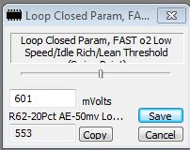

0x497=SLOW o2 Low TPS & MPH Rich/Lean UPPER Boundary
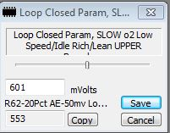

0x498=SLOW o2 Low TPS & MPH Rich/Lean LOWER Boundary
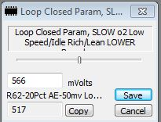
0x4A2=SLOW o2 NOT Low TPS & MPH Rich/Lean UPPER Threshold .vs. MAP
Factory
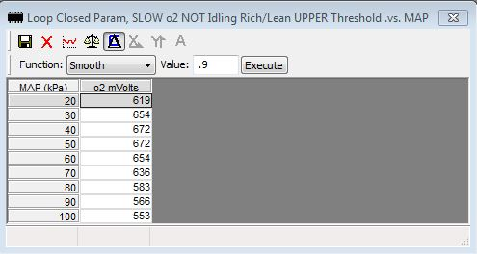

-50mv
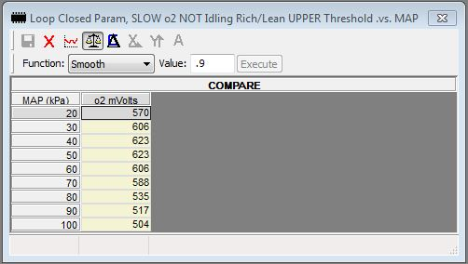

0x4AB=SLOW o2 NOT Low TPS & MPH Rich/Lean LOWER Threshold .vs. MAP
Factory
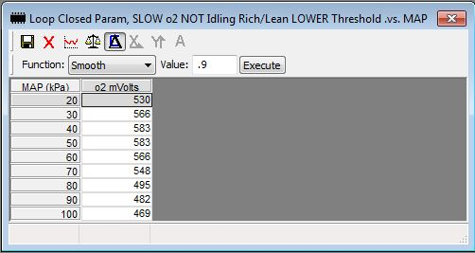

-50mv
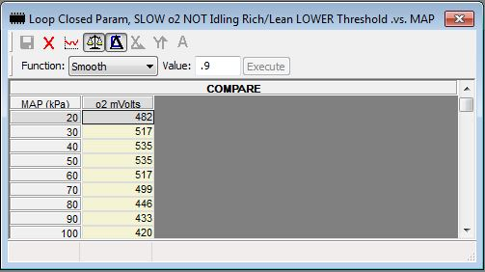

0x4B4=FAST o2 NOT Low TPS & MPH Rich/Lean Threshold .vs. MAP (Swing Point)
Factory
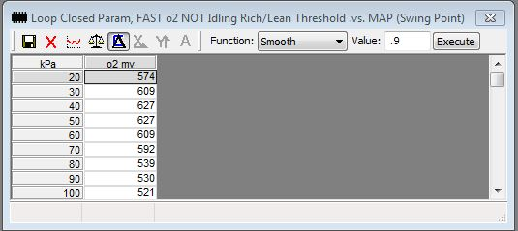

-50mv
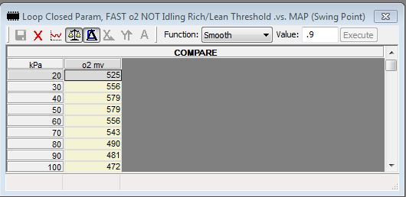

SUMMARY – BPW Calculation and Corrections

BPW calculation and subsequent o2 corrections for both the Factory and -50mv BINs are provided. Raw BPW values shown are decimal representations of hex values returned by the Simulation. The detail supporting this Summary is provided on the following pages.

SCENARIO #1: o2 going-Lean
 | Factory |  |  | -50mv |  |  | OL
 | BPW  Raw / ms | BPW Chg /  % Change | Cumulative  % Change | BPW  Raw / ms | BPW Chg /  % Change | Cumulative  % Change | BPW  ms
Calculated Speed Density BPW | 178 / 2.716 |  |  | 178 / 2.716 |  |  | 2.716
After BLM Correction | 180 / 2.747 | + 2 / + 1.1% | + 2 / + 1.1% | 180 / 2.747 | + 2 / + 1.1% | + 2 / + 1.1% | 2.716
After Rough Correction | 192 / 2.930 | +12 / + 6.7% | +14 / + 7.9% | 188 / 2.869 | + 8 / + 4.4% | +10 / + 5.6% | 2.716
After Fine Correction | 187 / 2.853 | - 5 / - 2.6% | + 9 / + 5.1% | 185 / 2.823 | - 3 / - 1.6% | + 7 / + 3.9% | 2.716
After Low PW Compensation | 187 / 2.853 | 0 / 0.0% | + 9 / + 5.1% | 185 / 2.823 | 0 / 0.0% | + 7 / + 3.9% | 2.716
After Injector Voltage Compensation  (Final Synchronous PW) | 229 / 3.494 | +42 / +22.5% | +51 / +27.3% | 227 / 3.464 | +42 / +22.7% | +49 / +26.5% | 3.357

SCENARIO #2: o2 going-Rich
 | Factory |  |  | -50mv |  |  | OL
 | BPW  Raw / ms | BPW Chg /  % Change | Cumulative  % Change | BPW  Raw / ms | BPW Chg /  % Change | Cumulative  % Change | BPW  ms
Calculated Speed Density BPW | 178 / 2.716 |  |  | 178 / 2.716 |  |  | 2.716
After BLM Correction | 175 / 2.670 | - 3 / - 1.7% | - 3 / - 1.7% | 175 / 2.670 | - 3 / - 1.7% | - 3 / - 1.7% | 2.716
After Rough Correction | 163 / 2.487 | -12 / - 6.9% | -15 / - 8.4% | 159 / 2.426 | -16 / - 9.1% | -19 / -10.7% | 2.716
After Fine Correction | 166 / 2.533 | + 3 / + 1.8% | -12 / - 6.7% | 164 / 2.502 | + 5 / + 3.1% | -14 / - 7.9% | 2.716
After Low PW Compensation | 166 / 2.533 | 0 / 0.0% | -12 / 0.0% | 164 / 2.502 | 0 / 0.0% | -14 / 0.0% | 2.716
After Injector Voltage Compensation  (Final Synchronous PW) | 208 / 3.174 | +42 / +25.3% | +30 / +18.1% | 206 / 3.143 | +42 / +25.6% | +28 / +17.0% | 3.357

- As expected when going-Lean, o2-corrected BPW before Synchronous Fuel Out compensations increased (Factory +5.1%; -50mv +3.9%). When going-Rich, it was expectedly decreased (Factory -6.7%; -50mv -7.9%). Again, note the greater percentage correction when going-Rich than going-Lean: 1) BLM Correction going-Lean was +2 Counts versus -3 going-Rich, which resulted in a greater going-Rich correction. In theory, the absolute value of the BLM corrections should be identical because the lean and rich BLM equally deviated from 128 by 4 points, but the code provides a slight bias. 2) The -50mv going-Rich Rough BPW Correction was significantly larger than all others due to the large % Adjusted SLOW o2 Voltage Error and associated Prop Gain Counts.

Rough BPW Correction = INT +/- Prop Gain Counts || BPW = BPW +/- ABS(Rough BPW Correction – 128) || (“+” if Lean; “-“ if Rich)
 | Factory BPW before Rough Corr: L=180; R=175 |  |  | -50mv BPW before Rough Corr: L=180; R=175
going | % Adj Error /  Prop Gain Cnts | Rough BPW  Correction | Rough-corrected BPW | % Adj Error /  Prop Gain Cnts | Rough BPW  Correction | Rough-corrected BPW
Lean | 212 / 8 | 140=132+8 | 192=180+ABS(140-128) | 163 / 4 | 136=132+4 | 188=180+ABS(136-128)
Rich | 212 / 8 | 116=124-8 | 163=175-ABS(116-128) | 254 / 12 | 112=124-12 | 159=175-ABS(112-128)

- Going-Lean CL Final Synchronous PW (both Factory and -50mv) was, on average, 3.5% richer than OL.
- Going-Rich CL Final Synchronous PW (both Factory and -50mv) was, on average, 5.9% leaner than OL.
DETAILED - BPW Calculation and Corrections
going-Lean: Pg 1 of 3

The activities below are in the order of code flow for both the Factory o2 values, and where they were reduced 50mv (-50mv).

SCENARIO #1: SLOW and FAST o2 both going-Lean
Not in Decel Enleanment in this example.

Fuel Minor Loop
+/- the INT (L00EB)
 | INT
Hex | 84
Dec | 132
- The INT was not +/-‘d this pass through the Fuel Minor Loop because the L00E6=CL INT Update Delay Timer =5 counts (5 counts =wait 5 passes through the Fuel Minor Loop =62.5ms before +/- the INT).

Compute L00EC=Prop Gain Counts based on % Adjusted SLOW o2 Voltage Error from Table 0x4DE
 | Factory | -50mv
Hex | 8 | 4
Dec | 8 | 4
- The -50mv BIN resulted in a reduction in the Prop Gain Counts from 8 to 4. This is because the -50mv % Adjusted SLOW o2 Voltage Error is lower than the Factory error (see Table below). Lower % Adjusted SLOW o2 Voltage Errors yield lower Prop Gain Counts.
 | Factory | -50mv
SLOW o2 Error | 212mv | 163mv
% Adjusted SLOW o2 Error | 212mv | 163mv

Note when going-Lean and NOT Low TPS & MPH, there is no difference between the SLOW o2 Error and the % Adjusted Error because a there is no percentage adjustment.

Compute L00E8=Rough BPW Correction (When going-Lean, L00E8 = INT plus L00EC=Prop Gain Counts)
 | Factory | -50mv
Hex | 8C | 88
Dec | 140 | 136
Factory: Rough BPW Correction = INT(132) + Prop Gain Counts(8) = 140
-50mv: Rough BPW Correction = INT(132) + Prop Gain Counts(4) = 136
Compute L00E2=Speed Density BPW going-Lean: Pg 2 of 3
 | Factory | -50mv | OL BPW
Hex | B2 | B2 | B2
Dec | 178 | 178 | 178
BPW (ms) | 2.716 | 2.716 | 2.716

The BPW values shown in the three Tables below are after the respective correction:

BPW Correction #1: Correct for L00E8=BLM
 | Factory | This %  Correction | Cumulative %  Correction |  | -50mv | This %  Correction | Cumulative %  Correction
Hex | B4 |  |  |  | B4
Dec | 180 |  |  |  | 180
BPW (ms) | 2.747 | 1.1% | 1.1% |  | 2.747 | 1.1% | 1.1%

BPW Correction #2: Correct with L00E8=Rough BPW Correction [BPW = BPW + ABS(Rough BPW Correction - 128)]
 | Factory | This %  Correction | Cumulative %  Correction |  | -50mv | This %  Correction | Cumulative %  Correction
Hex | C0 |  |  |  | BC
Dec | 192 |  |  |  | 188
BPW (ms) | 2.930 | 6.7% | 7.9% |  | 2.069 | 4.4% | 5.6%

BPW Correction #3: Correct with ½ L00E8=Prop Gain Counts (Fine BPW Correction)
 | Factory | This %  Correction | Cumulative %  Correction |  | -50mv | This %  Correction | Cumulative %  Correction
Hex | BB |  |  |  | B9
Dec | 187 |  |  |  | 185
BPW (ms) | 2.853 | -2.6% | 5.1% |  | 2.823 | -1.6% | 3.9%

This is the BPW reported in the ALDL Stream.

SUMMARY:
- Compared to Factory, reducing o2 Calibration values by 50mv when going-Lean reduced corrected BPW by 1.1% more than Factory:
(2.823(-50 Log BPW) – 2.853(Factory Log BPW)] / 2.853(Factory Log BPW)) * 100
Reducing o2 values by 50mv from Factory produces a slightly leaner mixture.
- Before Synchronous Fuel Out Routine compensations below, the calculated BPW was corrected upward (richened) based on o2 sensor input:
Factory: 5.1%
-50mv: 3.9%
Synchronous Fuel Out Routine Compensations going-Lean: Pg 3 of 3

Correct BPW if < 2.20ms using the Table at 0x40B=Injector PW Correction if PW < 3.90ms
 | Factory | This %  Correction | Cumulative %  Correction |  | -50mv | This %  Correction | Cumulative %  Correction | OL BPW
Approx. Compensation (ms) | 0 |  |  |  | 0 |  |  | 0
Hex | 0 |  |  |  | 0 |  |  | 0
Dec | 0 |  |  |  | 0 |  |  | 0
BPW (ms) | 2.853 | 0.0% | 5.1% |  | 2.823 | 0.0% | 3.9% | 2.716

Compensate for Voltage at 13.5v using the Table at 0x3FA=Injector PW Correction .vs. Fuel Pump or Ignition Switch Voltage
 | Factory | This %  Correction | Cumulative %  Correction |  | -50mv | This %  Correction | Cumulative %  Correction | OL BPW
Hex | 2A |  |  |  | 2A |  |  | 2A
Dec | 42 |  |  |  | 42 |  |  | 42
Table Compensation (ms) | 0.641 |  |  |  | 0.641 |  |  | 0.641
BPW (ms) | 3.494 | 22.5% | 27.3 % |  | 3.464 | 22.7% | 26.5% | 3.357
- All AUJP versions use Fuel Pump voltage for BPW Compensations rather than voltage at the Ignition per Flag (0x016 b6=0).
- One half of the voltage Table PW Compensation is added twice to BPW. Note this compensation increased the BPW by:
Factory: 32.0%
-50mv: 22.7%
OL: 23.6%
This major effect on PW is why Voltage Offsets are so important.

Going-Lean: Final Synchronous PW Sent to the ECM to Fire the Injectors
 | Factory  CL BPW | -50mv  CL BPW | OL BPW | OL BPW versus Factory  % Difference | OL BPW versus -50mv  % Difference
BPW (ms) | 3.494 | 3.464 | 3.357 | -4.1% | -3.2%
Dec | 229 | 227 | 219
Hex | E5 | E3 | DB
- Without o2 sensor-related compensation, the OL BPW was leaner than CL:
Factory (CL): 4.1%
-50mv (CL): 3.2%

SCENARIO #2: SLOW and FAST o2 both going-Rich going-Rich: Pg 1 of 3
Not in Decel Enleanment in this example.

Fuel Minor Loop
+/- the INT (L00EB)
 | INT
Hex | 7C
Dec | 124
- The INT was not +/-‘d this pass through the Fuel Minor Loop because the L00E6=CL INT Update Delay Timer = 5 counts (5 counts = wait 5 passes through the Fuel Minor Loop = 62.5ms before +/- the INT).

Compute L00EC=Prop Gain Counts based on % Adjusted SLOW o2 Voltage Error from Table 0x4DE
 | Factory | -50mv
Hex | 8 | 0C
Dec | 8 | 12
- The -50mv BIN resulted in an increase in the Prop Gain Counts from 8 to 12. This is because the -50mv % Adjusted SLOW o2 Voltage Error is higher than Factory (see Table below). Higher % Adjusted SLOW o2 Voltage Errors yield higher Prop Gain Counts:
 | Factory | -50mv
SLOW o2 Error | 242mv | 291mv
% Adjusted SLOW o2 Error | 212mv | 254mv

When going-Rich and NOT Low TPS & MPH, the % Adjusted SLOW o2 Voltage Error is 87.5% of the SLOW o2 Error.

Compute L00E8=Rough BPW Correction (When going-Rich, L00E8 = INT minus L00EC=Prop Gain Counts)
 | Factory | -50mv
Hex | 8C | 88
Dec | 140 | 136
Factory: Rough BPW Correction = INT(124) - Prop Gain Counts(8) = 116
-50mv: Rough BPW Correction = INT(124) - Prop Gain Counts(12) = 112

Compute L00E2=Speed Density BPW going-Rich: Pg 2 of 3
 | Factory | -50mv | OL BPW
Hex | B2 | B2 | B2
Dec | 178 | 178 | 178
BPW (ms) | 2.716 | 2.716 | 2.716

The BPW values shown in the three Tables below are after the respective correction:
BPW Correction #1: Correct for (L00EB=BLM)
 | Factory | This %  Correction | Cumulative %  Correction |  | -50mv | This %  Correction | Cumulative %  Correction
Hex | AF |  |  |  | AF
Dec | 175 |  |  |  | 175
BPW (ms) | 2.670 | -1.7% | -1.7% |  | 2.670 | -1.7% | -1.7%

BPW Correction #2: Correct with L00E8=Rough BPW Correction [BPW = BPW - ABS(Rough BPW Correction - 128)]
 | Factory | This %  Correction | Cumulative %  Correction |  | -50mv | This %  Correction | Cumulative %  Correction
Hex | A3 |  |  |  | 9F
Dec | 163 |  |  |  | 159
BPW (ms) | 2.487 | -6.9% | -8.4% |  | 2.426 | -9.1% | -10.7

BPW Correction #3: Correct with ½ L00E8= Prop Gain Counts (Fine BPW Correction)
 | Factory | This %  Correction | Cumulative %  Correction |  | -50mv | This %  Correction | Cumulative %  Correction
Hex | A6 |  |  |  | A4
Dec | 166 |  |  |  | 164
BPW (ms) | 2.533 | 1.8% | -6.7% |  | 2.502 | 3.1% | -7.9%

This is the BPW reported in the ALDL Stream.

SUMMARY:
- Compared to Factory, reducing o2 Calibration values by 50mv when going-Rich reduced corrected BPW by 1.2% more than Factory:
(2.502(-50 Log BPW) – 2.533(Factory Log BPW)] / 2.533(Factory Log BPW)) * 100
- Reducing o2 values by 50mv from Factory produces a slightly leaner mixture.
- Before Synchronous Fuel Out Routine compensations below, the calculated BPW was corrected downward (leaned) based on o2 sensor input:
Factory: 6.7%
-50mv: 7.9%

Synchronous Fuel Out Routine Compensations going-Rich: Pg 3 of 3

Correct BPW if < 2.20ms using the Table at 0x40B=Injector PW Correction if PW < 3.90ms
 | Factory | This %  Correction | Cumulative %  Correction |  | -50mv | This %  Correction | Cumulative %  Correction | OL BPW
Approx. Compensation (ms) | 0 |  |  |  | 0 |  |  | 0
Hex | 0 |  |  |  | 0 |  |  | 0
Dec | 0 |  |  |  | 0 |  |  | 0
BPW (ms) | 2.533 | 0.0% | -6.7% |  | 2.502 | 0.0% | -7.9% | 2.716

Compensate for Voltage at 13.5v using the Table at 0x3FA=Injector PW Correction .vs. Fuel Pump or Ignition Switch Voltage
 | Factory | This %  Correction | Cumulative %  Correction |  | -50mv | This %  Correction | Cumulative %  Correction | OL BPW
Hex | 2A |  |  |  | 2A |  |  | 2A
Dec | 42 |  |  |  | 42 |  |  | 42
Table Compensation (ms) | 0.641 |  |  |  | 0.641 |  |  | 0.641
BPW (ms) | 3.174 | 25.3% | 18.1% |  | 3.143 | 25.6% | 17.0% | 3.357
- All AUJP versions use Fuel Pump voltage for BPW Compensations rather than voltage at the Ignition per Flag (0x016 b6=0).
- One half of the voltage Table PW Compensation is added twice to BPW. Note this compensation increased the BPW by:
Factory: 25.3%
-50mv: 25.6%
OL: 23.6%
This major effect on PW is why Voltage Offsets are so important.

Going-Rich: Final Synchronous PW Sent to the ECM to Fire the Injectors
 | Factory  CL BPW | -50mv  CL BPW | OL BPW | OL BPW versus Factory  % Difference | OL BPW versus -50mv  % Difference
BPW (ms) | 3.174 | 3.143 | 3.357 | 5.8% | 6.8%
Dec | 208 | 206 | 219
Hex | D0 | CE | DB
- Without o2 sensor-related compensation, the OL BPW is richer than CL:
Factory (CL): 5.8%
-50mv (CL): 6.8%
Appendix C
Visual Representation of Reading the o2 Sensor
and
Related FAST and SLOW Voltage Errors

The graph below visually shows how the setting of Boundaries and Swing Points determines the direction, frequency and magnitude of BPW corrections. Some assumptions are made for the graph:
- Cross-Counts are occurring at an average of 4 per second, or 1 FAST o2 voltage direction change (Cross-Count) every 0.25 seconds (250ms).
- The sensor is read every 12.5ms, so it’s read 20 times in 250ms in this example:
250ms x 1 Sensor Read = 20 Sensor Reads in 250ms
12.5ms
- The sensor is swinging uniformly between 100mv to 900mv before BPW corrections cause a change in voltage direction, for an 800mv swing. The 800mv will be traversed in 250ms. Doing the math shows there will be one sensor read every 40mv of voltage movement:
800mv = 3.2mv x ____12.5ms___ = 40mv per Sensor Read
250ms ms per Sensor Read
Granted things are not exactly this precise, but some assumptions have to be made.
- Also for simplicity of graphing:
  - a linear rise and fall of voltage movement is used as opposed to a sine-wave
  - both FAST and SLOW voltages remain at equal values because lag-filtering of each is ignored. The impact is that FAST and SLOW voltages may be going in the same direction in this example for a few ms longer than actual.
- Finally, the example tracks Low TPS & MPH activity using the Factory Boundaries and Swing Point since they are singular values. We could pick any of the NOT Low TPS & MPH MAP kPa-based Table values and the procedure would be the same, but with slightly different results. Factory Low TPS & MPH values used:
 | Lower Boundary | Swing Point | Upper Boundary
Low TPS & MPH (Scalars)  Calibration Item:  Value (mv): | 0x498  566 | 0x496  601 | 0x497  601

The Swing Point trigger for a FAST Error is the Swing Point +/- 53mv:
 | Swing Point Trigger (mv)
going-Rich:  going-Lean: | 654 = 601 + 53  548 = 601 - 53

With the assumptions established, the graph below can now be interpreted to see what’s happening.

First, the scaling is purposefully enlarged to show more detail between 400 and 700mv where all the action occurs. In that range, each increment =10mv:
- Starting at 0 seconds and 100mv, and with both FAST and SLOW voltages going-Rich, it takes 14 sensor reads before there is a SLOW Error large enough, such that after being % Adjusted, it is large enough to allow an INT +/- for use in BPW correction. The first FAST Error is on the 13th sensor read where voltage of 660mv exceeds the 654mv =Swing Point +53mv Trigger by 4mv.
- From 660mv to 900mv, there are 6 more sensor reads. Each produces a FAST Error and a SLOW Error. When the SLOW Errors are % Adjusted, they are all > 18mv which ensures possible INT +/-, determination of Prop Gain Counts and computation of a Rough BPW Correction.
- At 900mv, FAST voltage changes direction from going-Rich to going-Lean, and the first Cross-Count is recorded (indicated by “CC #1”). Successive Cross-Counts are identified by “CC #n” (n =2-4).
- After CC #1 with o2 voltage now going-Lean, there is no significant activity above 540mv. But below 540mv, there are 11 going-Lean sensor reads which result in SLOW Errors large enough that when % Adjusted are > 18mv to begin consideration of an INT +/- and BPW correction. The first going-Lean FAST Error occurs on sensor read 9, after which there are concurrent SLOW and FAST going-Lean errors, resulting in possible INT +/-, determination of Prop Gain Counts and computation of the Rough BPW Correction.
- Here’s the important point: With Factory o2 Boundaries and Swing Points, there are 7 going-Rich sensor reads (#14 to #20) that could result in fuel being removed, compared to 11 (#10 to #20) when going-Lean that could add fuel. Over time, this difference will tend to richen the BPW.
Each sensor read providing a SLOW voltage Error > 18mv produces larger and larger % Adjusted SLOW Errors which result in larger and larger BPW corrections, which ultimately cause a change in voltage direction.

This clearly shows that when Boundaries and Swing Points are lowered, the BPW will be leaned and if raised, BPW will be richened. See Changing o2 Voltage Boundaries and Swing Points for more detail.

Graph of o2 Sensor Reads and FAST and SLOW Voltage Errors
(CC = Cross Count)
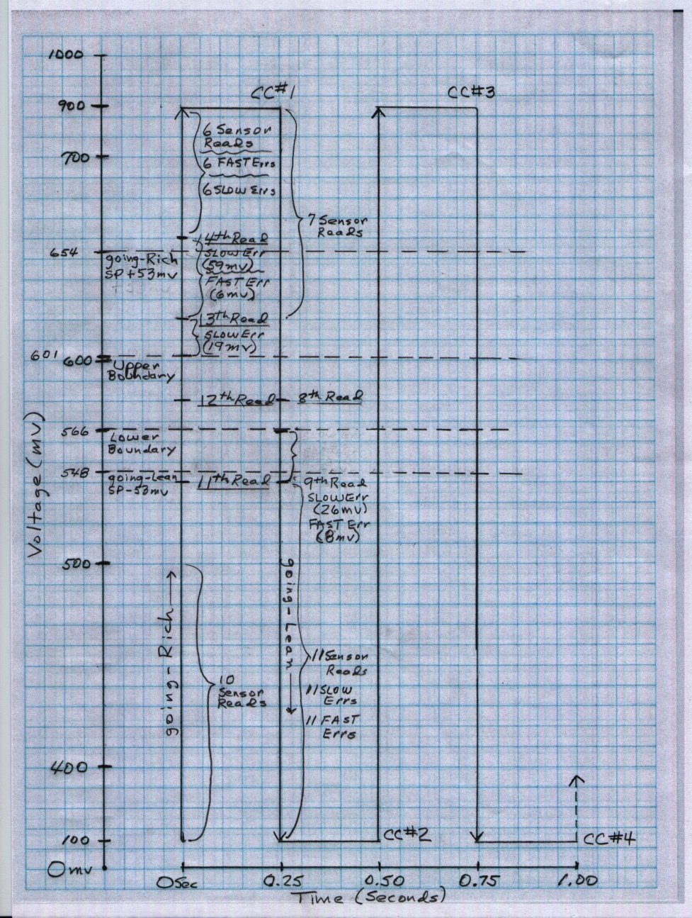
Appendix D
Log Results Using Various o2 mv Values

The 4 Logs reported in this Appendix had o2 values changed as follows:
- r67 (Factory): Contained Factory o2 values (Swing Points and Boundaries)
- r67 -50: All Factory o2 values reduced 50mv
- r67 +50: All Factory o2 values increased 50mv
- r67 450 +/-50: All Swing Points changed to 450mv; all Upper Boundaries increased 50mv to 500mv, and all Lower Boundaries decreased 50mv to 400mv

“Low T & M” below = Low TPS & MPH
“NOT Low” below = NOT Low TPS & MPH

A Summary of each Log is on this and the next page. The remainder of this Appendix provides the detail supporting this Summary.

Coolant Temp | 201-208 |  | 203-208 |  | 203-210 |  | 187-208
MAT | 98-118 |  | 92-106 |  | 108-118 |  | 86-124

Log File Name | r67 |  |  | r67 -50 |  |  | r67 +50 |  |  | r67 450 +/-50
Description | Factory mv |  |  | Factory -50mv |  |  | Factory +50 |  |  | 450mv +/-50mv
 | Low T & M | NOT Low |  | Low T & M | NOT Low |  | Low T & M | NOT Low |  | Low T & M | NOT Low
 | (750 RPM) | (2000 RPM) |  | (750 RPM) | (2000 RPM) |  | (750 RPM) | (2000 RPM) |  | (750 RPM) | (2000 RPM)
(A)
BLM
Avg | 129 | 129 |  | 128 | 122 |  | 130 | 129 |  | 128 | 122
Min | 124 | 126 |  | 126 | 118 |  | 128 | 126 |  | 122 | 114
Max | 130 | 132 |  | 128 | 128 |  | 130 | 132 |  | 134 | 130

INT
Avg | 131 | 129 |  | 129 | 122 |  | 129 | 129 |  | 129 | 122
Min | 121 | 111 |  | 123 | 112 |  | 125 | 122 |  | 124 | 114
Max | 139 | 138 |  | 136 | 134 |  | 135 | 137 |  | 138 | 146

(A) Had surging at this constant RPM. Prop Gain Counts likely too high for -50mv o2 values.

THESE DATA ARE WITH AN OLD o2 SENSOR POSSIBLY RESULTING IN LOW CROSS-COUNTS
Log File Name |  |  | r67 |  |  |  | r67 -50 |  |  |  |  | r67 +50 |  |  |  |  |  | r67 450 +/-50
Description |  |  | Factory mv |  |  |  | Factory -50mv |  |  |  |  | Factory +50 |  |  |  |  |  | 450mv +/-50mv
o2 mv
Median (mid-point)
 | Low TPS & MPH |  | 840 |  |  |  |  | 800 |  |  |  |  |  | 831 |  |  |  |  | 674
 | NOT Low TPS & MPH |  | 747 |  |  |  |  | 698 |  |  |  |  |  | 782 |  |  |  |  | 422
 | All |  | 747 |  |  |  |  | 712 |  |  |  |  |  | 791 |  |  |  |  | 354
Swing Points
 | Low TPS & MPH |  | 636 |  |  |  |  | 570 |  |  |  |  | 692 |  |  |  |  |  | 491
 | NOT Low TPS & MPH |  | 581 |  |  |  |  | 514 |  |  |  |  | 674 |  |  |  |  |  | 421
Cross-Counts
 | Low TPS & MPH  (750-899 RPM) |  | 1.1 |  |  |  |  | 1.0 |  |  |  |  | 2.1 |  |  |  |  |  | 0.8
 | NOT Low TPS & MPH  (2000-2599 RPM) |  | 6.8 |  |  |  |  | 2.7 |  |  |  |  | 7.2 |  |  |  |  |  | 2.9
 | All |  | 4.6 |  |  |  |  | 2.2 |  |  |  |  | 7.1 |  |  |  |  |  | 2.3
% o2 mv Rich (> 450mv) / Lean (< 450mv)
 |  | Low TPS & MPH
 |  | % Lean | 28.3 |  |  |  |  | 34.9 |  |  |  |  | 19.5 |  |  |  |  |  | 45.0
 |  | % Rich | 71.7 |  |  |  |  | 65.1 |  |  |  |  | 80.5 |  |  |  |  |  | 55.0
 |  | NOT Low TPS & MPH
 |  | % Lean | 30.6 |  |  |  |  | 43.4 |  |  |  |  | 19.3 |  |  |  |  |  | 53.5
 |  | % Rich | 69.4 |  |  |  |  | 56.6 |  |  |  |  | 80.7 |  |  |  |  |  | 46.5
 |  | All
 |  | % Lean | 30.2 |  |  |  |  | 41.5 |  |  |  |  | 19.4 |  |  |  |  |  | 51.8
 |  | % Rich | 69.8 |  |  |  |  | 58.5 |  |  |  |  | 80.6 |  |  |  |  |  | 48.2

Log Set #1 Results
Log Differences (Factory o2 values .vs. -50mv o2 values)
Reducing o2 Calibration values by 50mv provided no noted change in performance. There were also no perceptible BLM or INT differences, despite knowing from Simulation C previously discussed that reducing o2 values by 50mv reduces BPW.

Significant differences noted in the -50mv Log versus the Factory Log were:
- The percentage of time spent removing fuel in the -50mv Log was slightly greater than in the Factory Log. This is based on the state of INT and BLM values taken together above and/or below 128 (NOT based on their individual values +/- 128)
- Lower Average and Median FAST o2 voltage values in the -50mv Log .vs. Factory (Average =approximation of Swing Point; Median =mid-point)
- Lower Cross-Count frequency in the -50mv Log, indicating there were fewer changes in FAST o2 voltage direction. That also means there were fewer INT, BPW, and BLM changes.

Each of these differences is discussed below:
Percentage of time spent removing fuel based on INT and BLM
The data below show the -50mv Log was removing fuel (reducing BPW) in more samples (50%+), than the Factory Log. This supports Simulation C where lowering o2 mv values slightly leaned BPW. On a Log sample-by-sample basis, the conditions monitored to determine whether fuel was being added or removed were. In the Table below:
“% Rich” indicates “Removing Fuel” if:
INT < 128 & BLM < 128, or INT = 128 & BLM < 128, or INT < 128 & BLM = 128
“% Lean” indicates “Adding Fuel” if:
INT > 128 & BLM > 128, or INT = 128 & BLM > 128, or INT > 128 & BLM = 128
“Indeterminate” = Unknown if adding or removing fuel, and if no fuel change:
INT < 128 & BLM > 128, or INT > 128 & BLM < 128, or INT = 128 & BLM = 128

 | Results
 | % Rich | % Lean | Indeterminate
-50mv Log | 81.9% | 13.1% | 5.0%
Factory Log | 29.5% | 66.0% | 4.5%
-50mv Log Difference | + 52.4% | - 52.9% | + 0.5%
Details are provided later in this Appendix.

Lower Average FAST o2 mv
As expected, average FAST o2 voltages (approximation of Swing Points) were lower in the -50mv Log:
 | Low TPS & MPH (mv) | NOT Low TPS & MPH (mv)
-50mv Log | 570 | 514
Factory Log | 636 | 581
-50mv Log Difference | - 66 | - 67

Lower Median FAST o2 mv
As expected, median voltages (midpoint of all values) were lower in the -50mv Log:

 | Low TPS & MPH (mv) | NOT Low TPS & MPH (mv)
-50mv Log | 800 | 698
Factory Log | 840 | 747
-50mv Log Difference | - 40 | - 49
Note the significantly rich bias (> 450mv) remained even after reducing values 50mv.

Lower Cross-Count Frequency
At all RPMs, Cross-Counts were significantly less frequent in the -50mv Log than in the Factory Log indicating there were fewer FAST o2 going-Rich/Lean transitions. This was not expected, but resulted because the voltage pattern at -50mv o2 values was much smoother than at Factory o2 values. The Factory values produced an erratic voltage pattern providing more frequent FAST o2 direction changes. Cross-Counts averaged 4.6 per second in the Factory Log versus 2.2 per second in the -50mv Log -- a 52% reduction.

That means in the -50ms Log more time was spent in a Rich or Lean state without making a transition to the other state than in the Factory Log. This suggests o2 Calibration values should be set to produce the smoothest o2 pattern, which by its nature may reduce the number of Cross-Counts.

Log File Analyzer data excerpts are provided later in this Appendix showing Cross-Counts for both Low TPS & MPH (750-899 RPM) and NOT Low TPS & MPH (2000-2599 RPM). The data were captured and reported in 5 second time slices and then sorted on RPM and Sample Min/Max RPM Difference. Summarizing Cross-Counts:

 | Cross-Counts per Second
RPM Range | -50mv | Factory | Difference | % Difference
750-899 | 1.0 | 1.1 | - 0.1 | - 9.0%
2000-2599 | 2.7 | 6.8 | - 4.1 | - 60.0%
All | 2.2 | 4.6 | - 2.4 | - 52.2%

Log o2 Patterns

Below are the o2 mv patterns of the 4 Logs at:
- Low TPS & MPH: (750-800 RPM and NOT Moving)
- NOT Low TPS & MPH: (2000 RPM and MOVING

Color scheme in the o2mv patterns below:
Red =o2 mv; Black =INT; Orange =BLM; Blue =RPM; Green =TPS%

Factory mv (r67)

Note the significantly irregular Idle and NOT Idle patterns.

Low TPS & MPH (750-800 RPM)
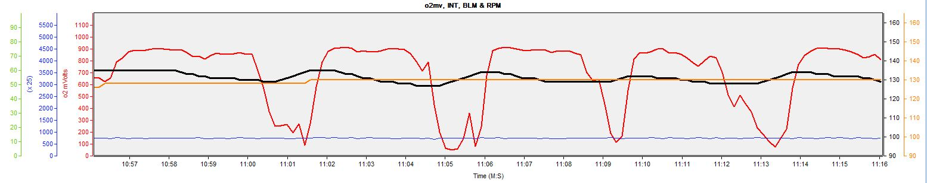

NOT Low TPS & MPH (2000 RPM)
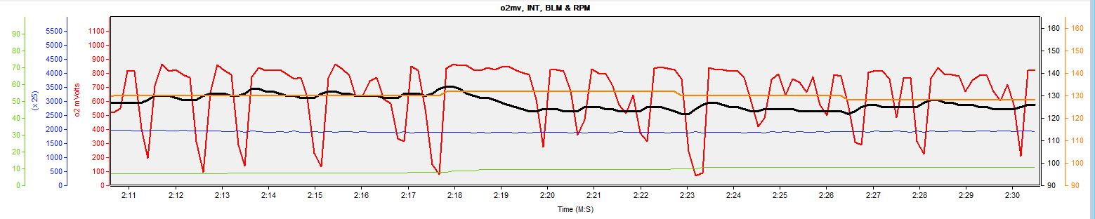
Factory -50mv

These are good patterns like those of the 450mv +/- 50 Log below, but not as smooth. Note how the INT is slightly changing above and below a constant BLM.

Low TPS & MPH (750-800 RPM)
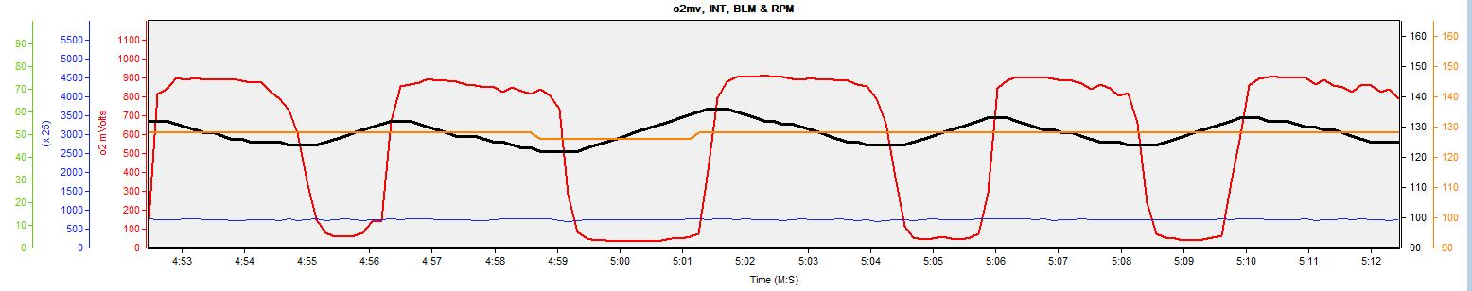

NOT Low TPS & MPH (2000 RPM)
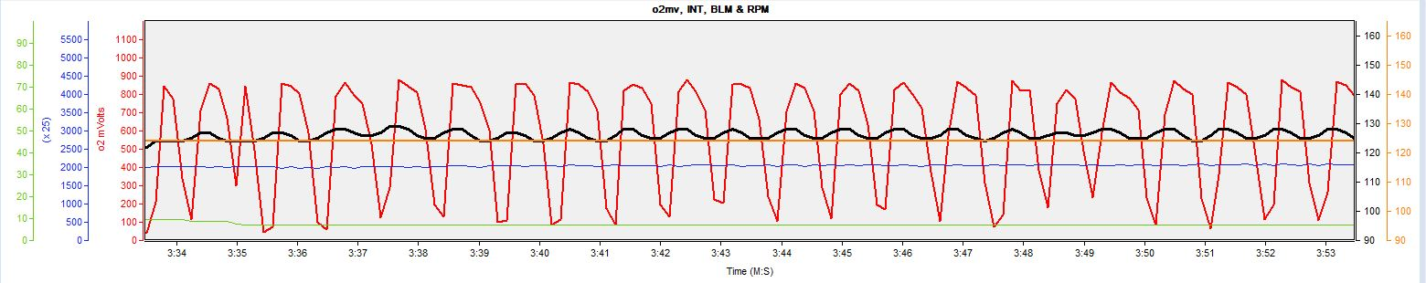

Factory +50mv

Not the best o2 patterns. The Swing Point and Boundaries have a significantly Rich bias.

Low TPS & MPH (750-800 RPM)
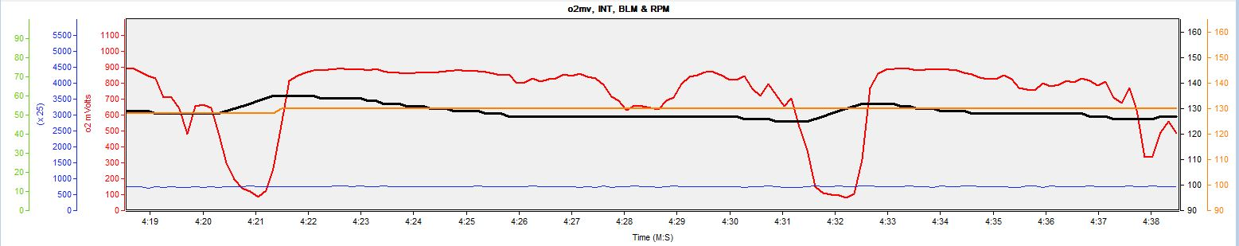

NOT Low TPS & MPH (2000 RPM)
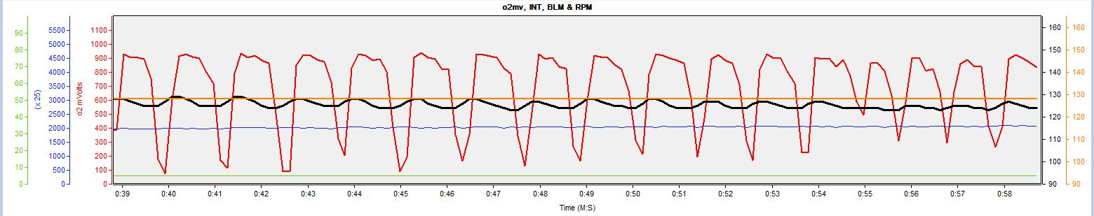

450mv Swing Points and +/-50mv Boundaries

These are the best o2 patterns of the 4 Logs. Note how the INT is slightly changing above and below a constant BLM.

Low TPS & MPH (750-800 RPM)
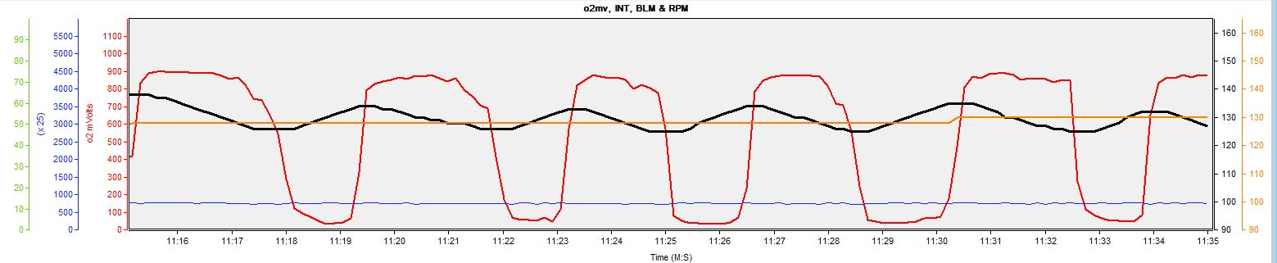

NOT Low TPS & MPH (2000 RPM)
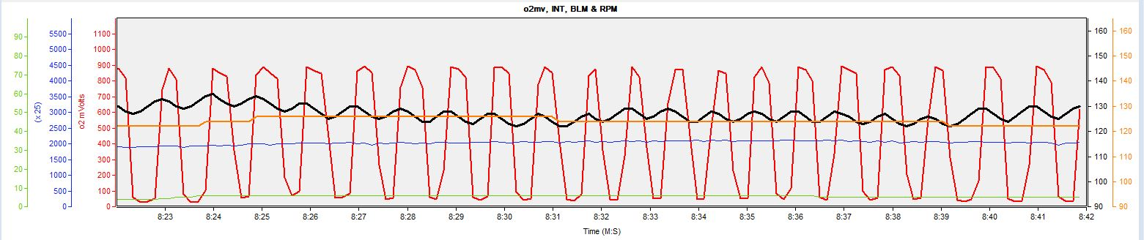

Percentage of time spent removing fuel based on INT and BLM

The data presented below was obtained using Version 11 of the Log File Analyzer available here in Post #2: http://www.ThirdGen.org/forums/diy-prom/716128-s_aujp-v5-log-file.html.

Factory Log
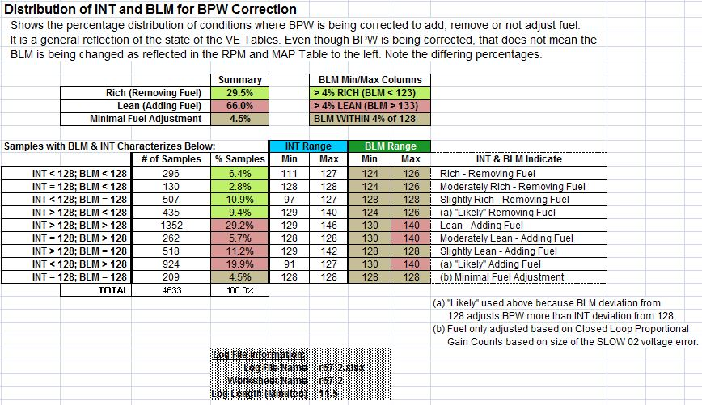

-50mv Log
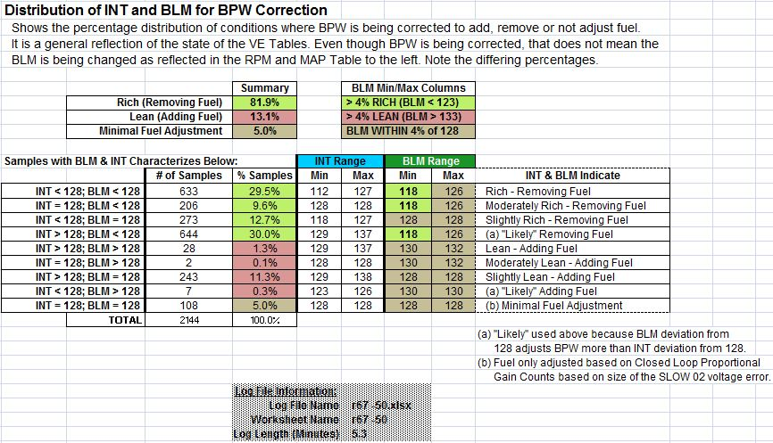

Percentage of time FAST o2 voltage Rich/Lean

Factory Log

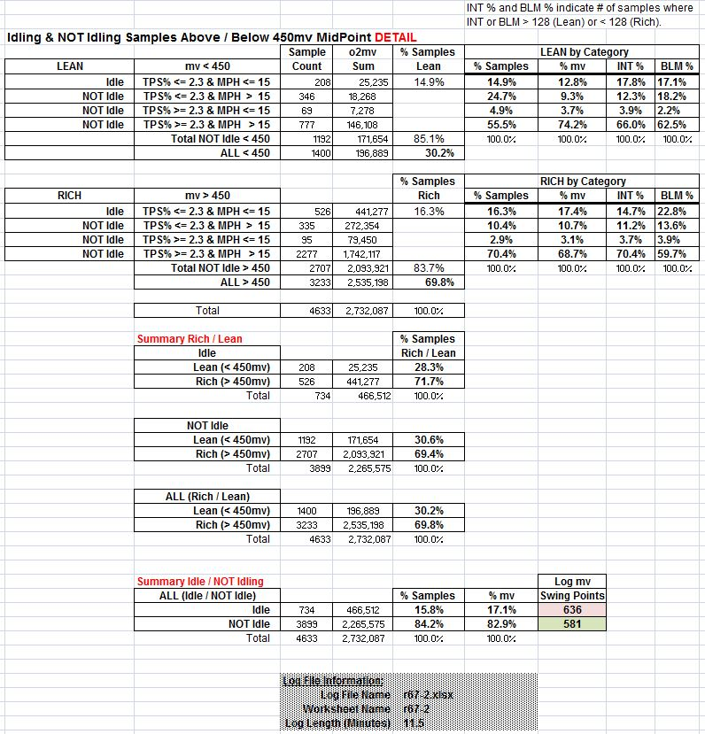

-50mv Log

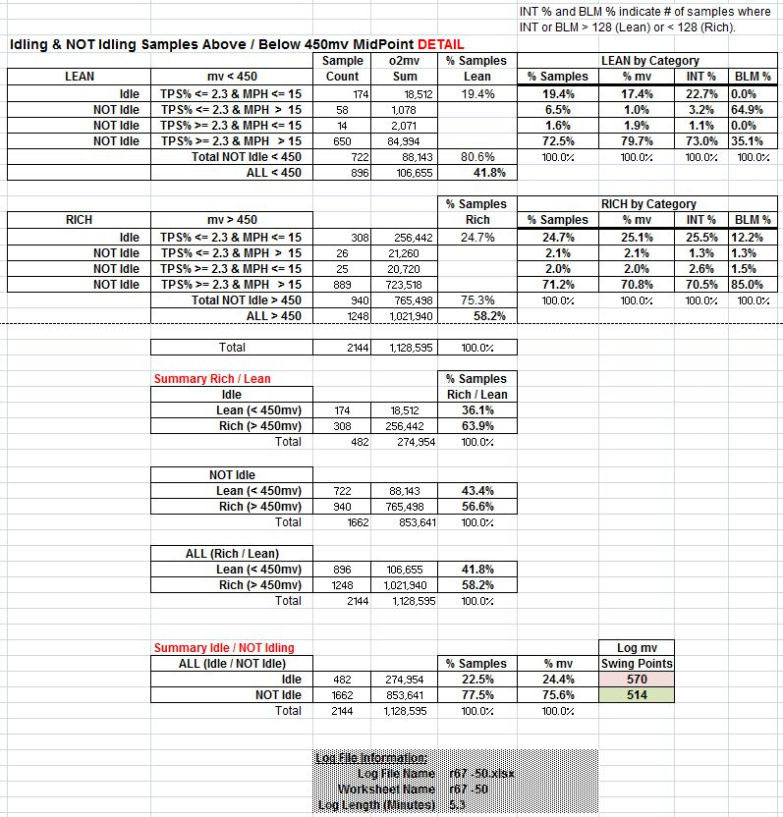

Log File Analyzer o2 Cross-Count Data
o2 Cross-Count data are presented below for completeness and review but without comment. The data were captured and reported in 5 second time slices and then sorted on RPM and Sample Min/Max RPM Difference.

Factory Log: Low TPS & MPH

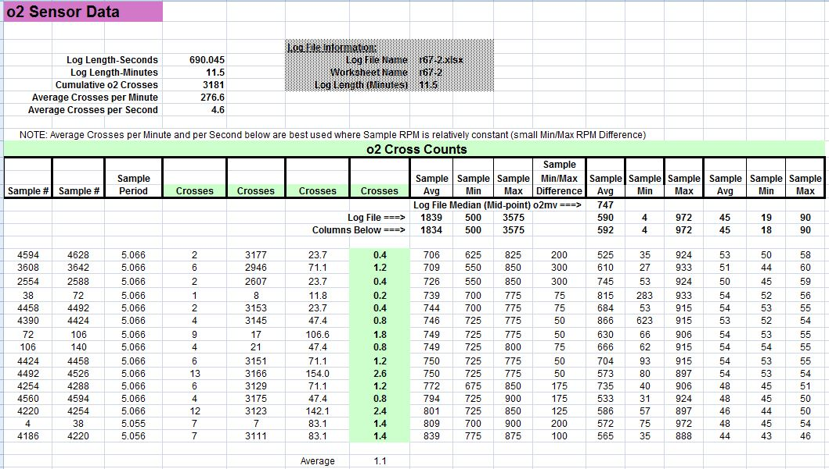

Factory Log: NOT Low TPS & MPH

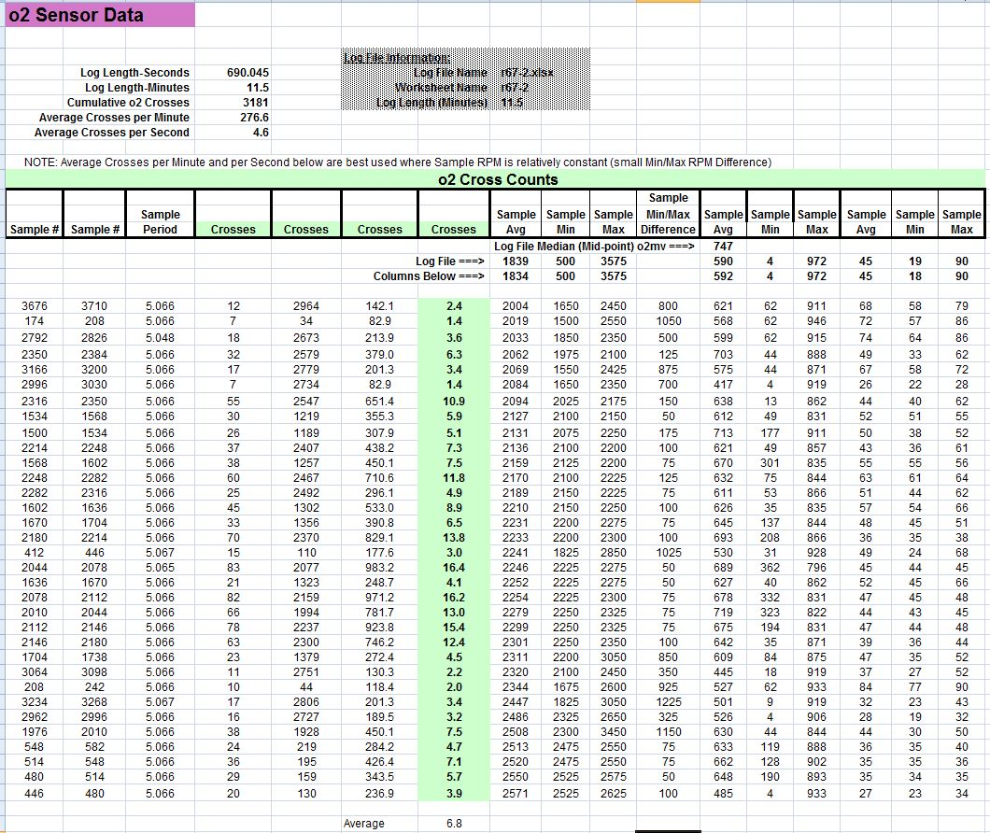

-50mv Log: Low TPS & MPH

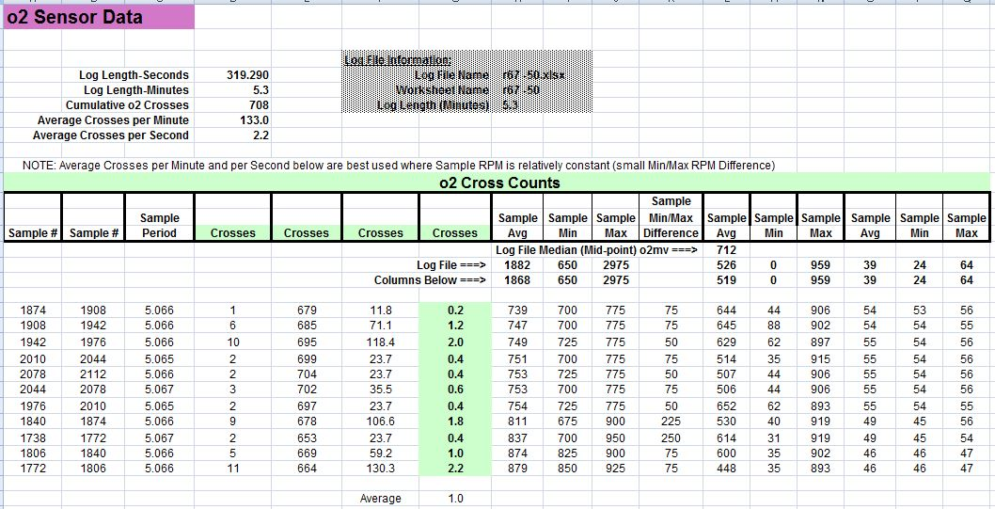
-50mv Log: NOT Low TPS & MPH

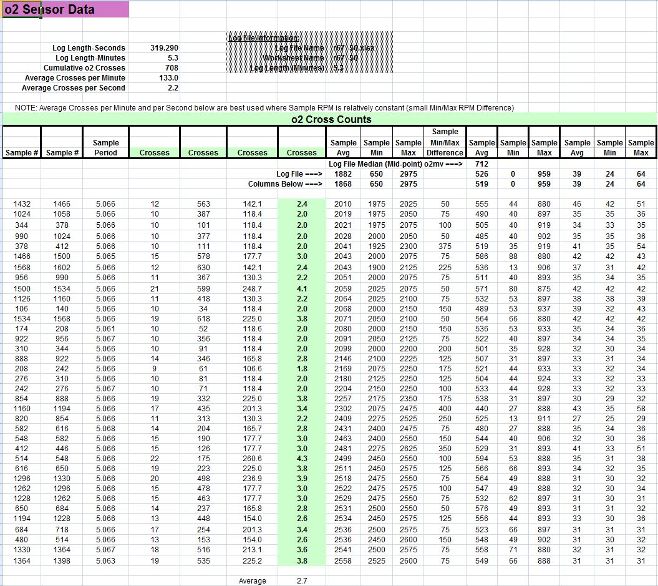

Appendix E
S_AUJP v5 Onward: o2 Sensor and Fueling Related Calibration Values

Scalar, Flag and Table values shown are defaults of S_AUJP.

Scalars
Scalars are not discussed further. All information regarding value and use are provided below.

Address Value __________________________Description_______________________________
0x1E6 800 (RPM) Compared to Commanded Idle RPM HI/LO Spark Gain Mode
0x3F1 0.937 12.5ms FILTER COEFF
0x41A 14.7 STOICH AF RATIO
0x41C 22 (#/hr) INJ FLOW Rate
0x45D 221 SCALAR added to Table L8431=START UP ENRICH .vs. TEMP calculating OL AFR
0x480 65 (kPa) No Conversion, DISABLE Highway Fuel IF KPa > 65 KPa
0x481 139 (*F) DISABLE HIGHWAY FUEL IF COOL 139*F (S_V2 185*F)
0x482 10 (Sec) LOCK OUT HIGHWAY Fuel FOR 10 SEC
0x483 60 (Sec) MAX TIME IN HIGHWAY MODE FUEL
0x484 53 (MPH) DISABLE HIGHWAY FUEL IF MPH < 53 MPH (S_V2 255 MPH)
0x48F 699 (mvDC) IF o2 < 699 mvDC THEN o2 IS READY
0x490 199 (mvDC) IF o2 > 199 mvDC THEN o2 IS READY
0x492 80 CLS LP MIN INTEGRATOR VALUE
0x493 180 CLS LP MAX INTEGRATOR VALUE
0x494 2.3 (%TPS) MAX FOR Low TPS & MPH
0x495 15 (MPH) MAX SPD FOR Low TPS & MPH
0x496 601 mvDC, FAST o2 Low TPS & MPH Rich/Lean Threshold (Swing Point)
0x497 601 mvDC, SLOW o2 Low TPS & MPH Rich/Lean UPPER Boundary
0x498 566 mvDC, SLOW o2 Low TPS & MPH Rich/Lean LOWER Boundary
0x499 0.25 25% MULT PROP STEP SIZE GAIN for Low TPS & MPH
0x49A 0 # 12.5ms Fuel Loops to Delay INT Corr at Low TPS & MPH
0x49B 160 0.625 MULT TO CLS LP GAIN FACTOR for Low TPS & MPH
0x49C 53 mvDC, DIFF TO MAKE R/L WINDOW (FAST o2)
0x49D 0 mvDC, DIFF R/L WHEN AIR DIVERTED (S_V2 100 mvDC)
0x49E 18 mvDC, MIN SLOW o2 ERROR ADDER TO MAKE INTEGRATOR CORRECTION
0x49F 0.875 MULT GAIN FACTOR FOR POS ERRORS
0x4A0 0.602 COEF FOR SLOW o2 FILTER CONSTANT
0x51B 1.0 (Sec) BLM update rate (S_V2 1.4 sec)
0x51C 2 BLM update amount: BLM changed 2 counts at a time
0x51F 5 If INT (Clsd Lp) GT 128+5 Lean Threshold, enable BLM update
0x520 5 If INT (Clsd Lp) LT 128-5 Rich Threshold, enable BLM update
0x5A4 1.95 (ms) AE TPS-A/C ON Pulse Width Adder for 1ST Time A/C ON
0x5EC 3.90 (ms) AE TPS-DFCO Stall Saver Pulse Width Adder
Flags (Bit Settings)
A discussion of these 4 INT-related Flags follows this list.
0x018 b1 Reset INT if in AE
0x018 b4 Use Air Flow for Coolant/MAT Diff Multiplier from Table 0x80E
0x018 b5 INT Status With BLM Cell Change
0x019 b3 Force INT to 128 if CCP Active (Y/N)

Tables
A discussion of each Table below follows this list.

Address ____________________________________Description______________________________________
0x3FA Injector PW Correction .vs. Fuel Pump or Ignition Switch Voltage (Injector Voltage Offset)
0x40B Injector PW Compensation if PW < 3.90ms (Low PW Compensation)
0x420 Loop Open Param, % Change AFR .vs. MAP
0x45E Loop Open Param, AFR % Change .vs. Temp
0x4C6 Loop Closed Param, SLOW o2 Lag Filtering Coefficient .vs. Air Flow
0x4A2 Loop Closed Param, SLOW o2 NOT Idling Rich/Lean UPPER Threshold .vs. MAP
0x4AB Loop Closed Param, SLOW o2 NOT Idling Rich/Lean LOWER Threshold .vs. MAP
0x4B4 Loop Closed Param, FAST o2 NOT Idling Rich/Lean Threshold .vs. MAP (Swing Point)
0x4BD Loop Closed Param, SLOW o2 INT Delay Time .vs. Air Flow
0x4CF Loop Closed Param, NOT Idling Prop Step Size Gain Multiplier .vs. Air Flow
0x4D8 Loop Closed Param, SLOW o2 Proportional Step Size .vs. RPM
0x4DE Loop Closed Param, CL o2 Proportional Gain Counts .vs. % Adjusted SLOW o2 Voltage Error
0x4EA Loop Closed Param, SLOW o2 Proportional Step Size .vs. % Adjusted SLOW o2 Voltage Error
0x504 Loop Closed Param, INT Delay Factor .vs. % Adjusted SLOW o2 Voltage Error
0x617 PE, % Change to AFR .vs. RPM (Lambda W)
0xB3A PE, % Change to AFR .vs. RPM EXTENDED (Z69) (Lambda W)
0x60E PE, % Change to AFR .vs. Coolant Temp (Lambda C)
0x7FD MAT or Coolant/MAT Differential Compensation Counts
0x81F VE Adjustment Factor .vs. Barometric Pressure
0x80E Coolant/MAT Differential Factor .vs. Air Flow

Flags (Bit Settings)

0x018 b1 - Reset INT if in AE
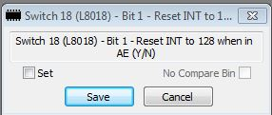
The Factory default setting is to NOT reset the INT to 128 when in AE.

0x018 b4 - Use Air Flow for Coolant/MAT Diff Multiplier from Table 0x80E
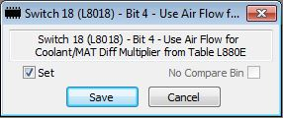
The Factory default setting is to use air flow to extract a factor from the Table at 0x80E. That factor is used to adjust the coolant temp/MAT differential in the computation of L006D=BPW Scaling Factor.

0x018 b5 - INT Status With BLM Cell Change
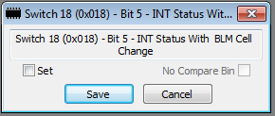
The Factory default setting is =0, to NOT reset the INT to 128 when the BLM Cell changes.

0x019 b3 - Force INT to 128 if CCP Active (Y/N)
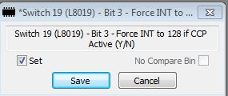
The Factory default setting is to reset the INT to 128 when CCP is active.
Tables
0x3FA Injector PW Correction .vs. Fuel Pump or Ignition Switch Voltage
(Injector Voltage Offset)
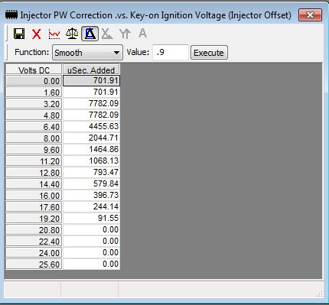
The Table contains BPW compensation values applied to BPW as a function of Fuel Pump or Ignition Switch Voltage. The Table contains the full compensation required according to the injector manufacturer. However, the XDF causes only 1/2 of that value to be placed into the Calibration. Then when needed, the code adds the Calibration value twice to ensure the full compensation is applied. This gyration is done because of small microsecond values.
b6 of Switch 16 (0x016) controls usage:
0 = Use Pump Voltage (Default of all AUJP versions)
1 = Use Ignition Voltage

0x40B Injector PW Compensation if PW < 3.90ms
(Low PW Compensation)
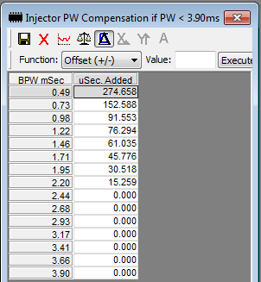
This PW will be added in the Synchronous Fuel Out Routine if the condition exists.
0x420 Loop Open Param, % Change AFR .vs. MAP
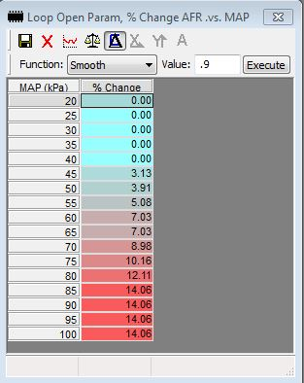
A value from this Table is used to compute a Final OL AFR, along with the values below:
- Table at 0x45E=Loop Open Param, AFR % Change .vs. Temp
- Scalar at 0x45D=0xDD =221d.

0x45E Loop Open Param, AFR % Change .vs. Temp
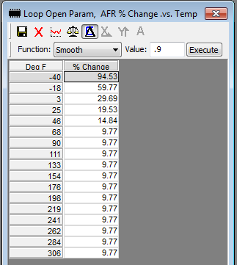
Coolant used by default unless coolant sensor error 14/15, which results in MAT being used.
A value from this Table is used to compute a Final OL AFR, along with the values below,:
- Table at 0x420=Loop Open Param, % Change AFR .vs. MAP
- Scalar at 0x45D=0xDD =221d.
0x4C6 Loop Closed Param, SLOW o2 Lag Filtering Coefficient .vs. Air Flow
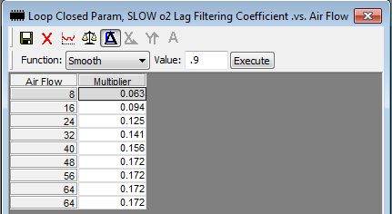
A value from this Table is used along with values below to compute the factor used to smooth o2 Voltage used for SLOW 02 Voltage Error decisions:
- L005D=Coolant Temperature
- Scalar Constant 0x4A0 =60.2% =Coefficient for SLOW o2 Filter Constant used to factor the coolant temperature

0x4A2 Loop Closed Param, SLOW o2 NOT Idling Rich/Lean UPPER Threshold .vs. MAP
This Table provides the NOT Low TPS & MPH Upper SLOW o2 boundary based on MAP kPa used for determining if a going-Rich SLOW o2 Voltage Error occurred. The variable L0090=Filtered o2 Voltage for SLOW Error is compared with a value from this Table for error determination.

0x4AB Loop Closed Param, SLOW o2 NOT Idling Rich/Lean LOWER Threshold .vs. MAP
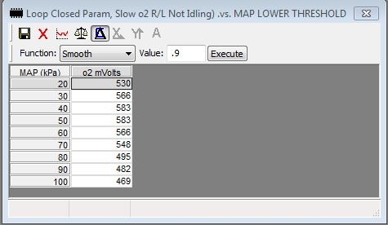
This Table provides the NOT Low TPS & MPH Lower SLOW o2 boundary based on MAP kPa used for determining if have a going-Lean SLOW o2 Voltage Error. The variable L0090=Filtered o2 Voltage for SLOW Error is compared with a value from this Table for error determination.

0x4B4 Loop Closed Param, FAST o2 NOT Idling Rich/Lean Threshold .vs. MAP
(Swing Point)
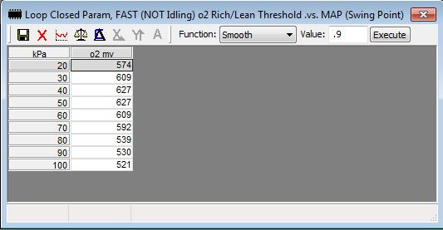
This Table provides the NOT Low TPS & MPH FAST o2 Voltage Swing Point based on MAP used to determine if a FAST o2 Voltage Error occurred. The variable L008E=Filtered o2 Voltage for FAST Error is compared to a value from this Table, +/- 53mv (the ‘FAST o2 Swing Point +/- 53mv’), to make that determination.
0x4BD Loop Closed Param, SLOW o2 INT Delay Time .vs. Air Flow
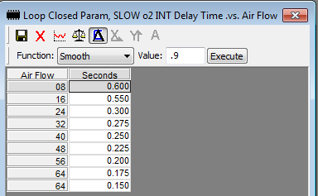
A time value is extracted from this Table based on Air Flow. It and a value from the Table at 0x504=INT Delay Adder to Inverted Coolant .vs. % Adjusted SLOW o2 Voltage Error, possibly coolant temp adjusted, are multiplied. The product is the calculated number of loops through the Fuel Minor Loop required before the INT can be increased/decreased. The # loops decreases as air flow increases providing more frequent INT updates at higher air flows. As can be seen from these two Tables:
- The larger the % Adjusted SLOW o2 Voltage Error, the smaller the factor from Table 0x504 and thus the product, resulting in more frequent INT changes.
- The higher the air flow, the shorter the time coefficient in Table 0x4BD and thus the product, resulting in more frequent INT changes.

0x4CF Loop Closed Param, NOT Idling Prop Step Size Gain Multiplier .vs. Air Flow
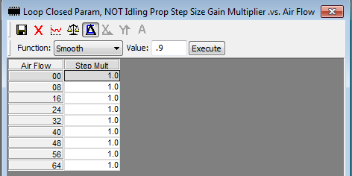
A value from this Table, and that extracted from the Table at 0x4DE=CL o2 Proportional Gain Counts .vs. % Adjusted SLOW o2 Voltage Error, are multiplied. That product provides a range of values 4 to 12. Because all the values in this Table are 100%, the values in the Table at 0x4DE are used without change.

0x4D8 Loop Closed Param, SLOW o2 Proportional Step Size .vs. RPM
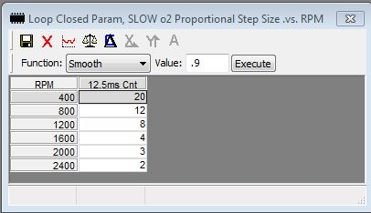
A value from this Table is added to a value extracted from the Table at 0x4EA=Proportional Step Duration .vs. % Adjusted SLOW o2 Voltage Error to yield a total “Count” value based on the % Adjusted SLOW o2 Voltage Error and RPM. This total count value is the number of loops through the 12.5ms Fuel Minor Loop required before an increase/decrease of the INT is allowed if there has not been a Rich/Lean voltage transition.

0x4DE Loop Closed Param, CL o2 Proportional Gain Counts .vs.
% Adjusted SLOW o2 Voltage Error
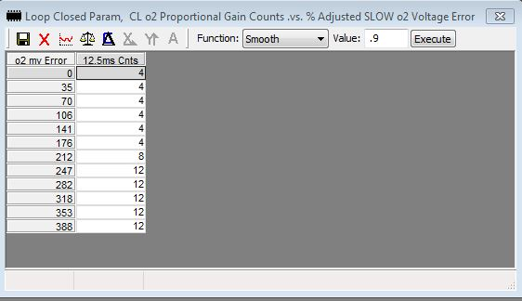
The value in the “o2 mv Error” column of this Table is the % Adjusted SLOW o2mv Voltage Error. A value from this Table, and that extracted from the Table at 0x4CF=NOT Idling Proportional Step Size Gain Multiplier .vs. Air Flow, are multiplied. That product provides a range of values 4 to 12 (larger values at higher % Adjusted Voltage Errors). Because all the values in Table 0x4CF are 100%, the values in this Table are used without change.
The “12.5ms Cnts” column of this Table represents L00EC=Prop Gain Counts. This is the value added/subtracted to/from the INT to create the Rough BPW Correction. Additionally, after BPW is corrected with the Rough BPW Correction, it is next adjusted in the opposite direction by ½ of the value from this Table. This is the Fine BPW Correction which somewhat offsets the Rough BPW Correction.

0x4EA Loop Closed Param, SLOW o2 Proportional Step Size .vs.
% Adjusted SLOW o2 Voltage Error
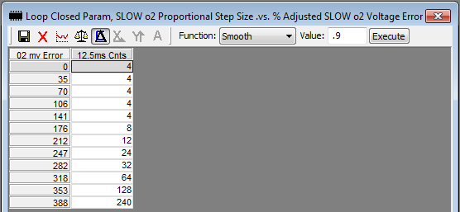
The value in the “o2 mv Error” column of this Table is the % Adjusted SLOW o2mv Voltage Error. While the % Adjusted SLOW o2 Voltage Error is <= 18mv, a value from this Table is added to a value extracted from the Table at 0x4D8=Proportional Step Size Gain .vs. RPM to yield Summed Prop Counts. These Summed Counts are based on both RPM and the % Adjusted SLOW o2 Voltage Error. Summed Prop Counts represent the number of passes through the 12.5ms Fuel Minor Loop required before the INT can be +/-d and the Rough BPW Correction computed if there has not been a Cross-Count during the time period represented by the Summed Counts.

0x504 Loop Closed Param, INT Delay Factor .vs. % Adjusted SLOW o2 Voltage Error
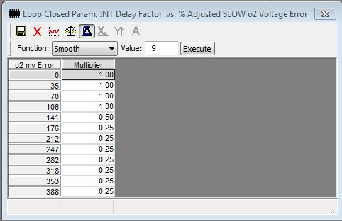
A value extracted from this Table based on % Adjusted SLOW o2 Voltage Error, and a value from the Table at 0x4BD=SLOW o2 INT Delay Time .vs. Air Flow (possibly coolant temperature adjusted), are multiplied. That product is the “Calculated # of Passes through the Fuel Minor Loop’ required before the INT can be +/-‘d”. The calculated # of passes decreases as air flow and the % Adjusted SLOW o2 Voltage Error increase, providing more frequent INT updates.

0x617 PE, % Change to AFR .vs. RPM (Lambda W)
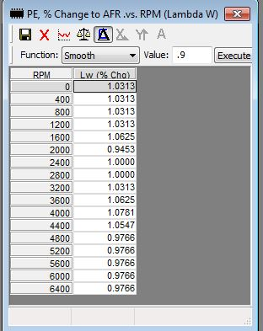

0xB3A PE, % Change to AFR .vs. RPM EXTENDED (Z69) (Lambda W)
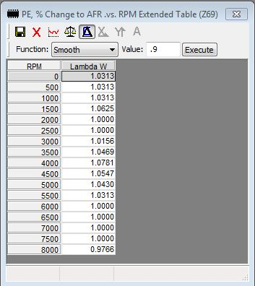
A Lambda W value is obtained from one of these two Tables above based on RPM (6400 RPM Max Table or 8000 RPM Max Table). That value, plus 128, is added to a value from the Table at 0x60E=PE, % Change to AFR .vs. Coolant Temp (Lambda C). The resulting value is used to calculate PE AFR. Using DECIMAL values, not hex values, PE AFR can be computed as follows:
PE AFR = Stoich AFR / (Lc + Lw)
0x60E PE, % Change to AFR .vs. Coolant Temp (Lambda C)
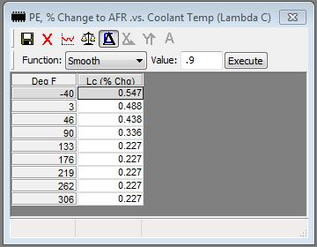
A Lambda C value is obtained from this Table based on coolant temperature. It is added to a value from the Lambda W Table at (0x617=PE, % Change to AFR .vs. RPM (Lambda W), or from S_AUJP Extended PE Table if 0x99E b7=1). 128 is added to the sum. The resulting value is used to calculate PE AFR. Using DECIMAL values, not hex values, PE AFR can be computed as follows:
PE AFR = Stoich AFR / (Lc + Lw)

0x7FD MAT or Coolant/MAT Differential Compensation Counts
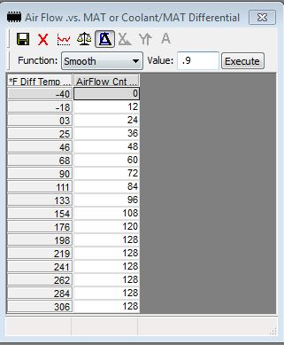
Counts from this Table are used to compute a BPW Temperature Scaling Factor. Generally, it's not necessary to adjust this Table, but any upward/downward change in Counts will result in increased/decreased BPW.
The temperatures used as Input to this Table are based on the Flag 0x018 b4:
- If b4=0, Input = Use MAT
- If b4=1, Input = Use an Air Flow factored Coolant/MAT differential
When b4=1 and Coolant >= MAT, the input is MAT plus an additional value. The added value is an Air-Flow-factored Coolant/MAT temperature differential.
When b4=1 and Coolant < MAT, Input is MAT as when b4=0.
0x81F VE Adjustment Factor .vs. Barometric Pressure
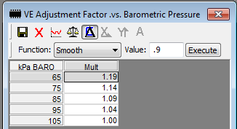
VE will be adjusted upward for Barometric Pressure using this Table value if MAP < 105 kPa. There will be no change if MAP >=105+ kPa (WOT).
The lower the MAP, the larger the upward BARO adjustment to VE.

0x80E Coolant/MAT Differential Factor .vs. Air Flow
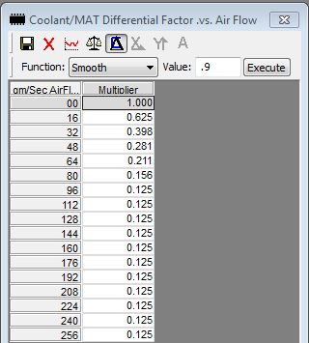
If Flag 0x018 b4 =1, a multiplier from this Table is extracted based on Air Flow. The extracted value is then used to factor a Coolant/MAT differential used in the calculation of ’Air Flow Factored Coolant/MAT Differential & Cylinder Volume Scaling Factor’ (the “Scaling Factor”), which is used to compute BPW.
To lean-out BPW: Increase the Table Multipliers
To Richen BPW: Decrease the Table Multipliers
The higher the Air Flow, the lower the factor returned from this Table.
This Table is not used if 0x018 b4 =0.

Appendix F
SLOW and FAST o2 Errors and Effect on INT, BLM and BPW

This Appendix provides the details of how SLOW and FAST o2 Errors are used in OL and CL to affect the INT, BLM and BPW.

SLOW o2
Errors and going-Rich/Lean Conditions
- A SLOW o2 Voltage Error occurs when SLOW o2 voltage exceeds a SLOW o2 Voltage Boundary. SLOW Errors are % Adjusted and are retained for later CL use (see Usage, CL below)
- A SLOW going-Rich/Lean condition occurs concurrent with and in the same direction as a SLOW Voltage Error

How SLOW o2 Errors are Used
General
- The larger the % Adjusted SLOW o2 Voltage Error, the larger the BPW correction
In CL Only
- If a SLOW o2 Voltage Error occurs, a % Adjusted SLOW o2 Voltage Error is computed using varying percentages depending upon whether Low TPS & MPH or NOT Low TPS & MPH
- If the % Adjusted SLOW o2 Voltage Error is:
> 18mv:
    - the INT may be +/-‘d if sufficient time has passed since last change and other conditions have been met
    - Prop Gain Counts are obtained from a Calibration Table
    - A Rough BPW Correction value is computed using the Prop Gain Counts
Rough BPW Correction = INT + Prop Gain Counts
<= 18mv
    - Summed Prop Counts are computed. They define the time after which Prop Gain Counts will later be determined and the Rough BPW Correction computed. The INT is not +/-‘d.

IN OL Only
- SLOW o2 not used in OL.

FAST o2
Errors and going-Rich/Lean Conditions
- A FAST o2 Voltage Error occurs if FAST o2 voltage exceeds the ‘FAST o2 Swing Point +/- 53mv’. Unlike a % Adjusted SLOW o2 Error, the magnitude of a FAST o2 Error is not used.
- A FAST o2 going-Rich/Lean condition (voltage direction) is indicated concurrent with and in the same direction as a FAST o2 Voltage Error.
- If a FAST o2 Voltage Error does not occur, current FAST o2 voltage is compared to that 12.5ms ago for determination of FAST o2 Voltage direction:
  - If current FAST voltage is > than that 12.5ms ago, a FAST going-Rich condition is indicated
  - Else if <=, a FAST going-Lean condition is indicated (assumed by default)
Once a FAST going-Rich/Lean condition has been determined, there is no further use of a FAST o2 Error. It merely determines voltage direction.

How FAST o2 going-Rich/Lean is Used
In CL Only
- Determines the direction of an INT adjustment if the INT Delay time period has passed:
  - Increment the INT to increase fuel if both SLOW and FAST o2 are going-Lean and the INT <> Max Allowed
Max Allowed (Default) =180 (0x493)
  - Decrement the INT to reduce fuel if both SLOW and FAST o2 are going-Rich and the INT <> Min Allowed
Min Allowed (Default) =80 (0x492)
- Determines the direction of the Rough BPW Correction:
  - If FAST o2 going-Rich (BPW will be leaned):
Rough BPW Correction = INT minus Prop Gain Counts
  - Else if FAST o2 going-Lean (BPW will be richened):
Rough BPW Correction = INT plus Prop Gain Counts
- Used to determine BLM adjustment if sufficient time has passed since the last BLM update and the INT is more than 5 counts from 128:
  - If the INT is Lean (> 128) & FAST o2 going-Lean
    - Increase BLM 2 counts in the current BLM Cell
  - Else if the INT is Rich (< 128) & FAST o2 going-Rich
    - Decrease BLM 2 counts in the current BLM Cell
The BLM follows the INT and FAST o2 direction.
- Used to set the blink-state of the Check Engine Light (CEL) during o2 sensor ALDL Diagnostics with engine running and ALDL connector Pins A&B shorted:
going-Rich: CEL On
going-Lean: CEL Off

In Both OL and CL
- Causes the INT to be forced to 128 if any one of several conditions exist (see Check the status of INT related Flags above in the Fuel Minor Loop Code Flow below for details)
- Causes a Cross-Count to be recorded in variable L00FC when the FAST o2 voltage direction changes (indicated by a change in L0047 b6), and causes L00E9=# 12.5ms Fuel Minor Loop Passes without Cross-Count to be cleared
- If no Cross-Count, causes L00E9=# 12.5ms Fuel Minor Loop Passes without Cross-Count to be incremented
- Determines the direction of each of the 3 BPW corrections, which are:
  - based on the BLM’s distance from 128
  - based on the Rough BPW Correction (=INT +/- Prop Gain Counts)
  - based on the Fine BPW Correction (½ Prop Gain Counts in the opposite direction of the Rough BPW Correction)
The above corrections are also performed in OL, but there is no change to BPW because all values and correction factors =128 base, which is equivalent to no correction.

Document Revisions

October, 2021 Revision 3
- Added Turbo now supported in v7 S_AUJP.
- Minor changes for additional clarity.

September, 2020 Revision 2
- Discussion of the following Tables was modified for clarity.
0x80E= Coolant/MAT Differential Factor .vs. Air Flow
0x7FD=MAT or Coolant/MAT Differential Compensation Counts
- Modified discussion of the effect of changing SLOW o2 Voltage Boundaries providing more detail.
- Changed all Calibration Titles and Descriptions to match those in the v6 S-AUJP XDF.
- Added Flags and Tables to the lists in Appendix E.
- Corrected comment about reversion to OL when o2 Errors 13, 44 or 45 are encountered.

April, 2017 Revision 1
- The titles of the Tables below were changed to better describe their usage:
0x4BD
Prev: SLOW o2 Filter Coefficient .vs. Air Flow
New: SLOW o2 INT Delay Time .vs. Air Flow

0x4C6
Prev: SLOW o2 Filter Coefficient Multiplier .vs. Air Flow
New: SLOW o2 Lag Filtering Coefficient .vs. Air Flow

February, 2017 Initial Document

***** END of DOCUMENT *****

