How To Make A Opti-Dizzy

After seeing photos of distributors converted with the innards from a Opti-Spark Dizzy, I wanted to do it myself. The original photos used a small caped HEI, for some reason I cannot seem to find one of those around South Georgia. I ended up using a couple of the large cap HEI I had lying around here. First I acquired a Opti from a local yard and disassembled it according to Mike Chaney's Optispark Disection Page found at:

http://www.charm.net/~mchaney/optisprk/optisprk.htm

I then placed it on a brake lathe turning it down to fit inside the HEI and also removing the bottom foot where it will sit flush.

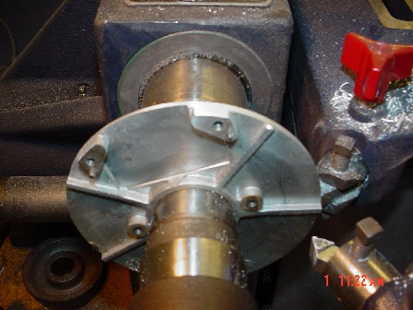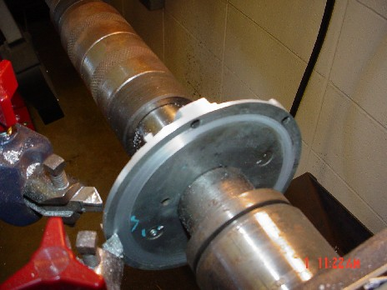

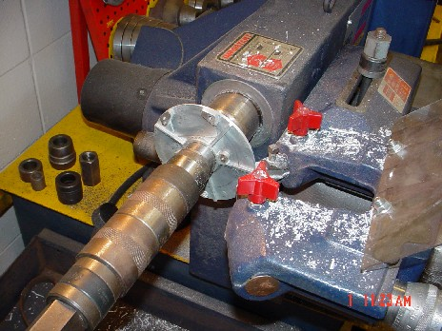

I then began disassembling my large cap HEI’s. The first was a Vac. Advanced HEI & the other was a Computer HEI. You can check out Rick Draganowski’s Site if you have any questions on how to tear down a HEI.

http://www.rustpuppy.org/ignition2/Ignition%202b.htm

Once I had the HEI Dist housing, I gave it to the welding Instructor to weld up the area under the ignition module. When that was completed, I began the process of hogging out the inside of the HEI Dist. This was a Royal PITA. I used about 4 carbide bits plus a cut-off tool. I did notice the area that had been welded did shrink a little.

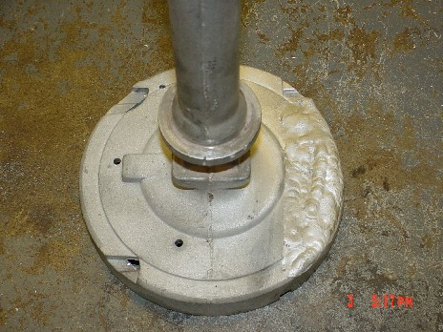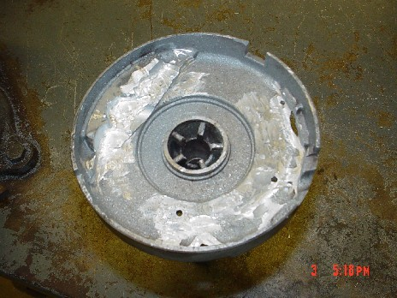

After which I ordered shaft bushings. The upper bushing is no longer available which really doesn’t make any difference. I was able to order 2 bottom bushings along with the plastic seal through Kendrick Auto. They also rebuild Dists. as well as sell parts.

http://www.kendrick-auto.com/ignition.htm

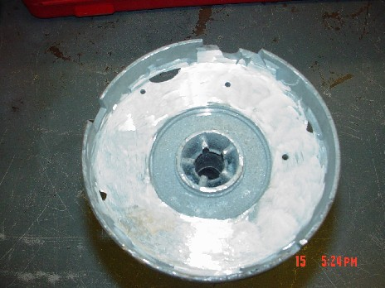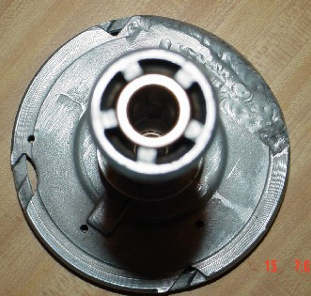

The top bushing was pressed in flush with the top of the grease well. The bottom was pressed in flush as well.

With the bushings installed, I’m ready to get the collar machined.

While that’s taking place, I’ve modified the dist shaft. I used the shaft from the Computerized HEI due to it not having weight advancement. This allows the rotor to be mounted directly to the shaft and not the mechanical weights.. The reluctor wheel needed to be removed. Held carefully in a vice by the reluctor, use a chisel and a hammer to break the reluctor. Later the area where the reluctor was mounted will have to be machined to help set shaft end-play.

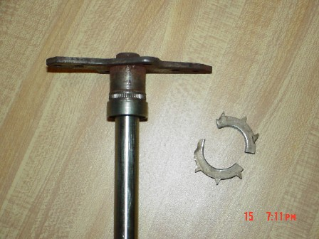

Another item which needs to be looked at while waiting is the opti itself. Using the cut off tool, I removed and trimmed the 4wire connector from the opti housing. Placing the 4 wire connector inside the connector housing, I was able to join the connector housing to the opti sensor with shrink wrap. This was done to prevent corrosion.

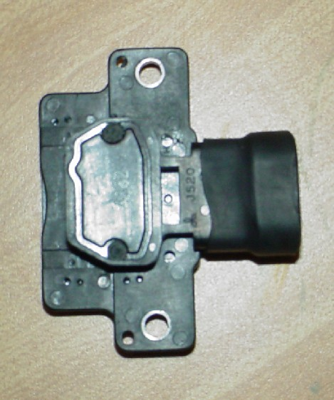

The connector itself needed to have part of the tab removed so it would fit inside the dist.
Note: Once installed this connector will not be removed. The stock harness has a service connector which I will utilized. On none stock harnesses, one can be added if needed.

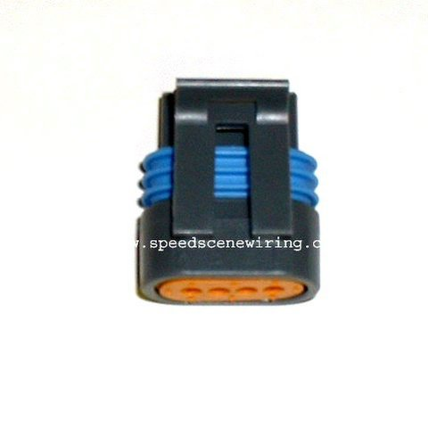

I placed the Opti guts inside to get an idea of how it looks.

