medium/gunmetal gray a 1988 color only wa9243 someone posted posted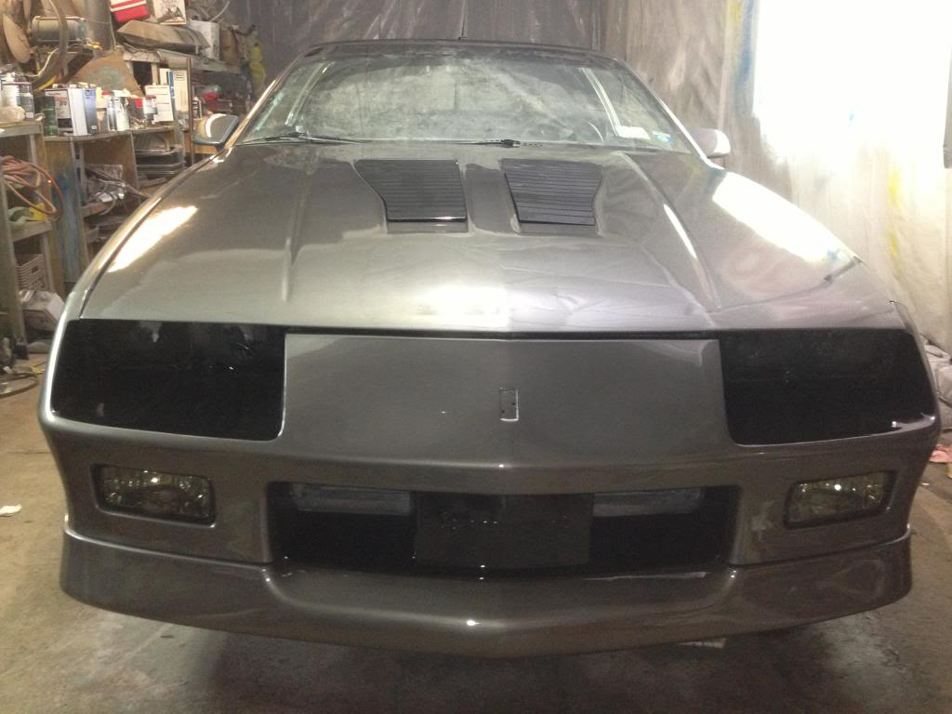
2012 Gun Metallic Nissan 370Z Coupe code KAD
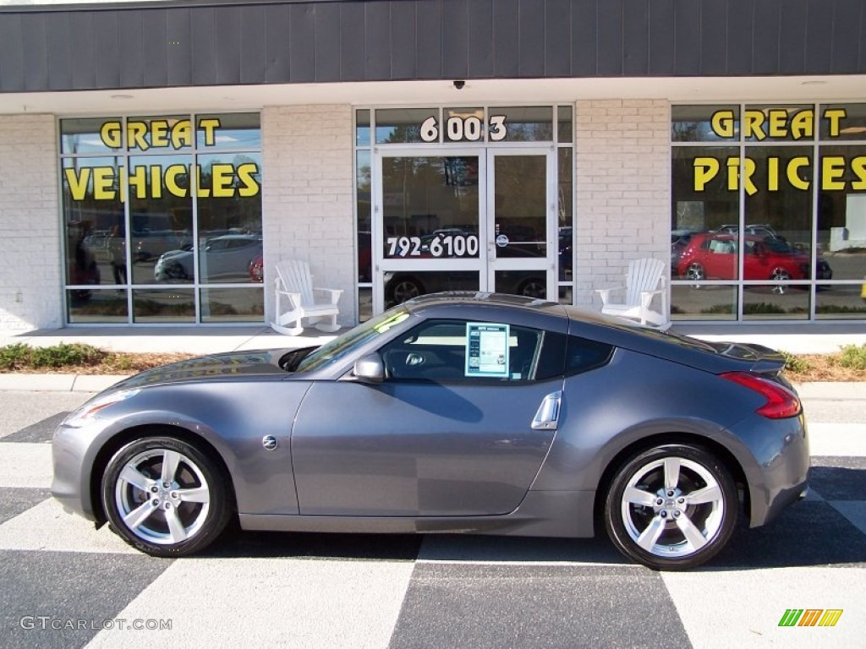
Next is 2010 nissan platinum graphite code k51
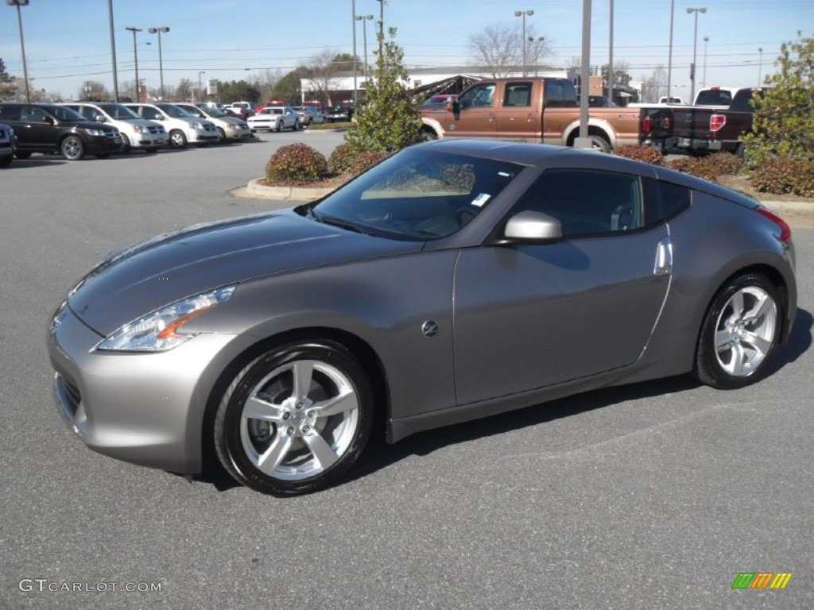
Kaiser Silver – don’t have code
